CHAPTER 2

MODEL ANIMAL HEALTH/OFFICIAL CERTIFICATE FOR THE ENTRY INTO THE UNION OF FRESH MEAT INTENDED FOR HUMAN CONSUMPTION, EXCLUDING MECHANICALLY SEPARATED MEAT, OF DOMESTIC OVINE AND CAPRINE ANIMALS (MODEL OVI)

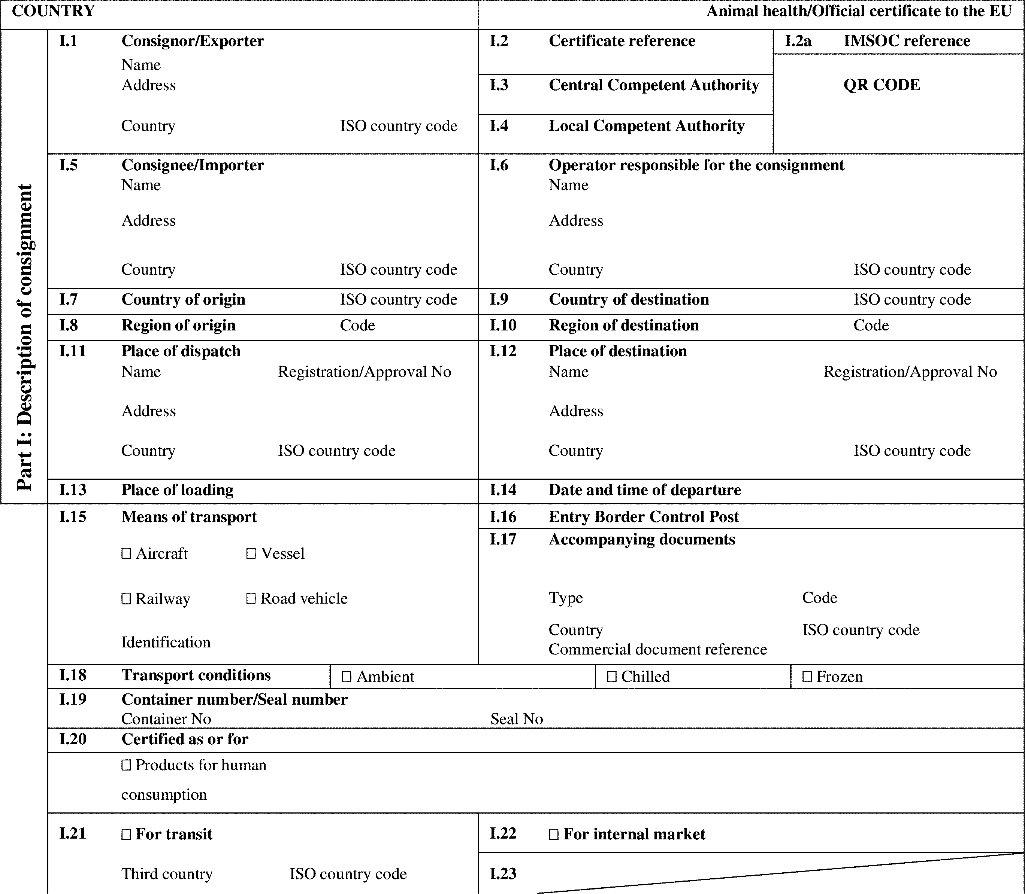

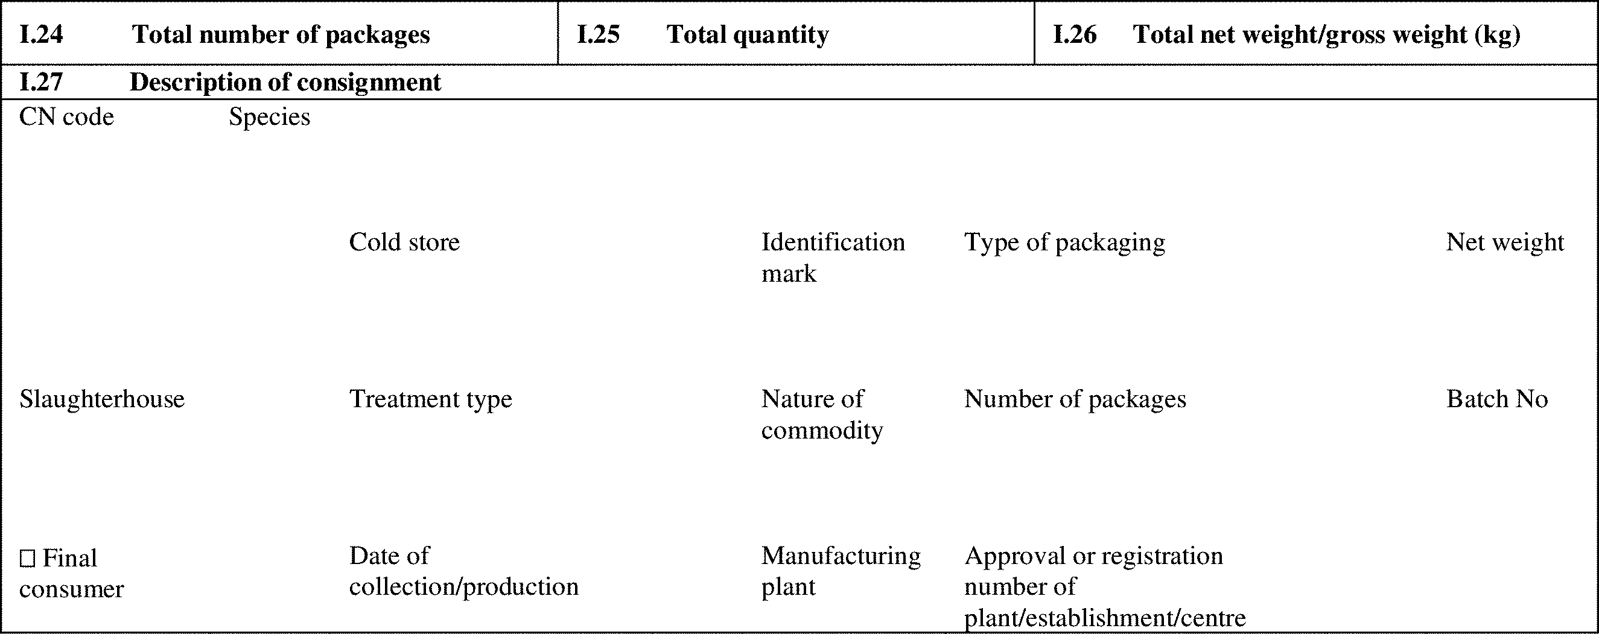

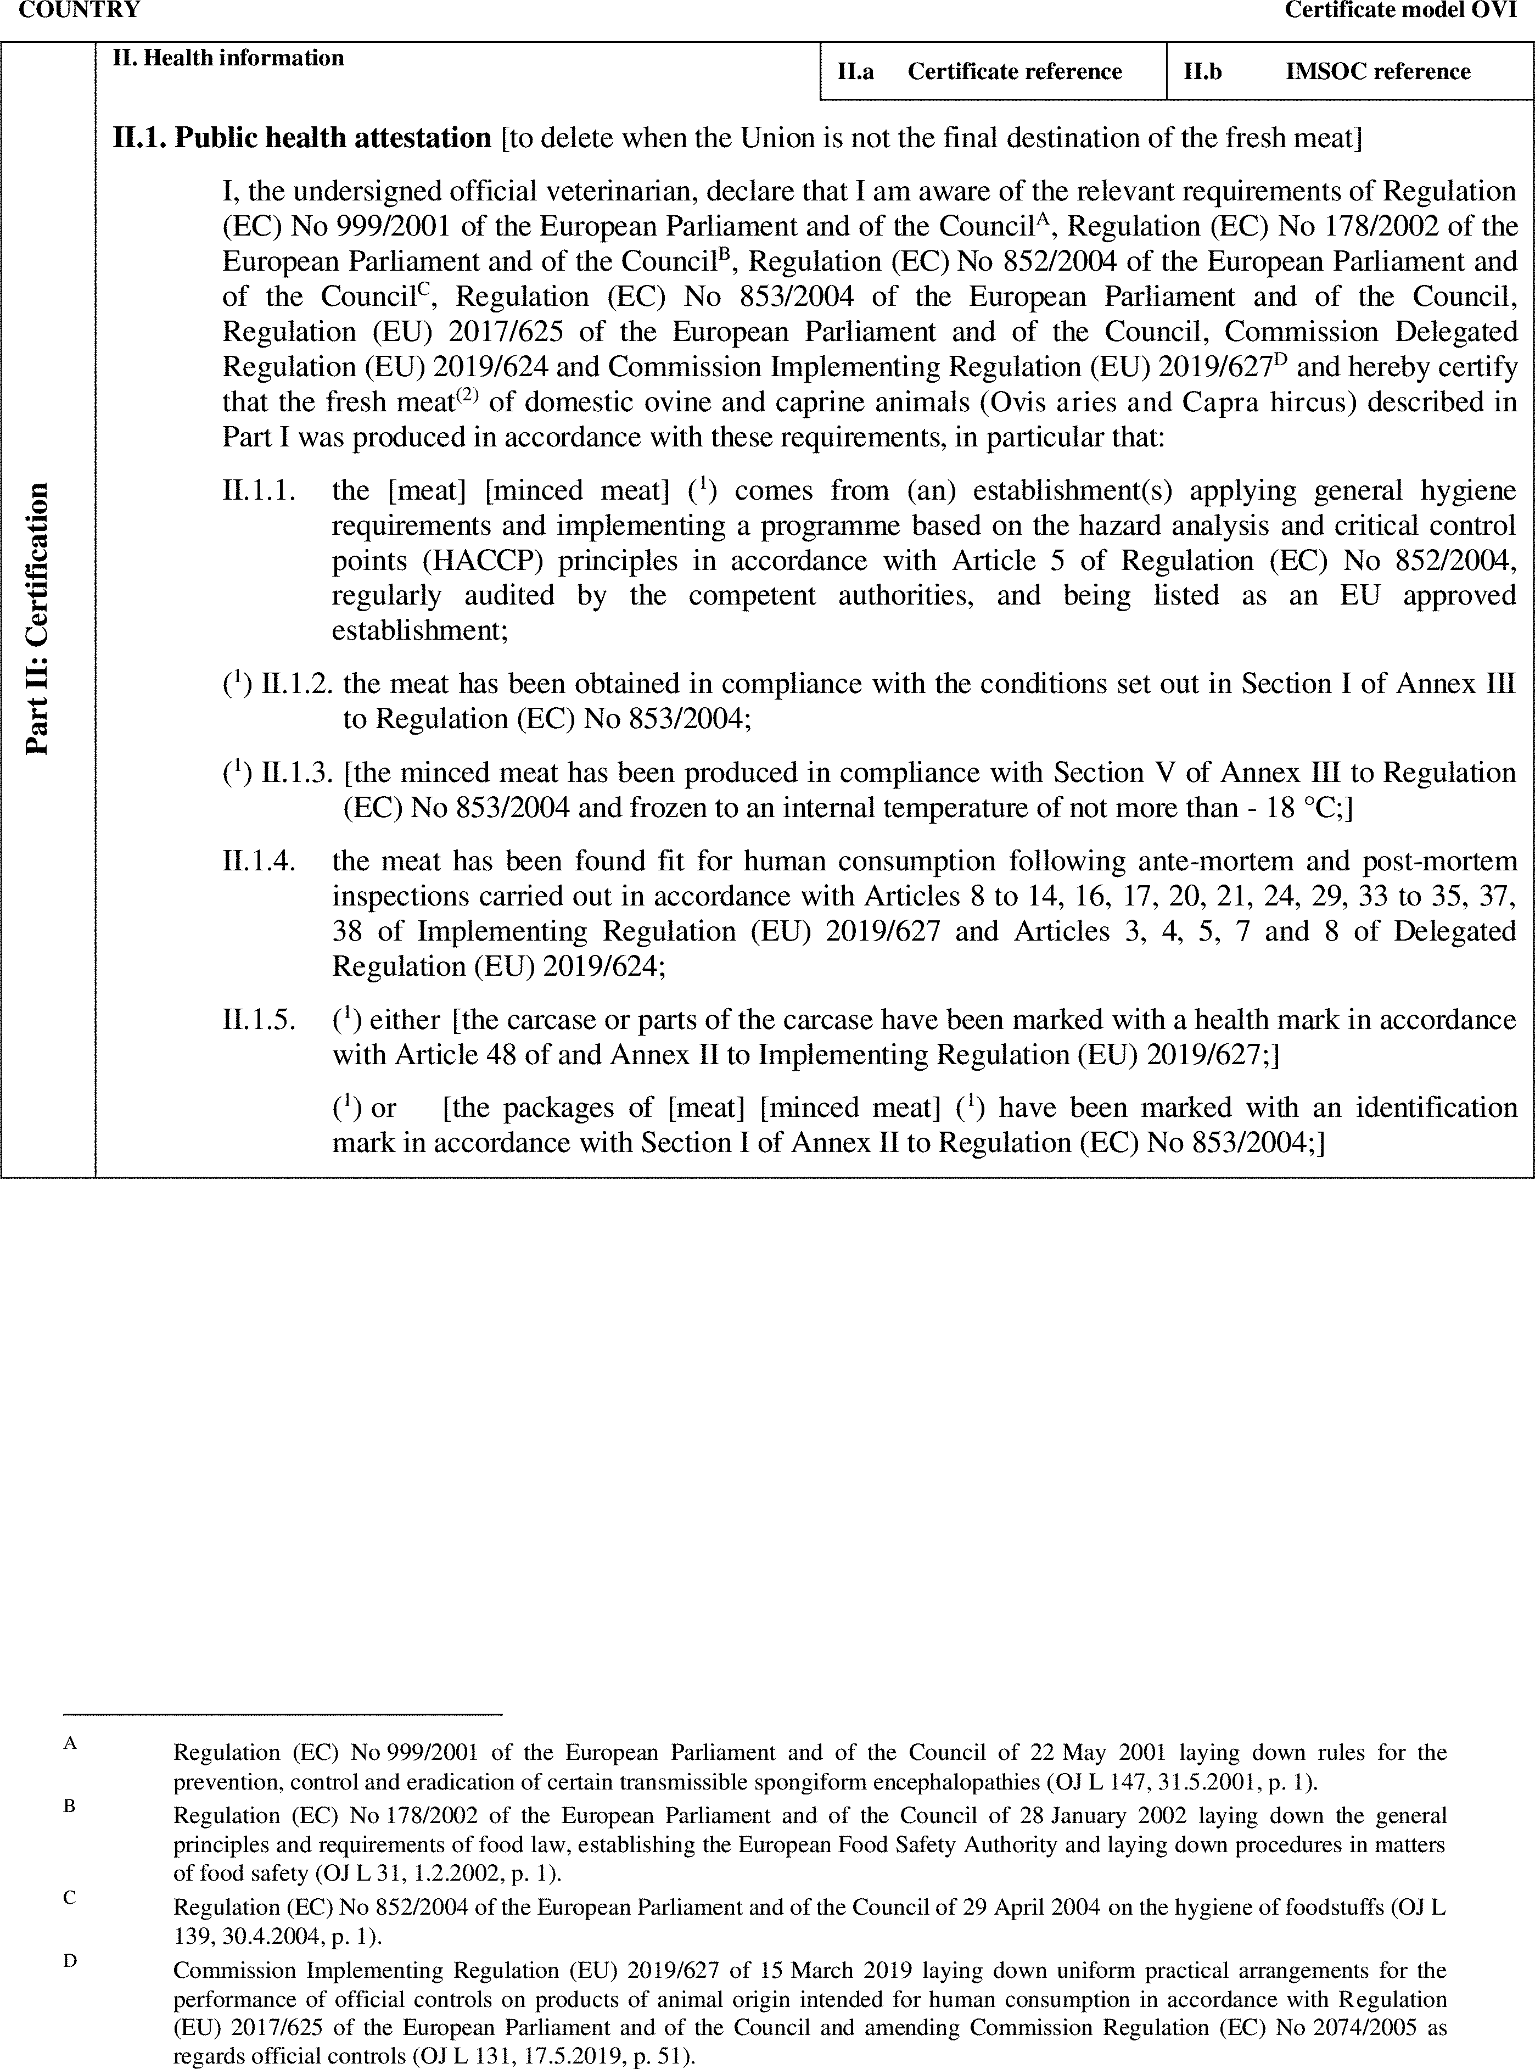

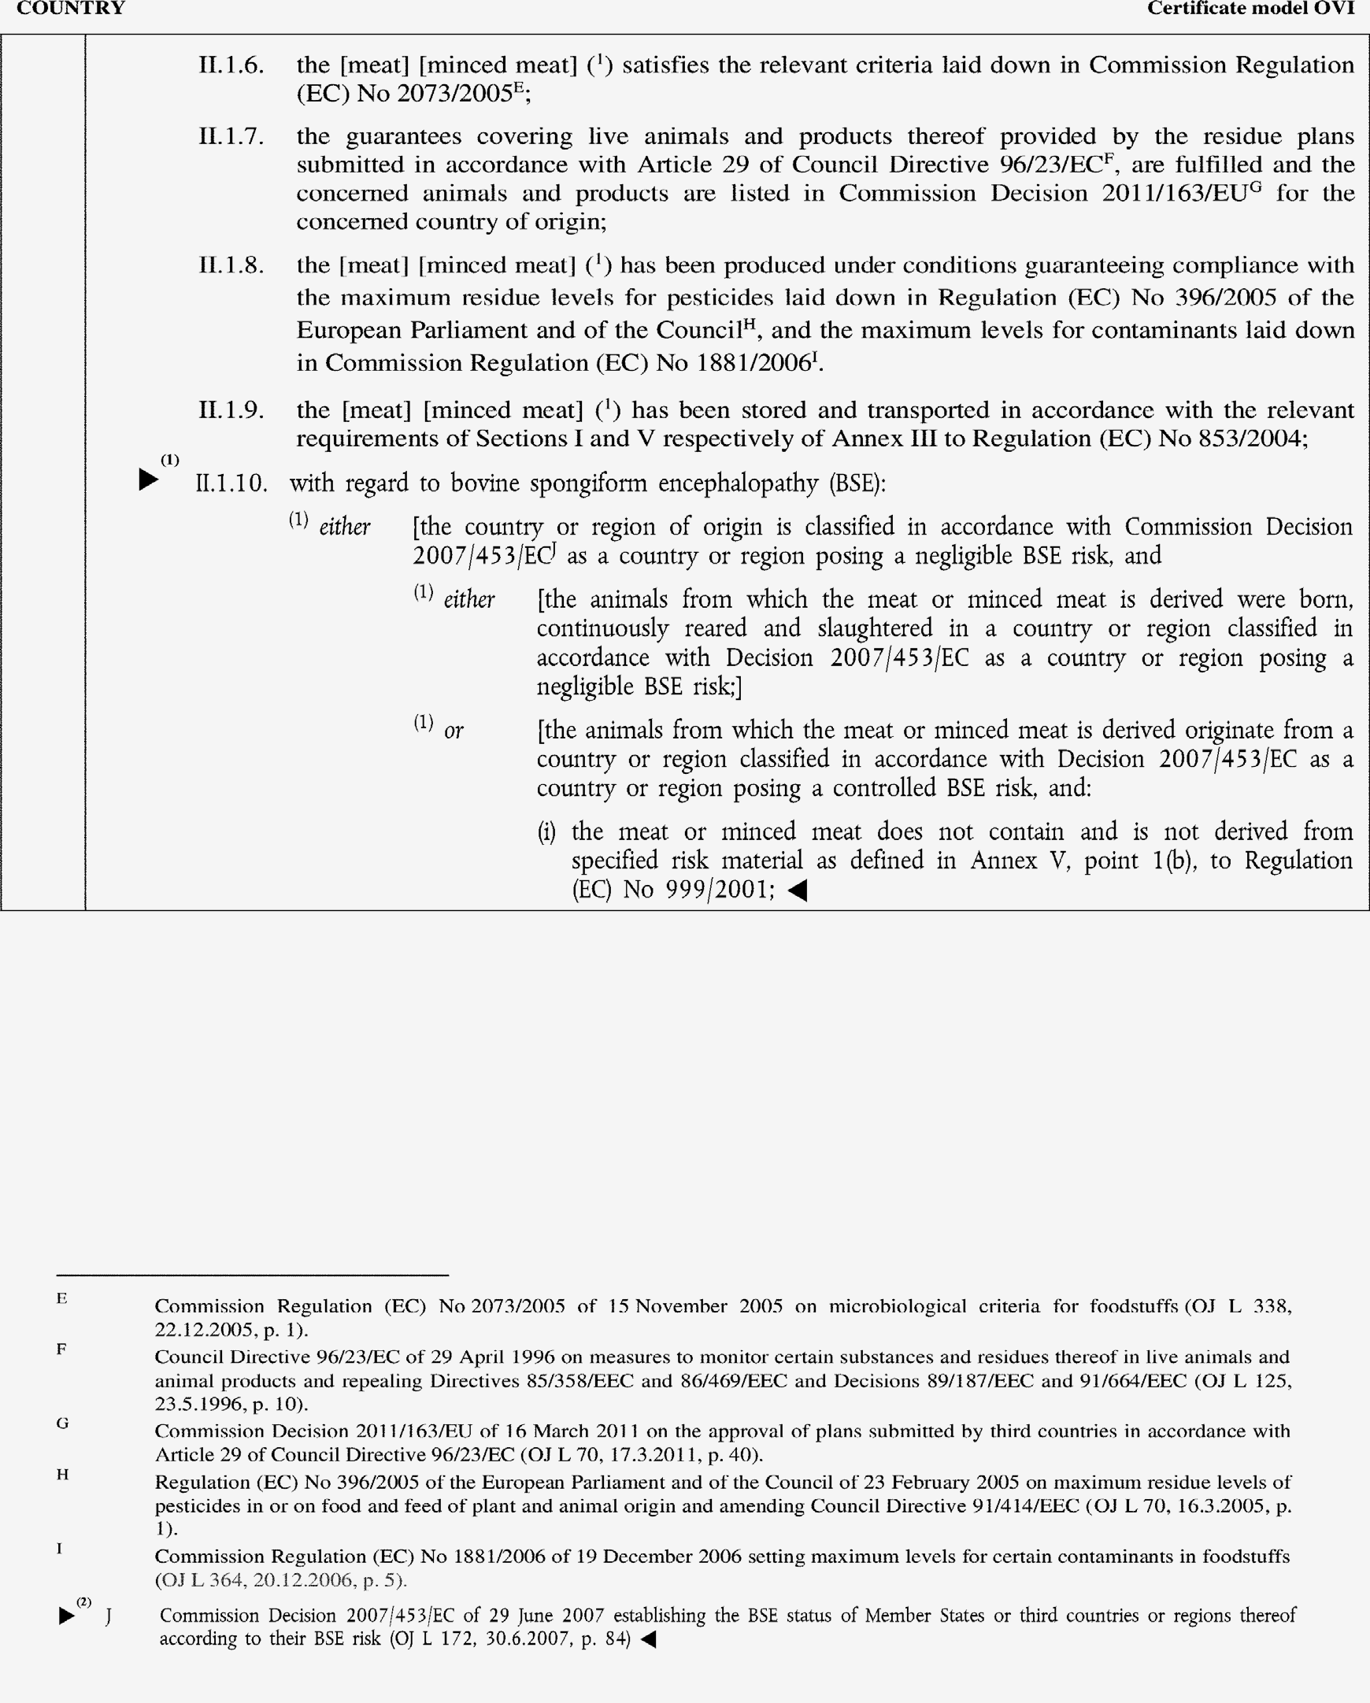

►(1) (2) M7

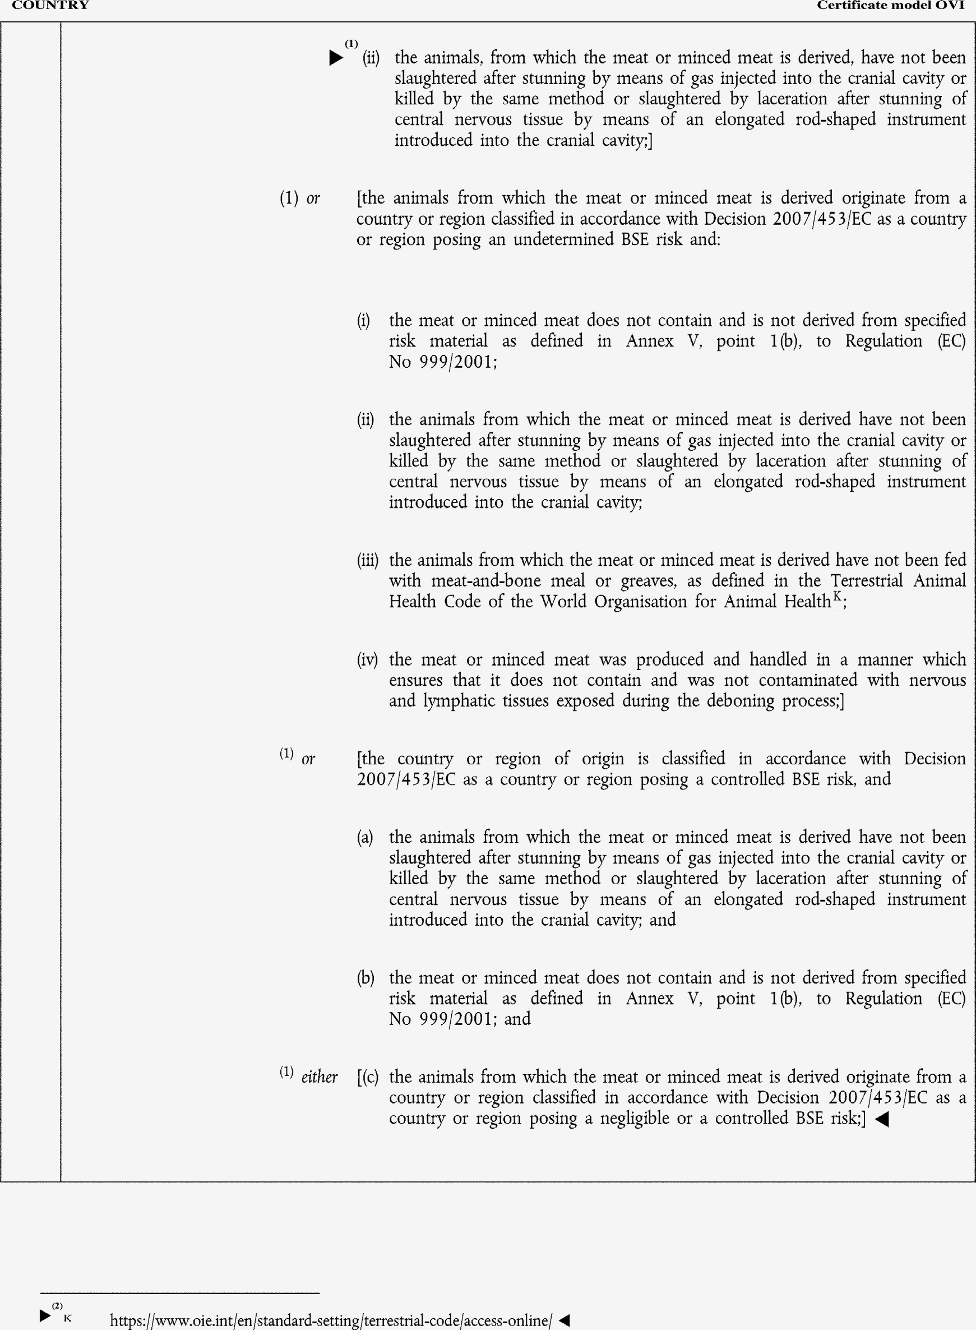

►(1) (2) M7

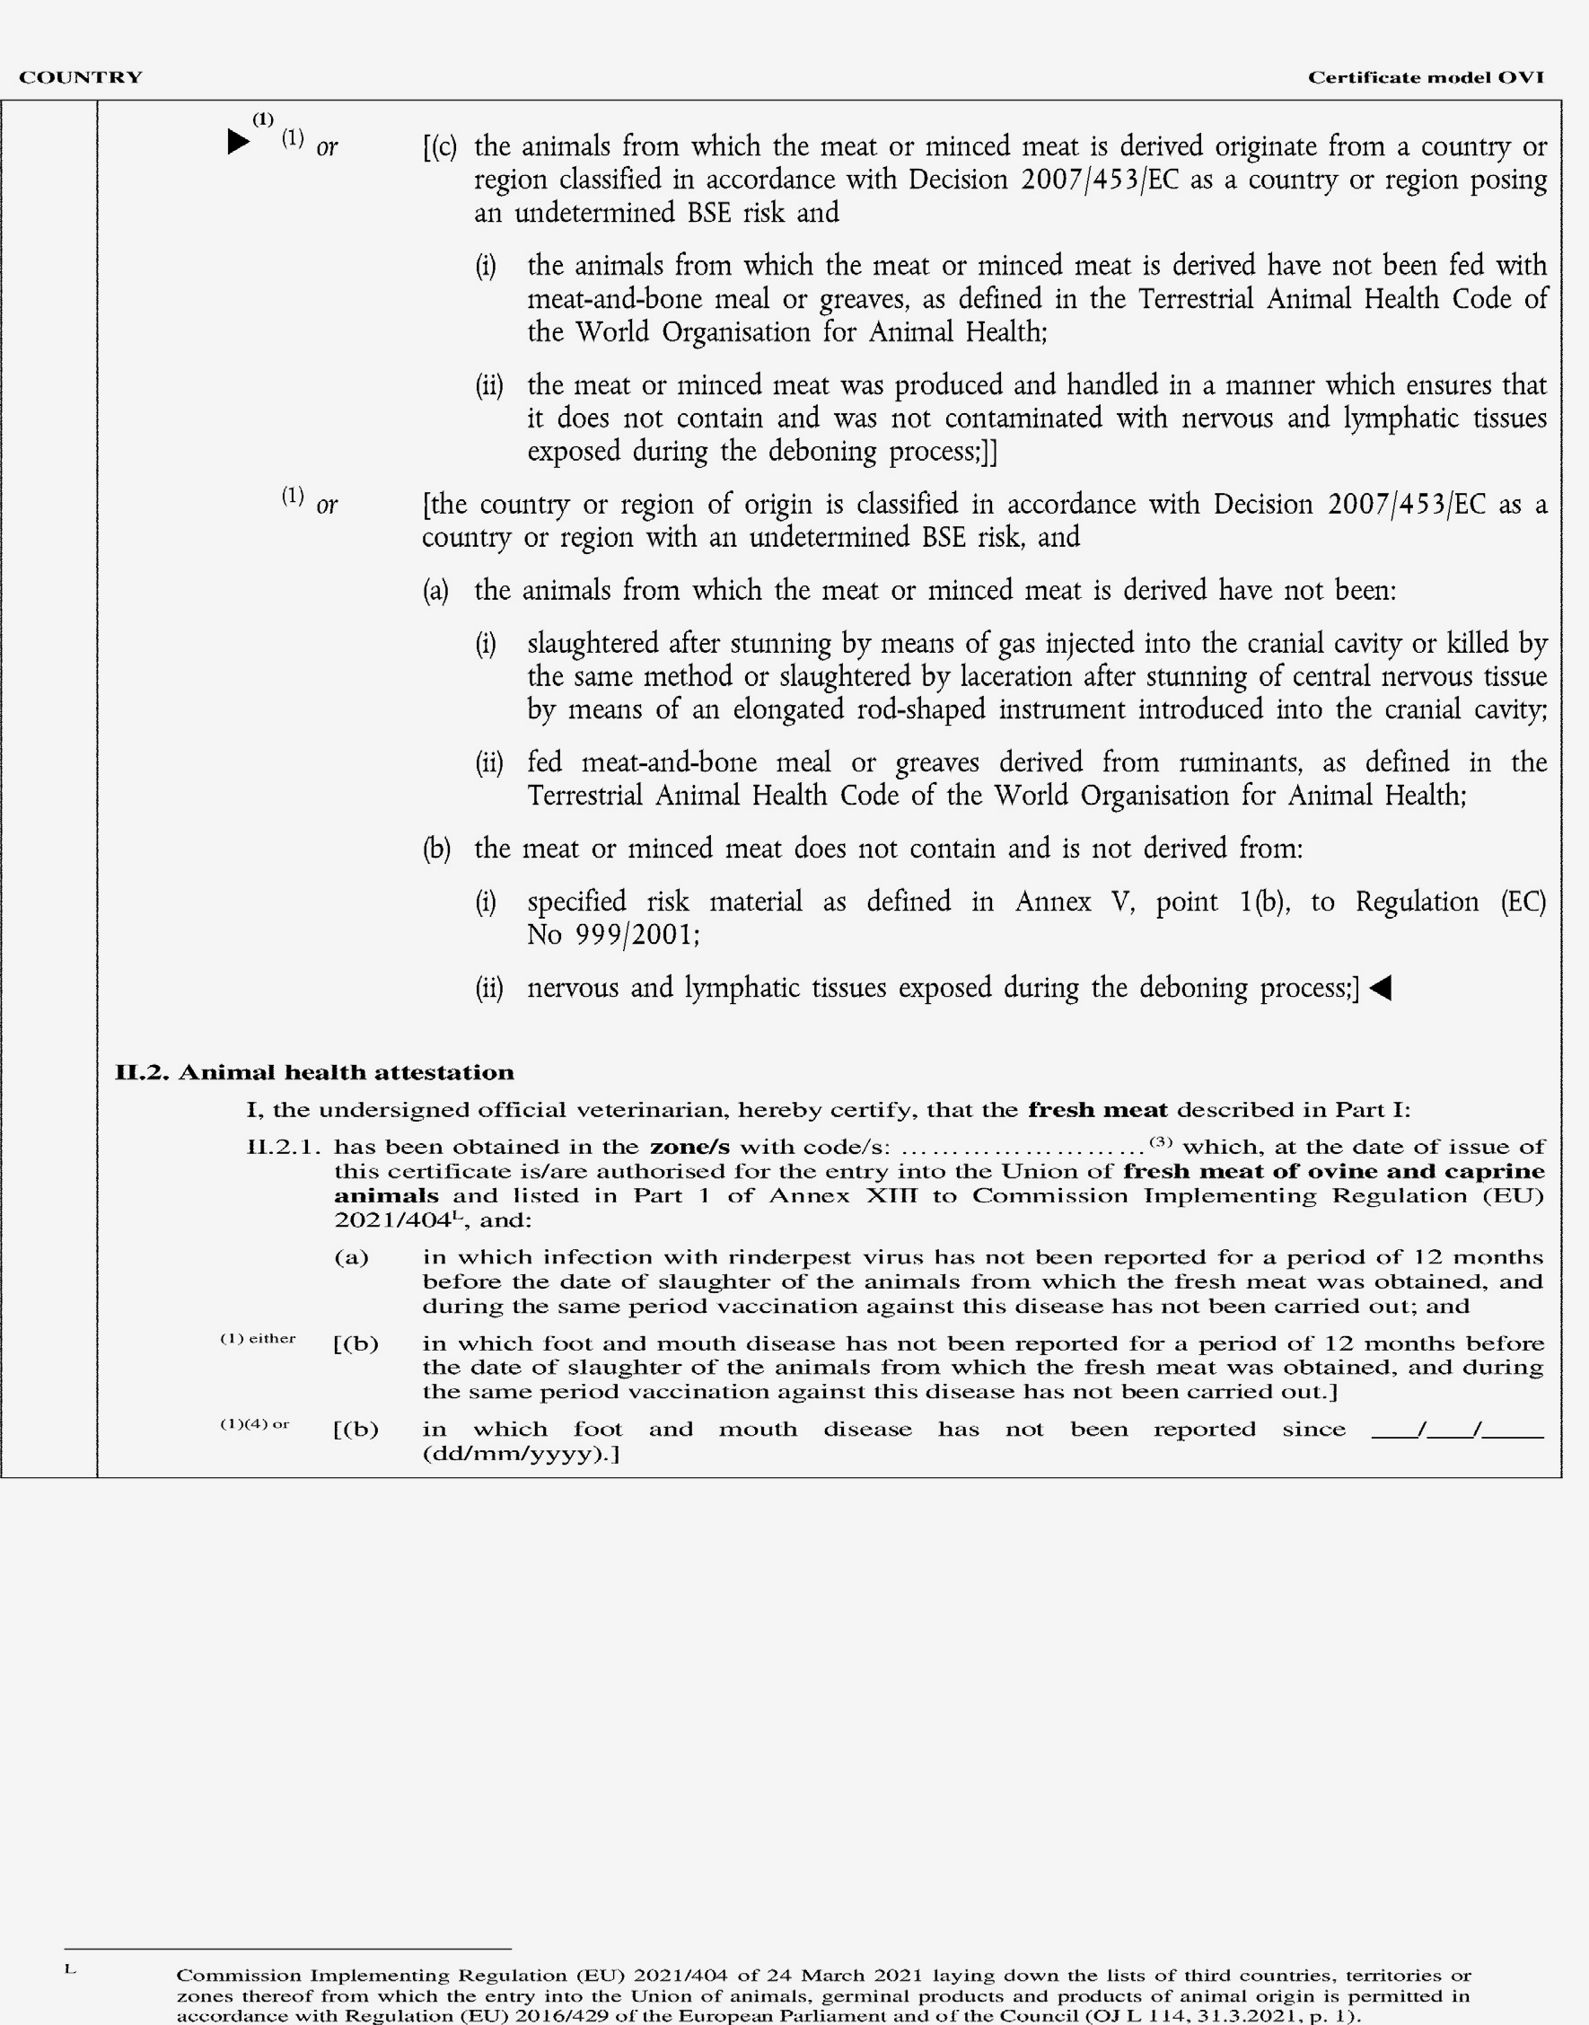

►(1) M7

