CHAPTER 1

MODEL ANIMAL HEALTH/OFFICIAL CERTIFICATE FOR THE ENTRY INTO THE UNION OF FRESH MEAT INTENDED FOR HUMAN CONSUMPTION, EXCLUDING MECHANICALLY SEPARATED MEAT, OF DOMESTIC BOVINE ANIMALS (MODEL BOV)

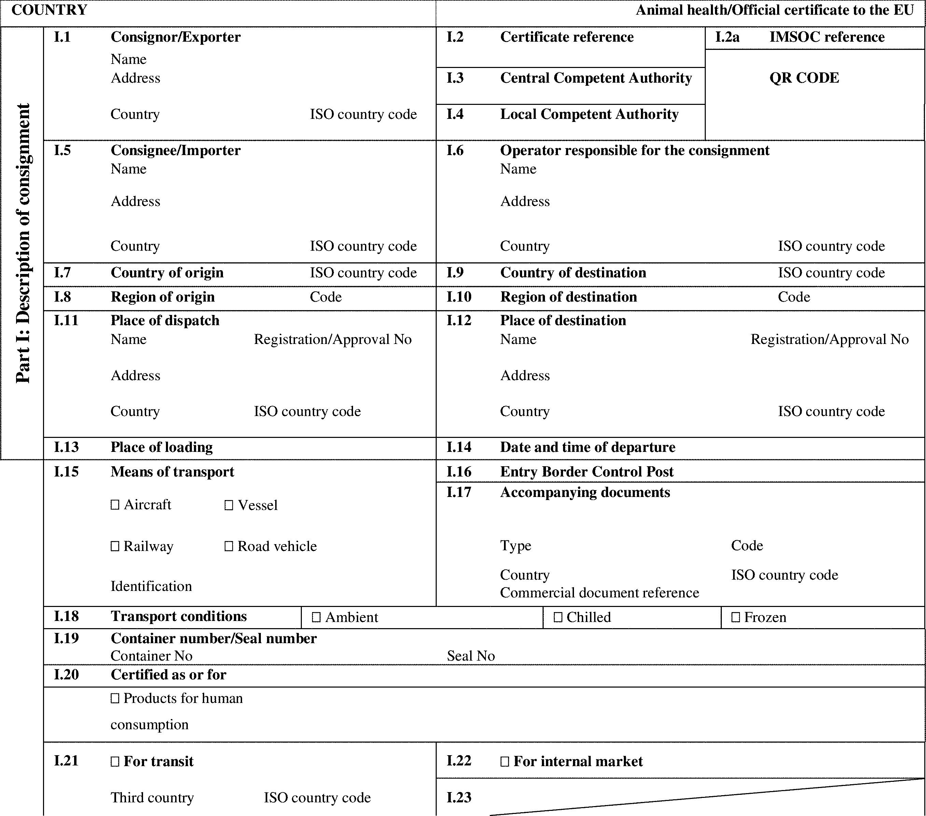

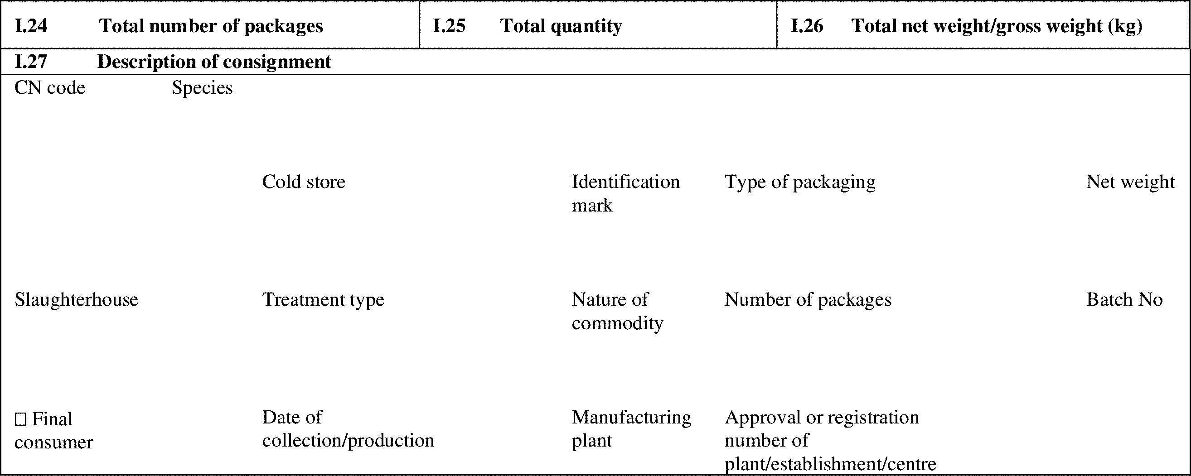

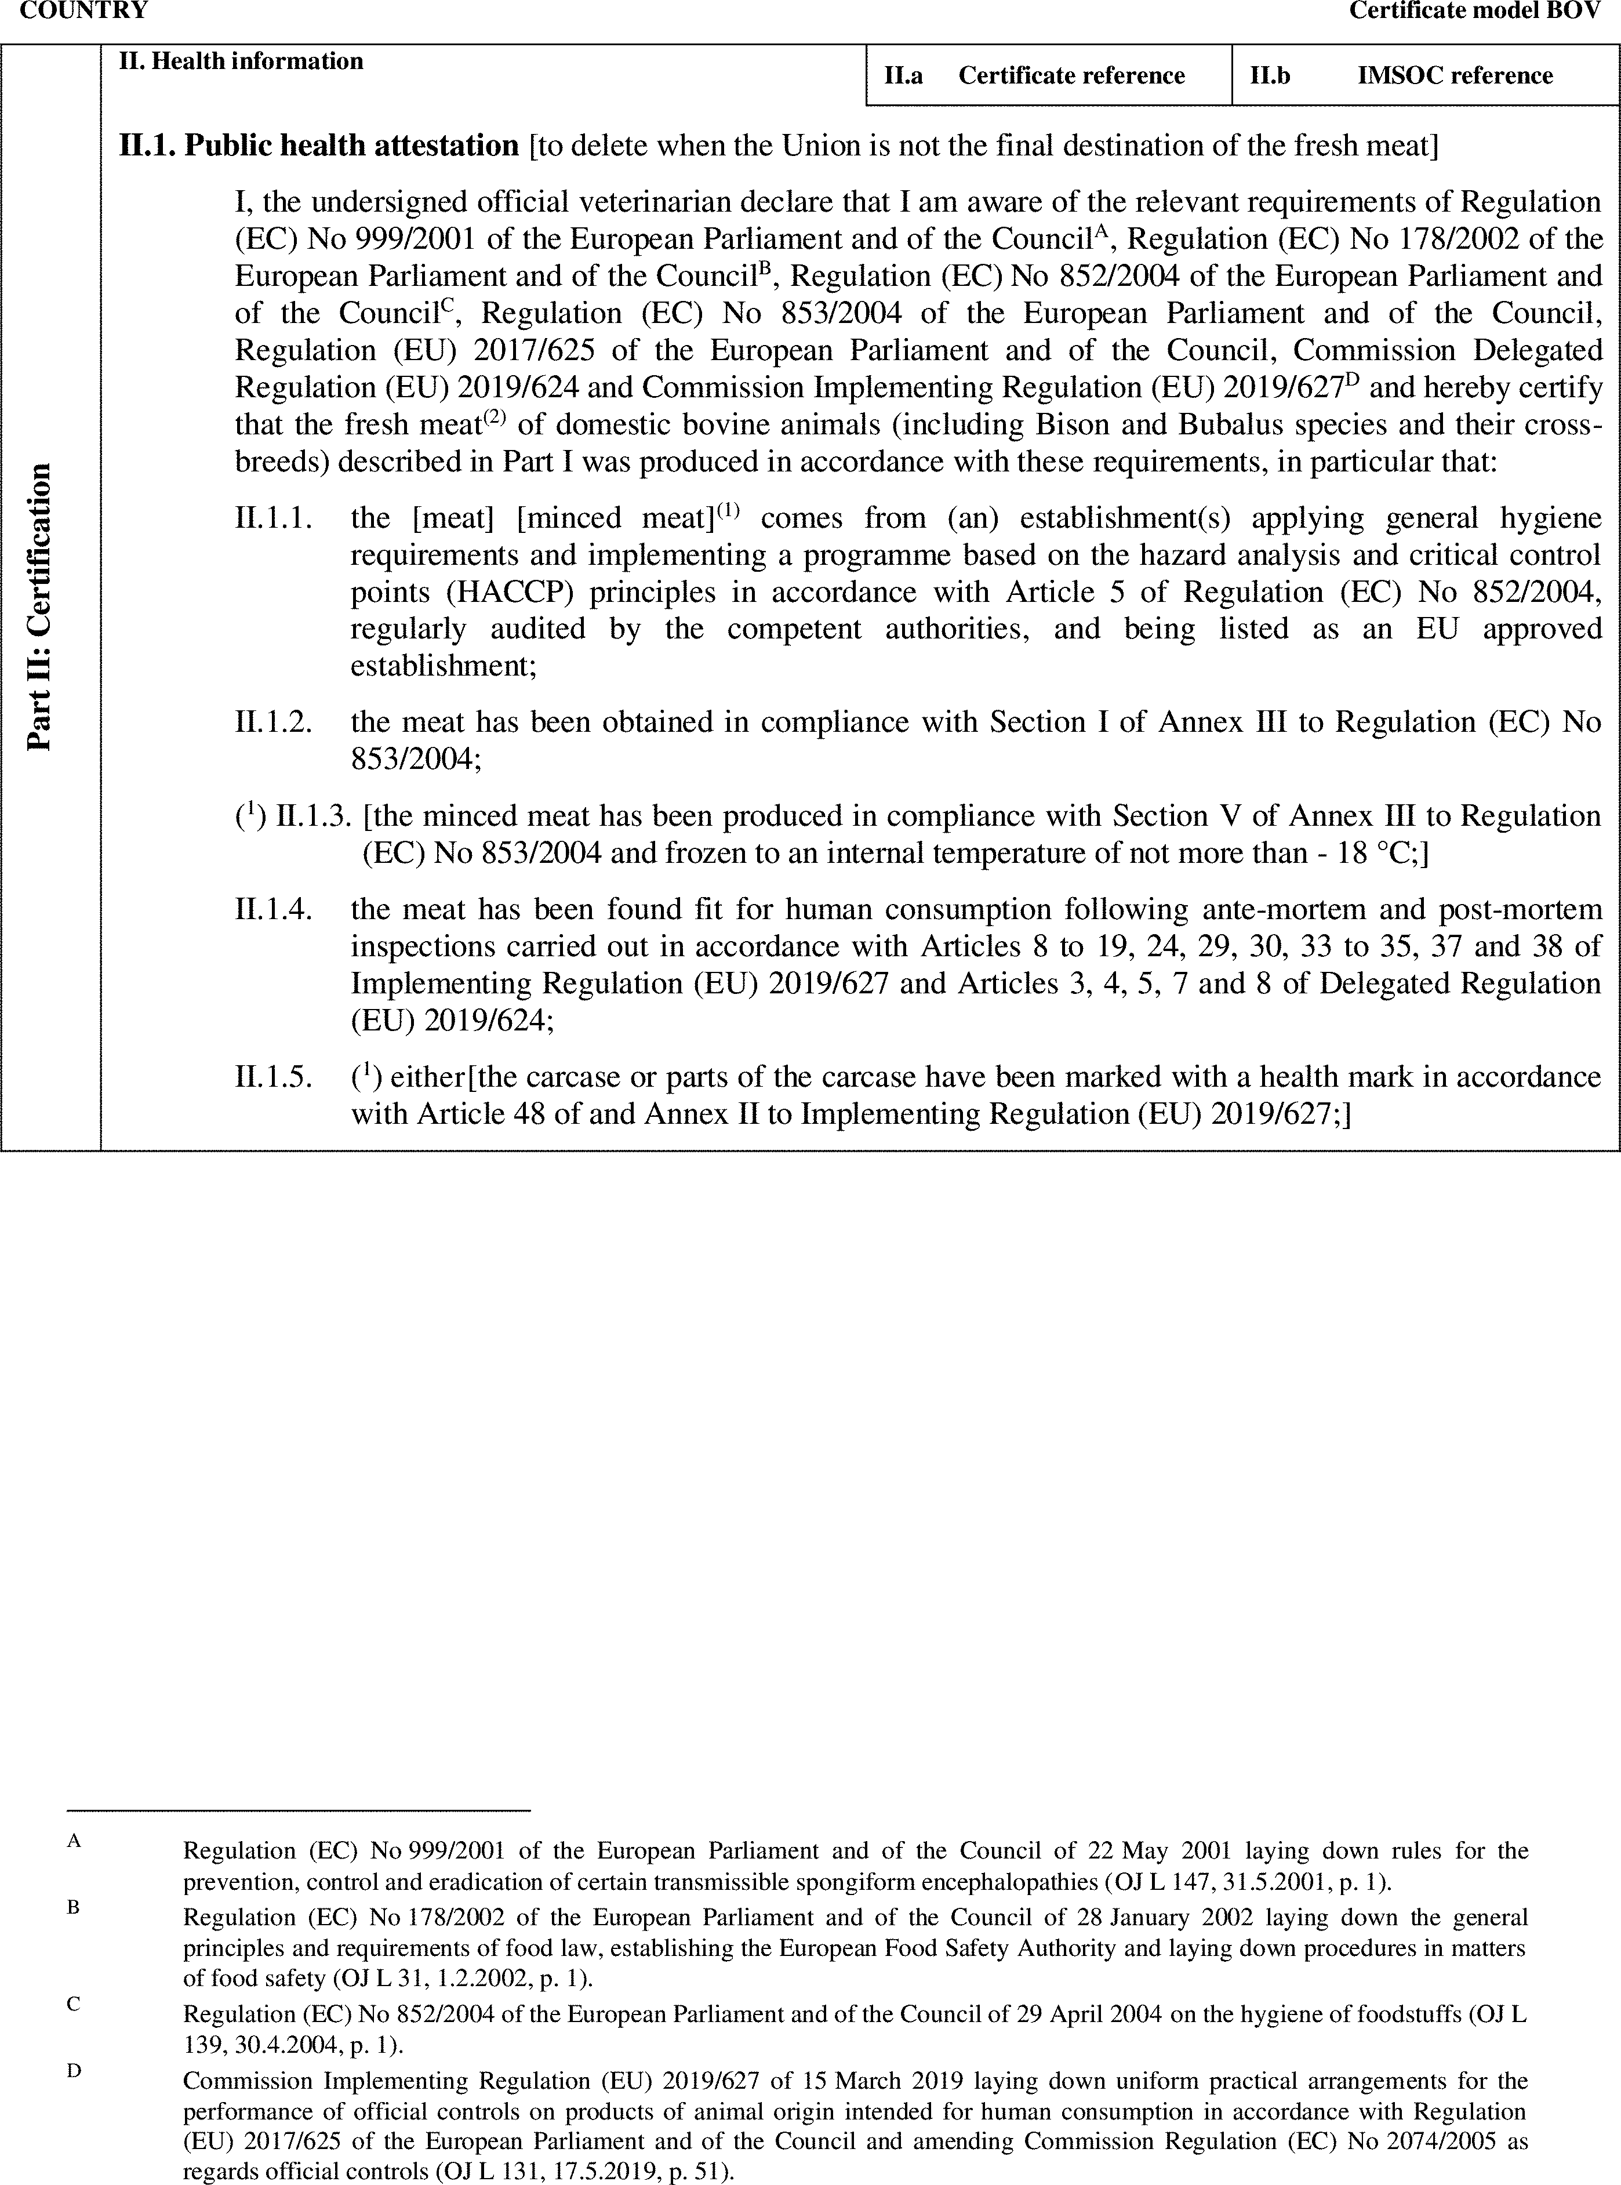

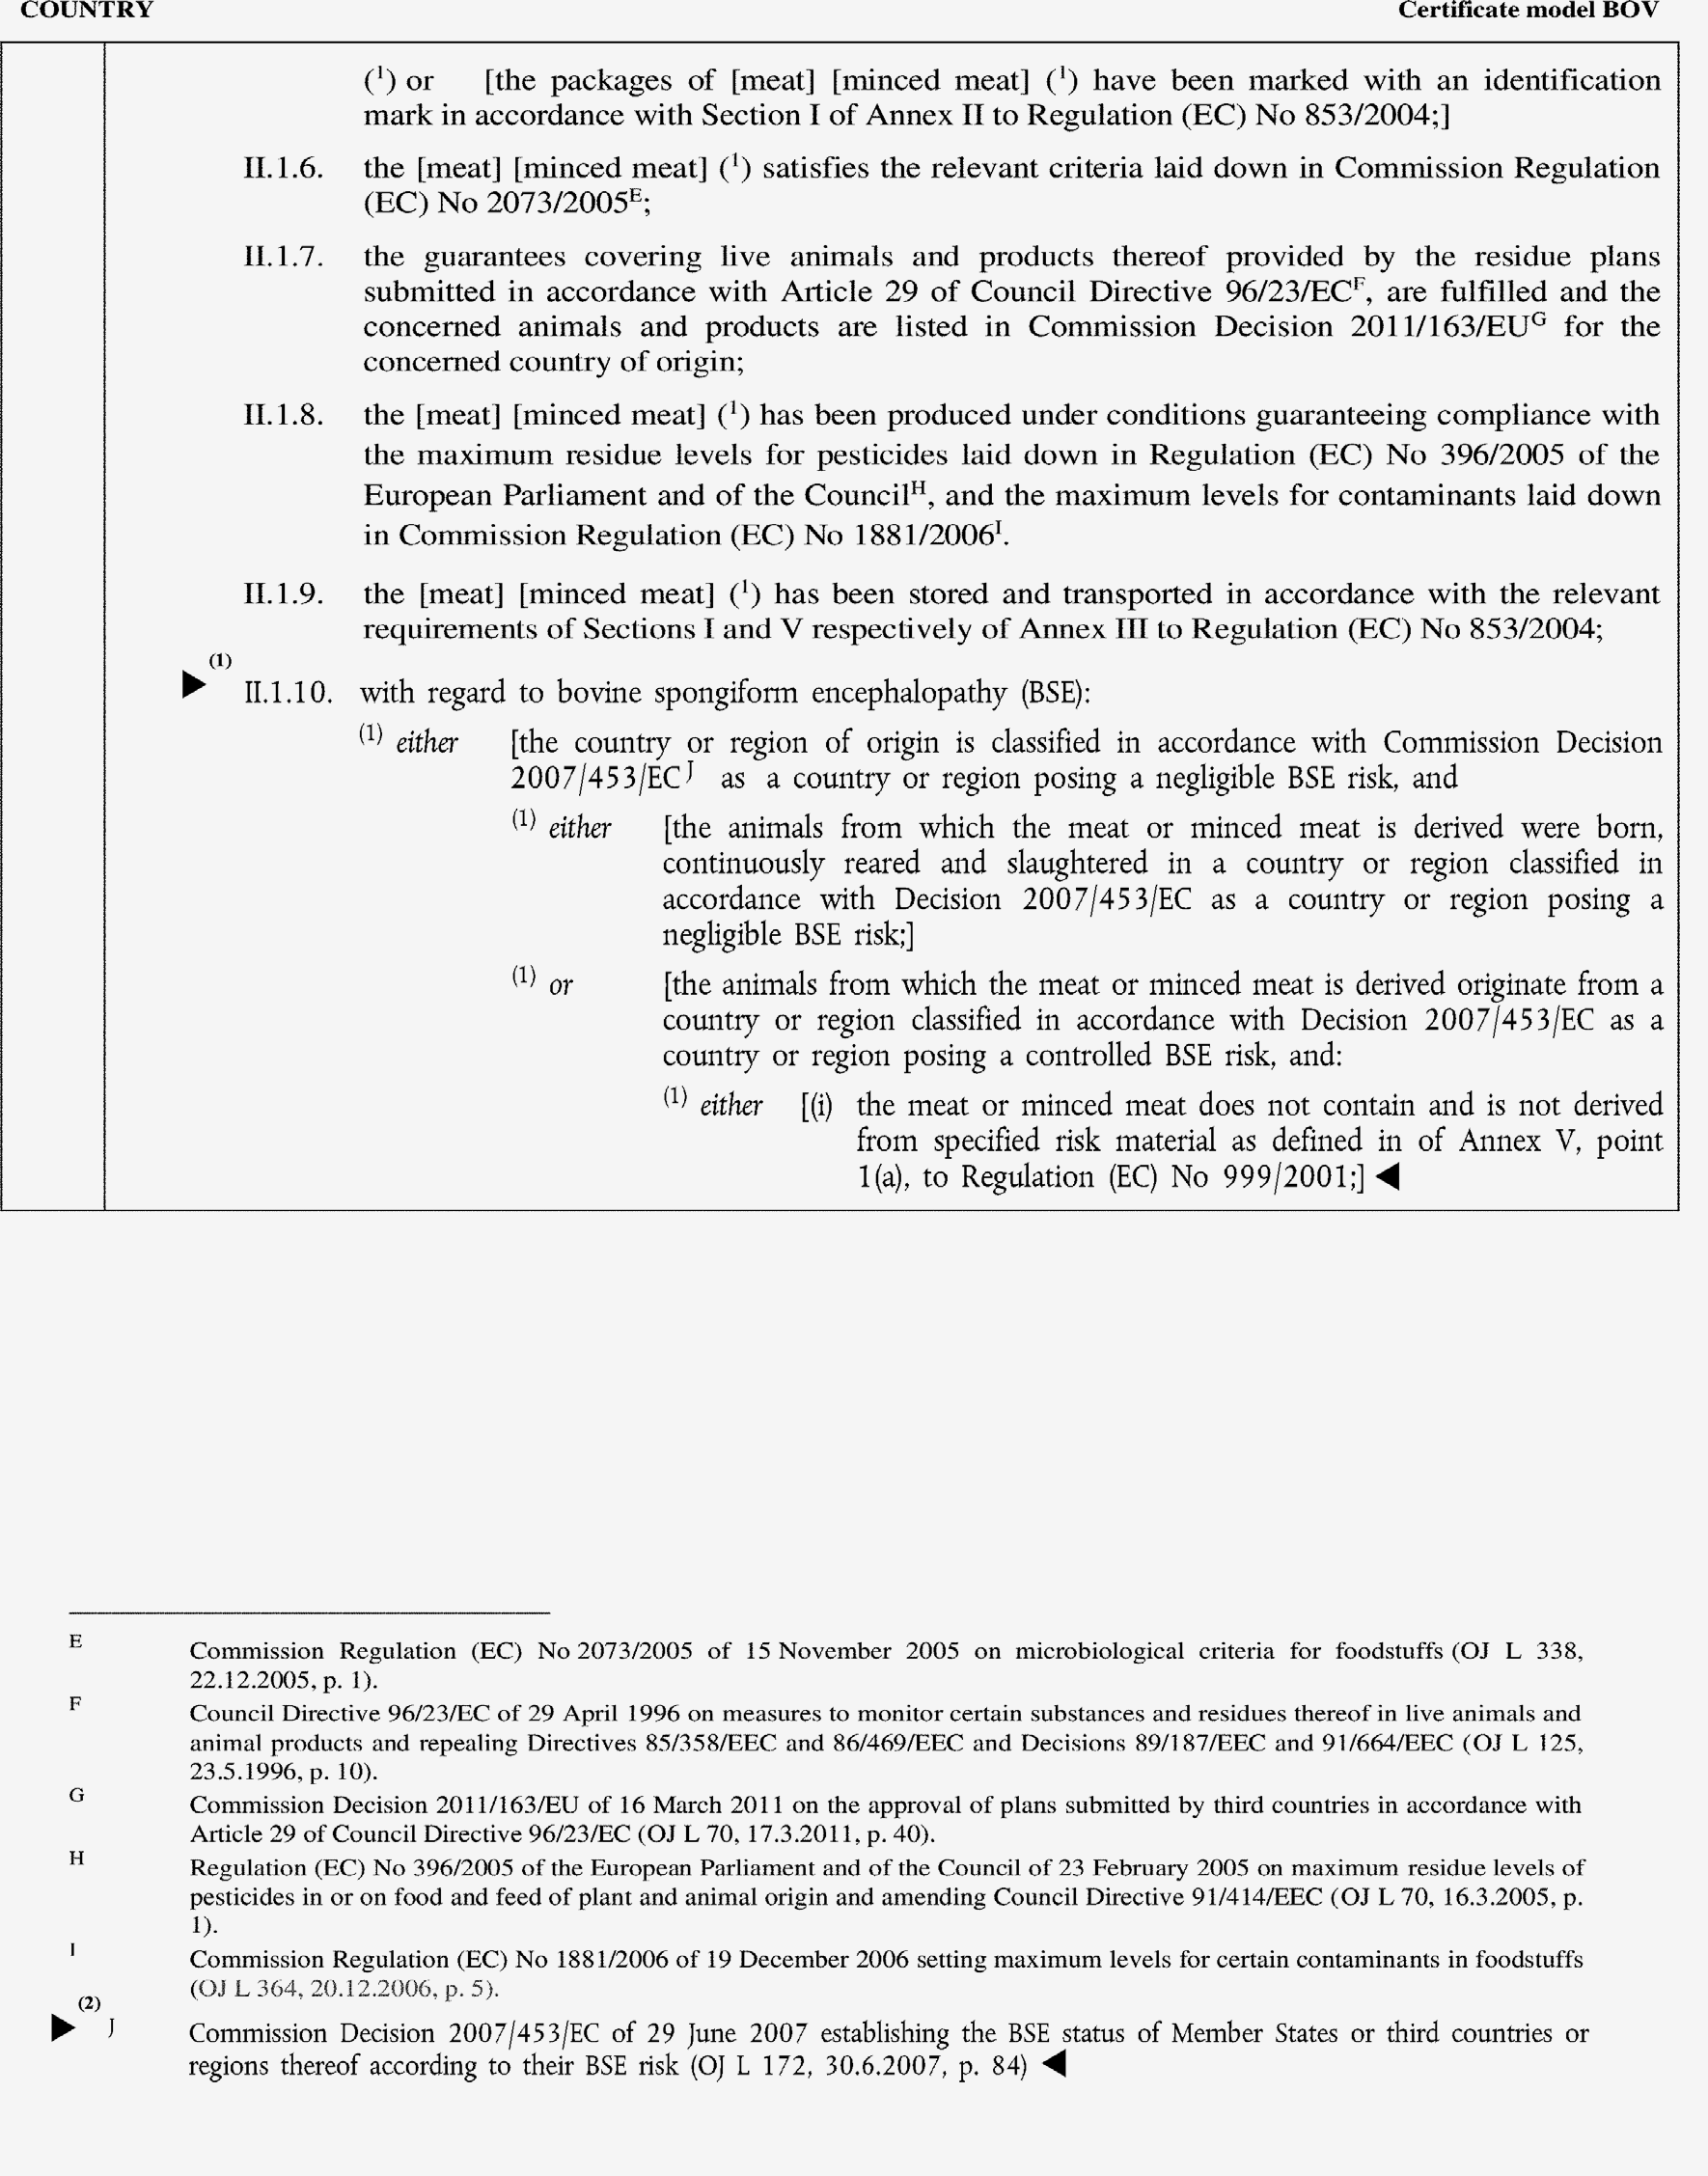

►(1) (2) M7

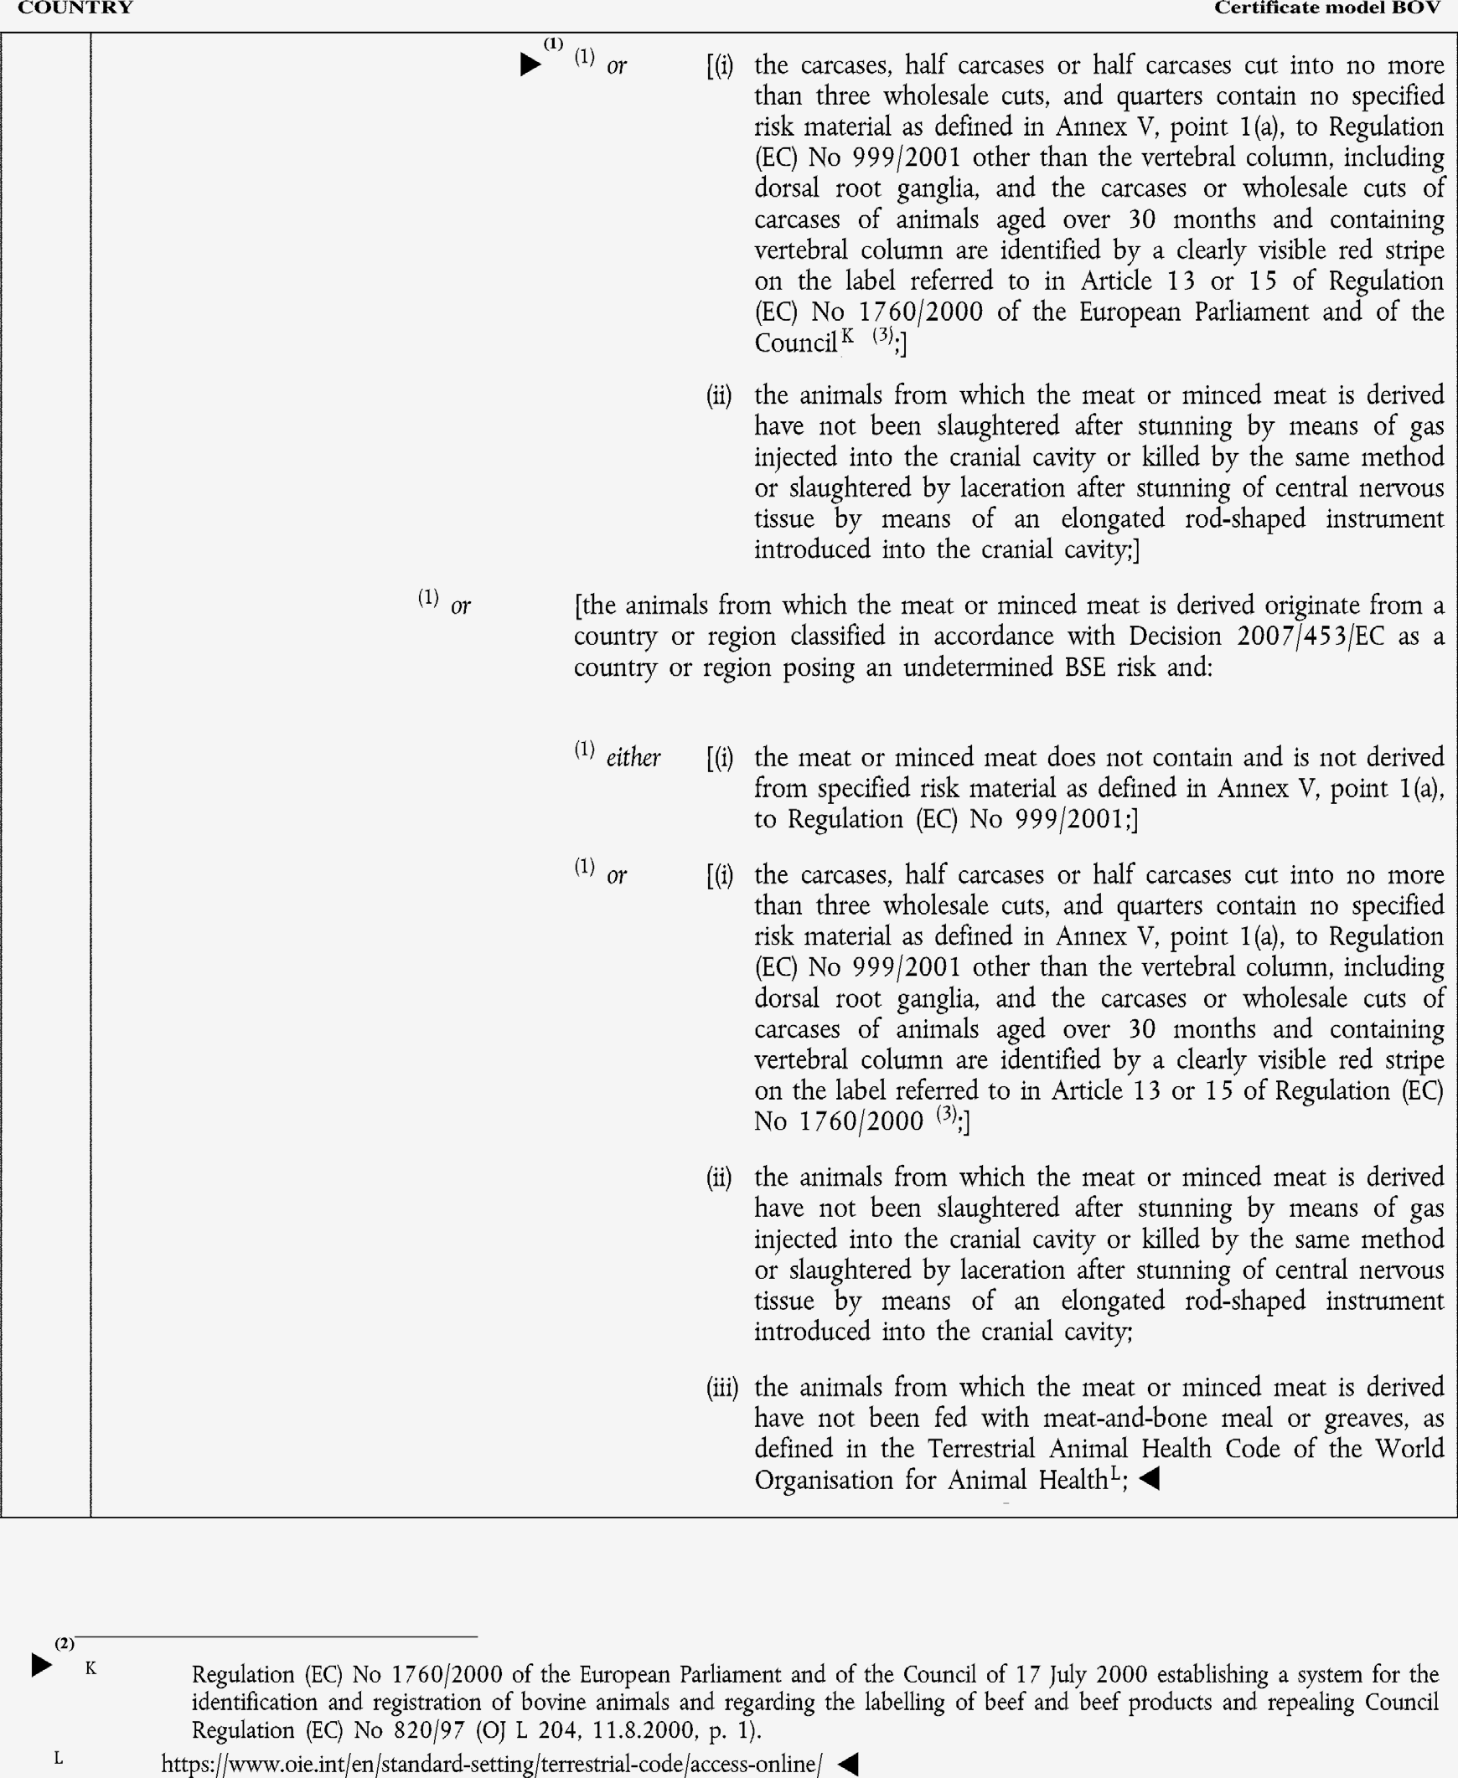

►(1) (2) M7

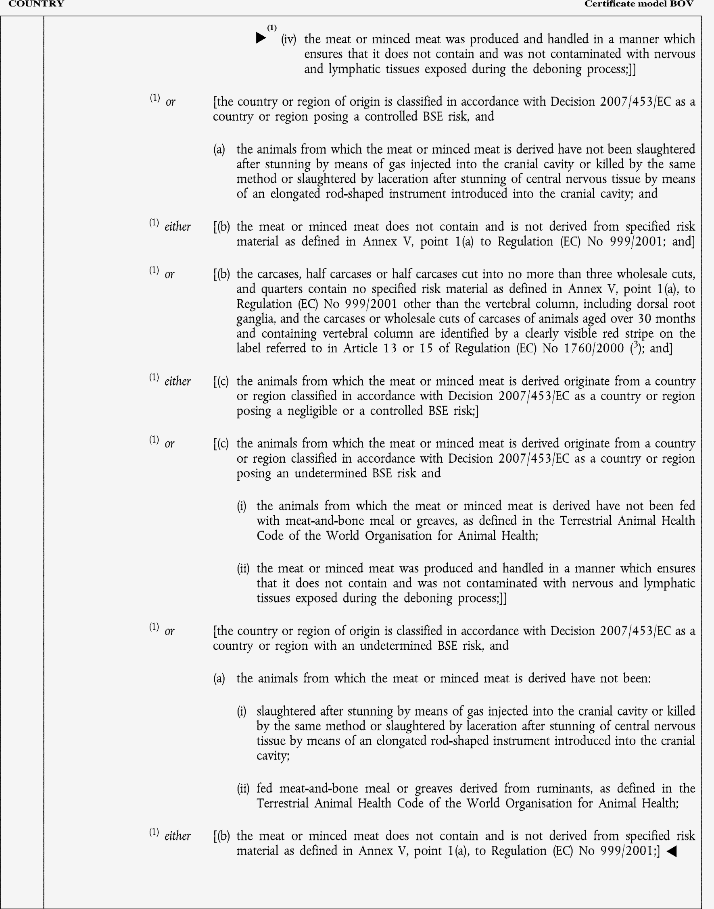

►(1) M7

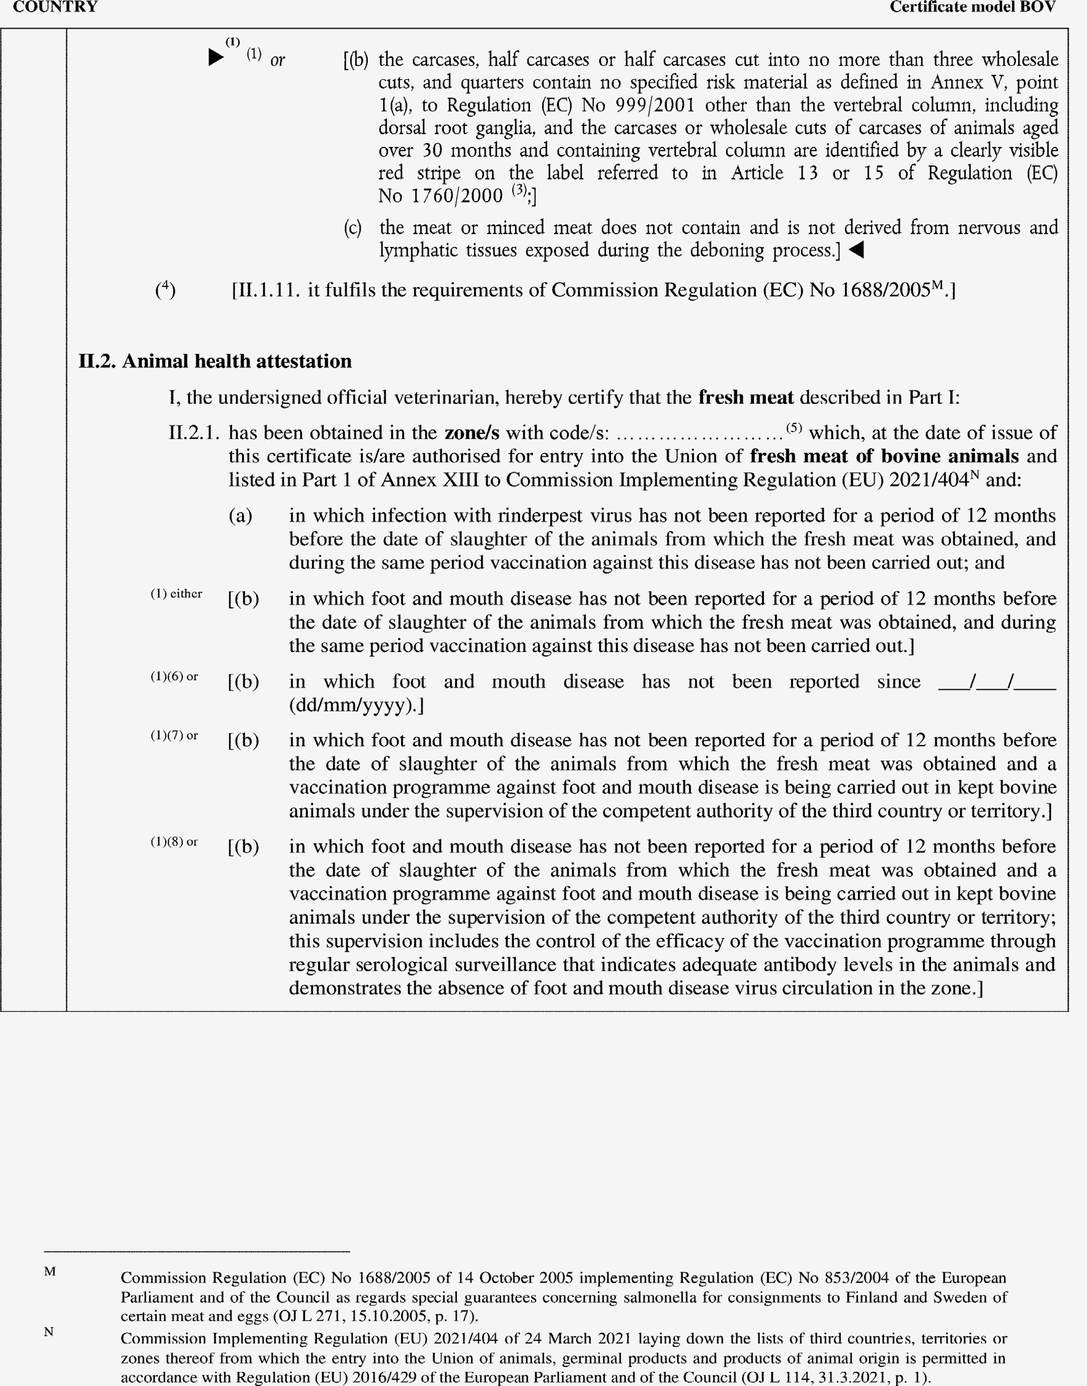

►(1) M7

