CHAPTER 44

MODEL ANIMAL HEALTH/OFFICIAL CERTIFICATE FOR THE ENTRY INTO THE UNION OF TREATED RAW MATERIALS FOR THE PRODUCTION OF GELATINE AND COLLAGEN INTENDED FOR HUMAN CONSUMPTION (MODEL TCG)

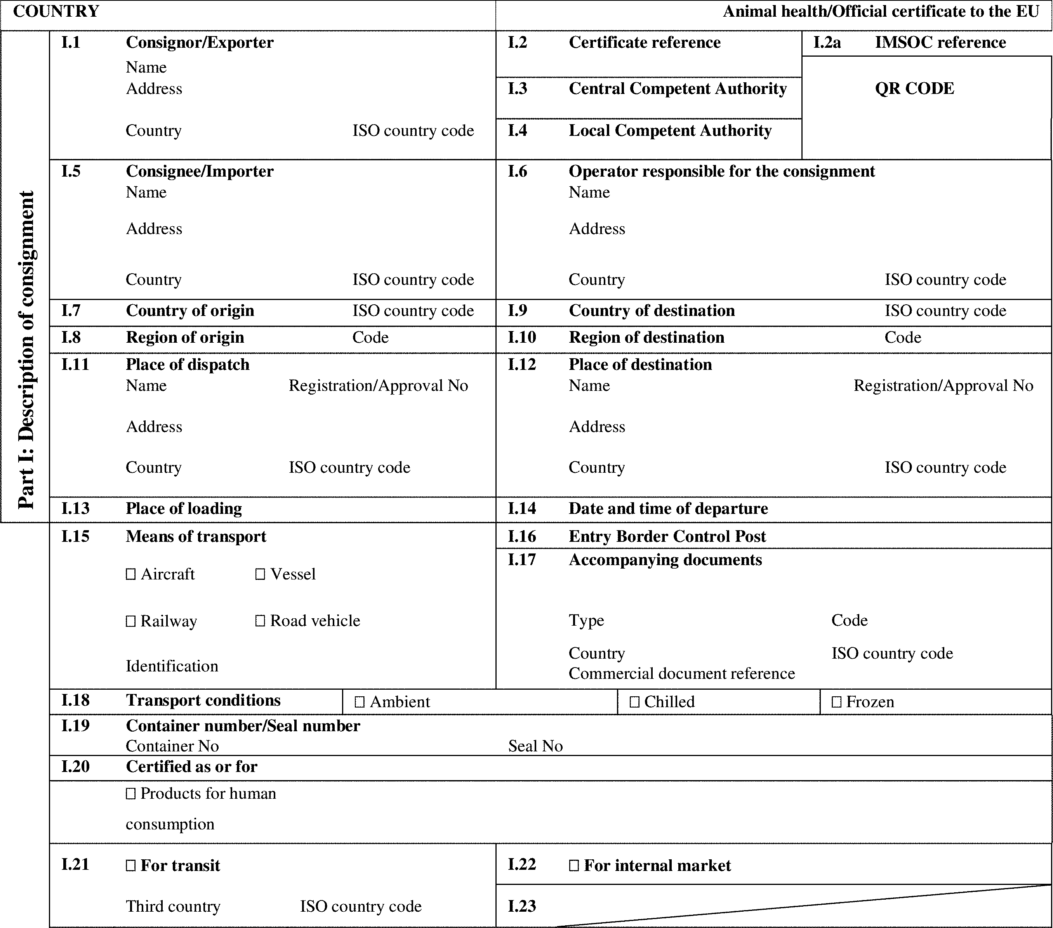

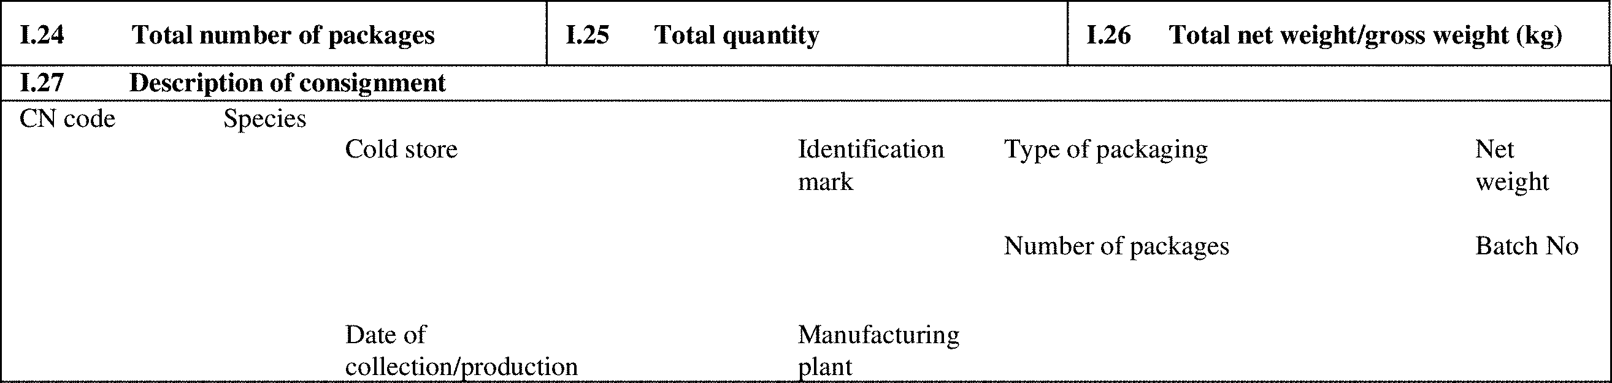

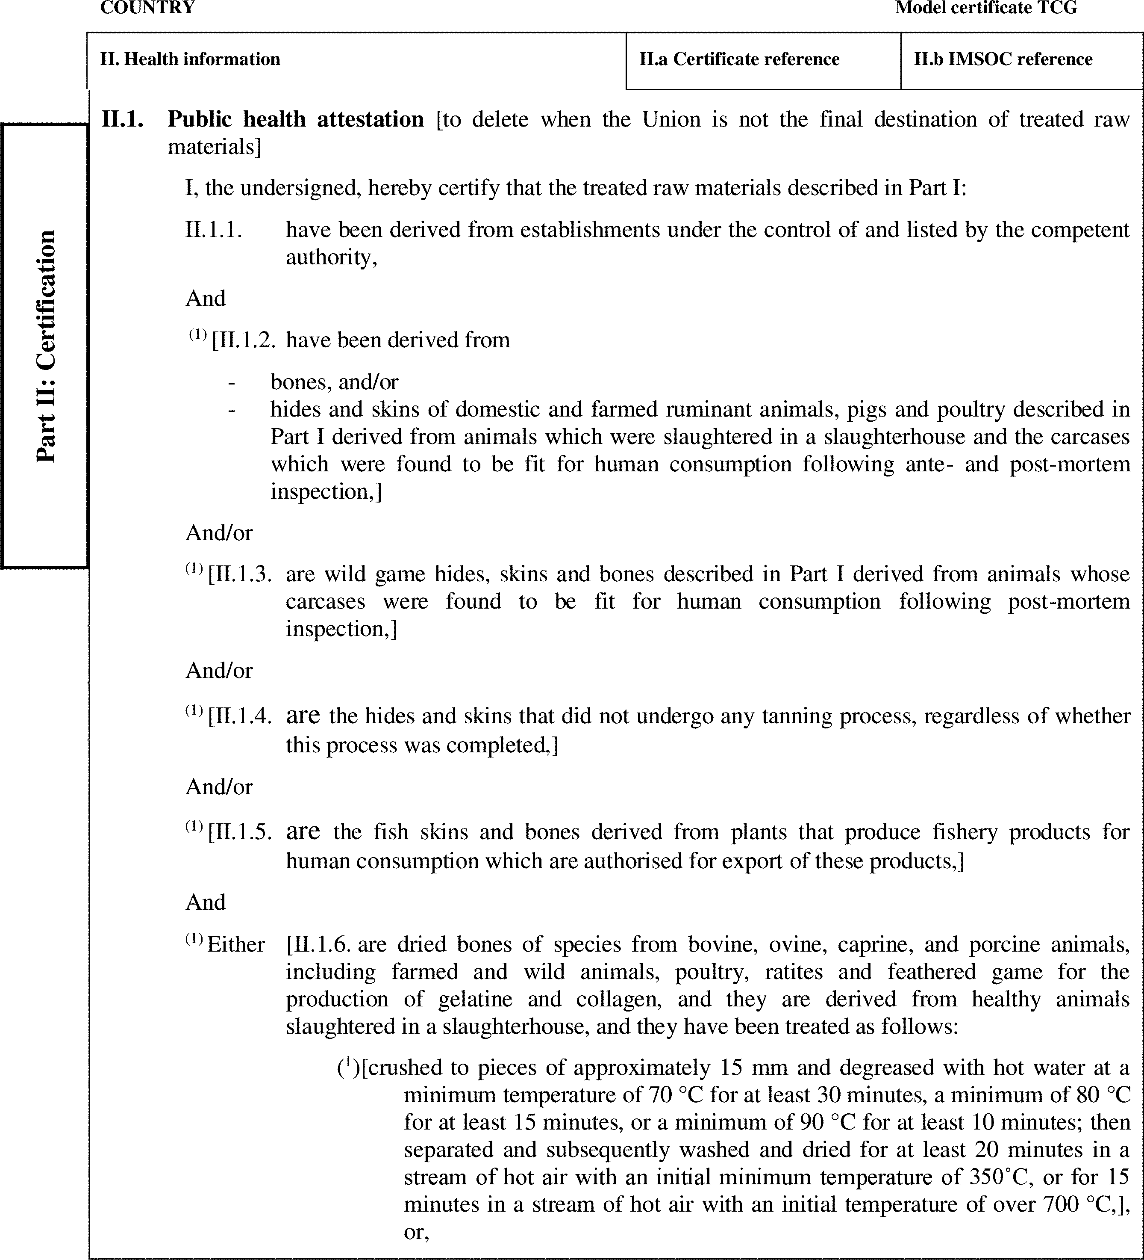

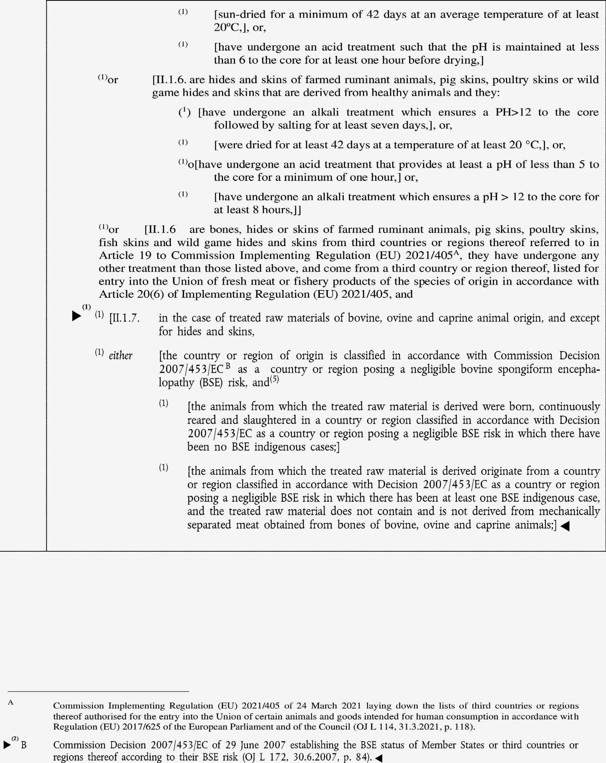

►(1) (2) M7

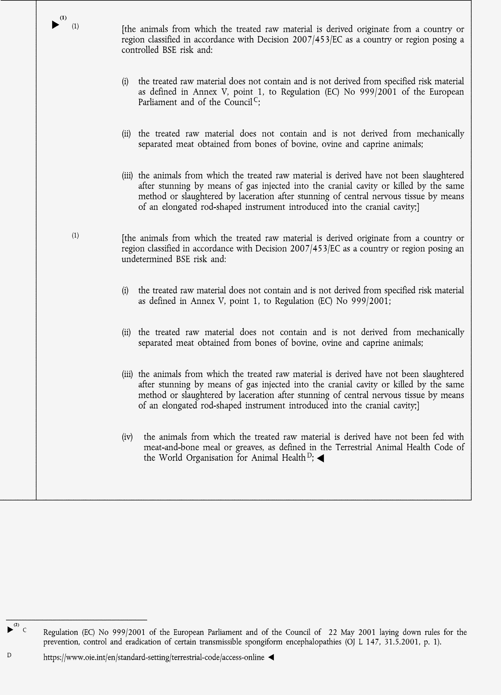

►(1) (2) M7

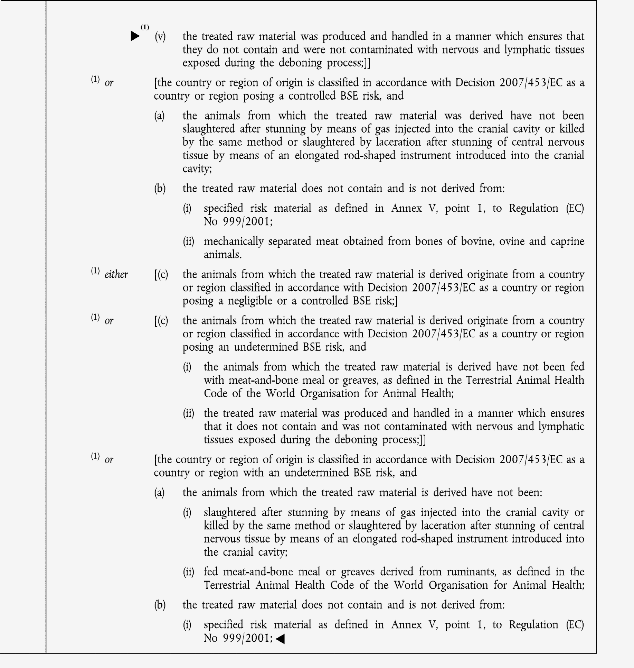

►(1) M7

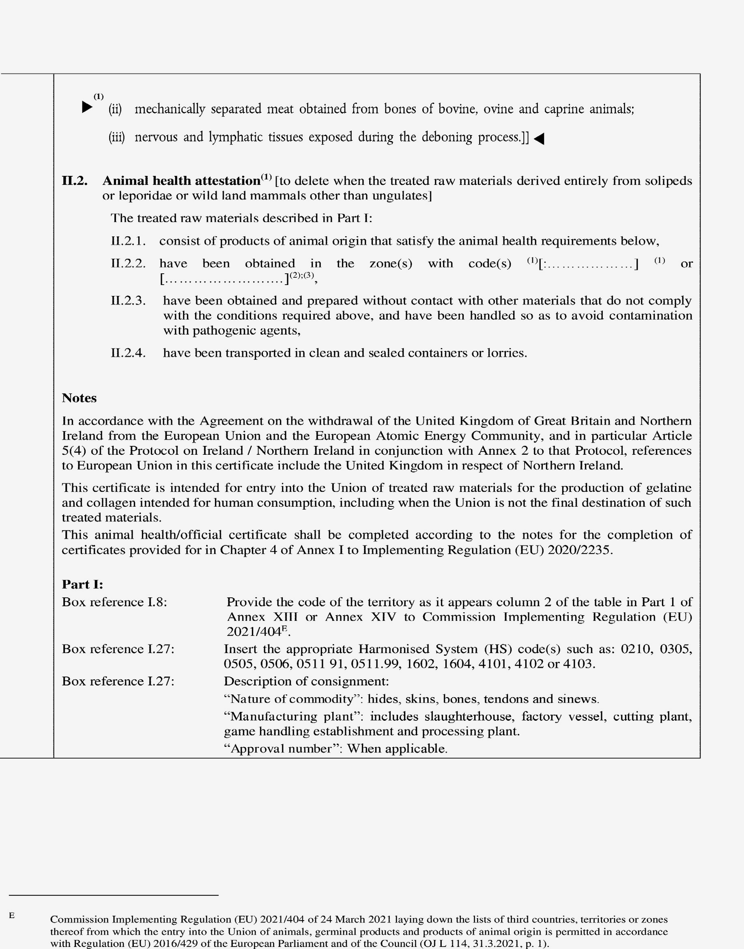

►(1) M7

