CHAPTER 43

MODEL ANIMAL HEALTH/OFFICIAL CERTIFICATE FOR THE ENTRY INTO THE UNION OF RAW MATERIALS FOR THE PRODUCTION OF GELATINE AND COLLAGEN INTENDED FOR HUMAN CONSUMPTION (MODEL RCG)

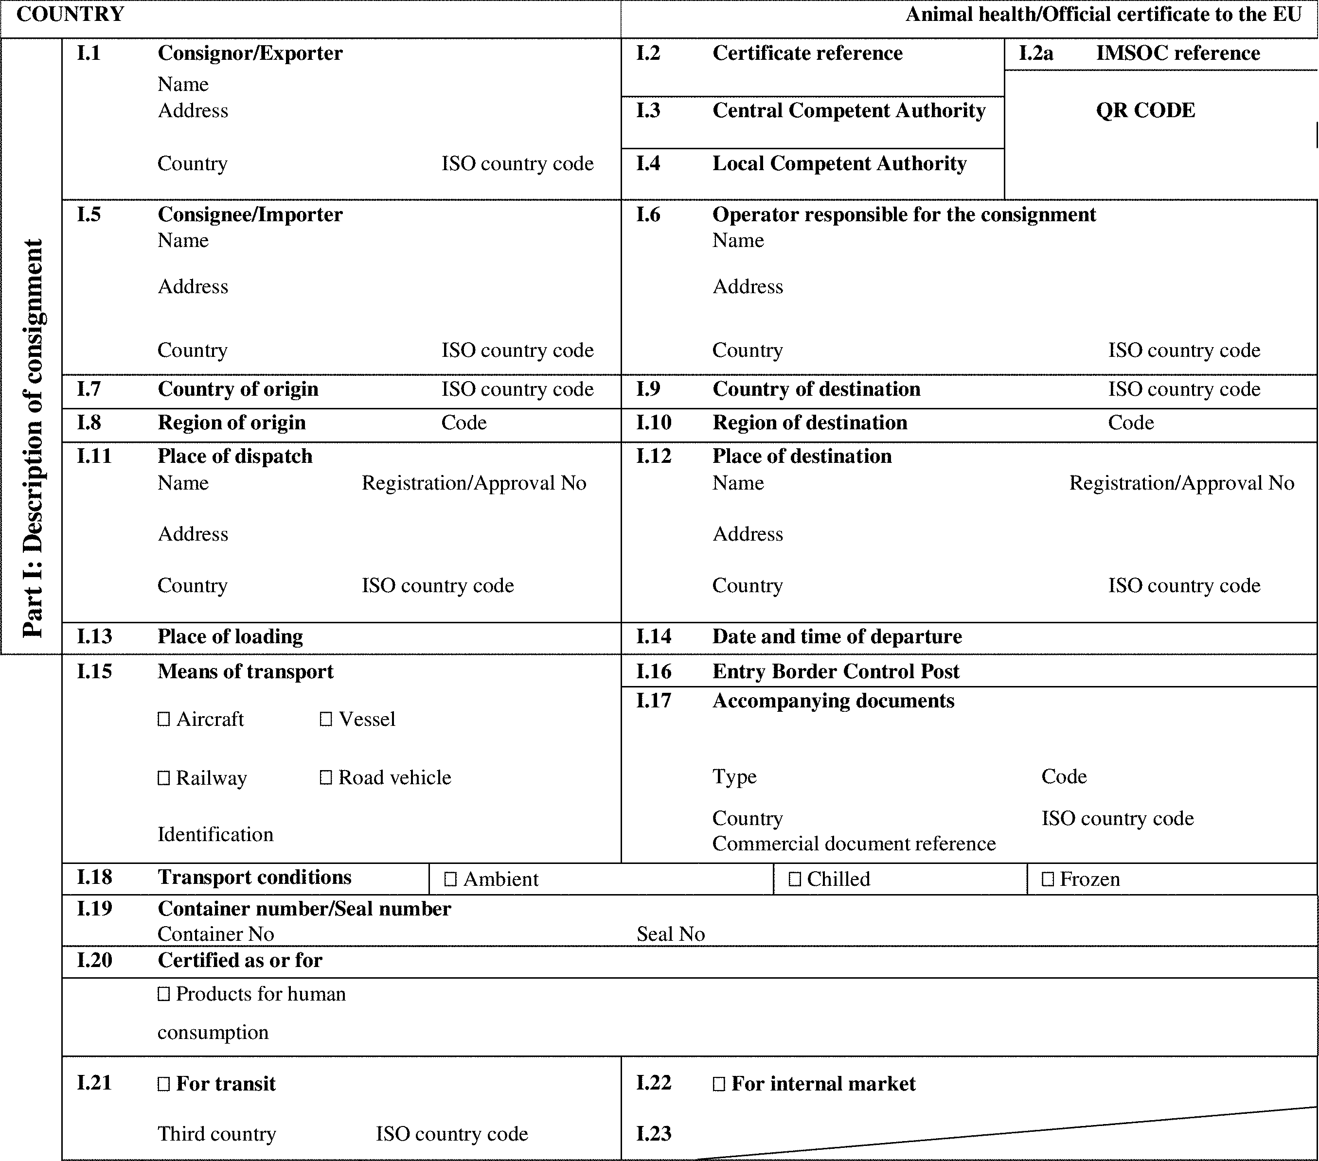

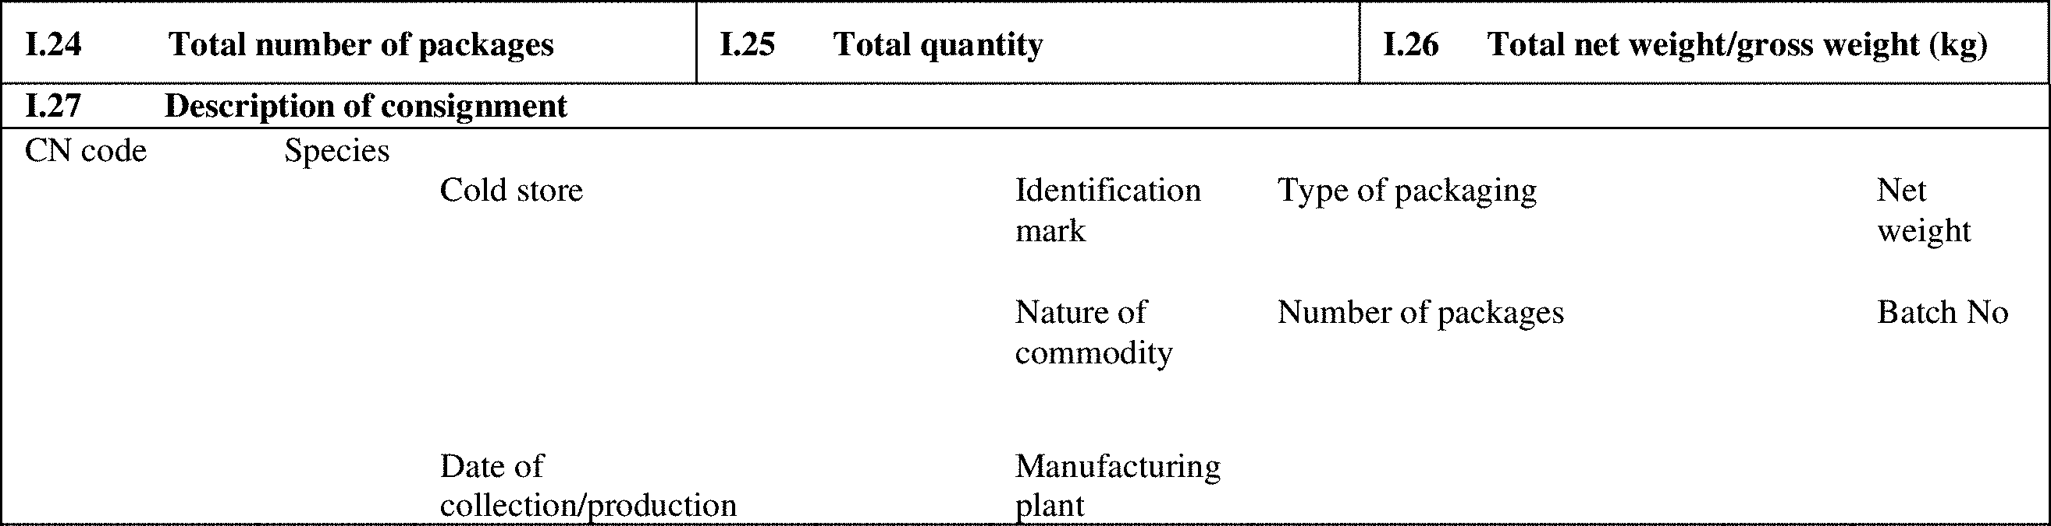

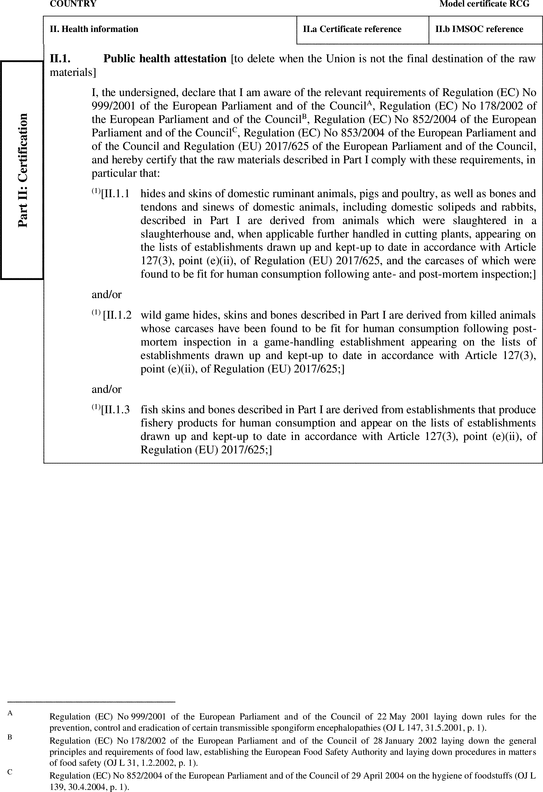

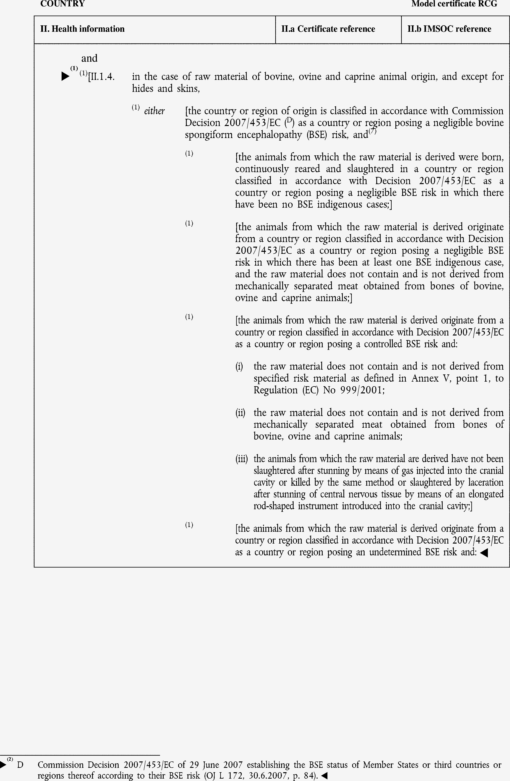

►(1) (2) M7

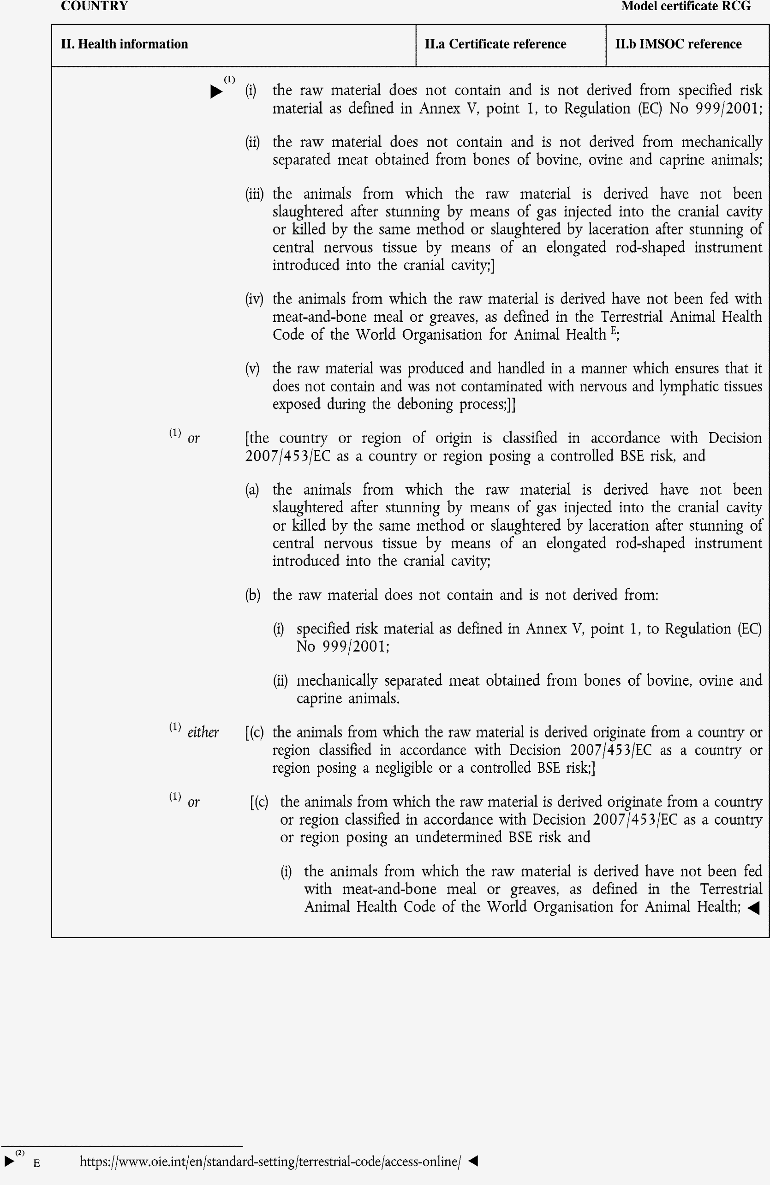

►(1) (2) M7

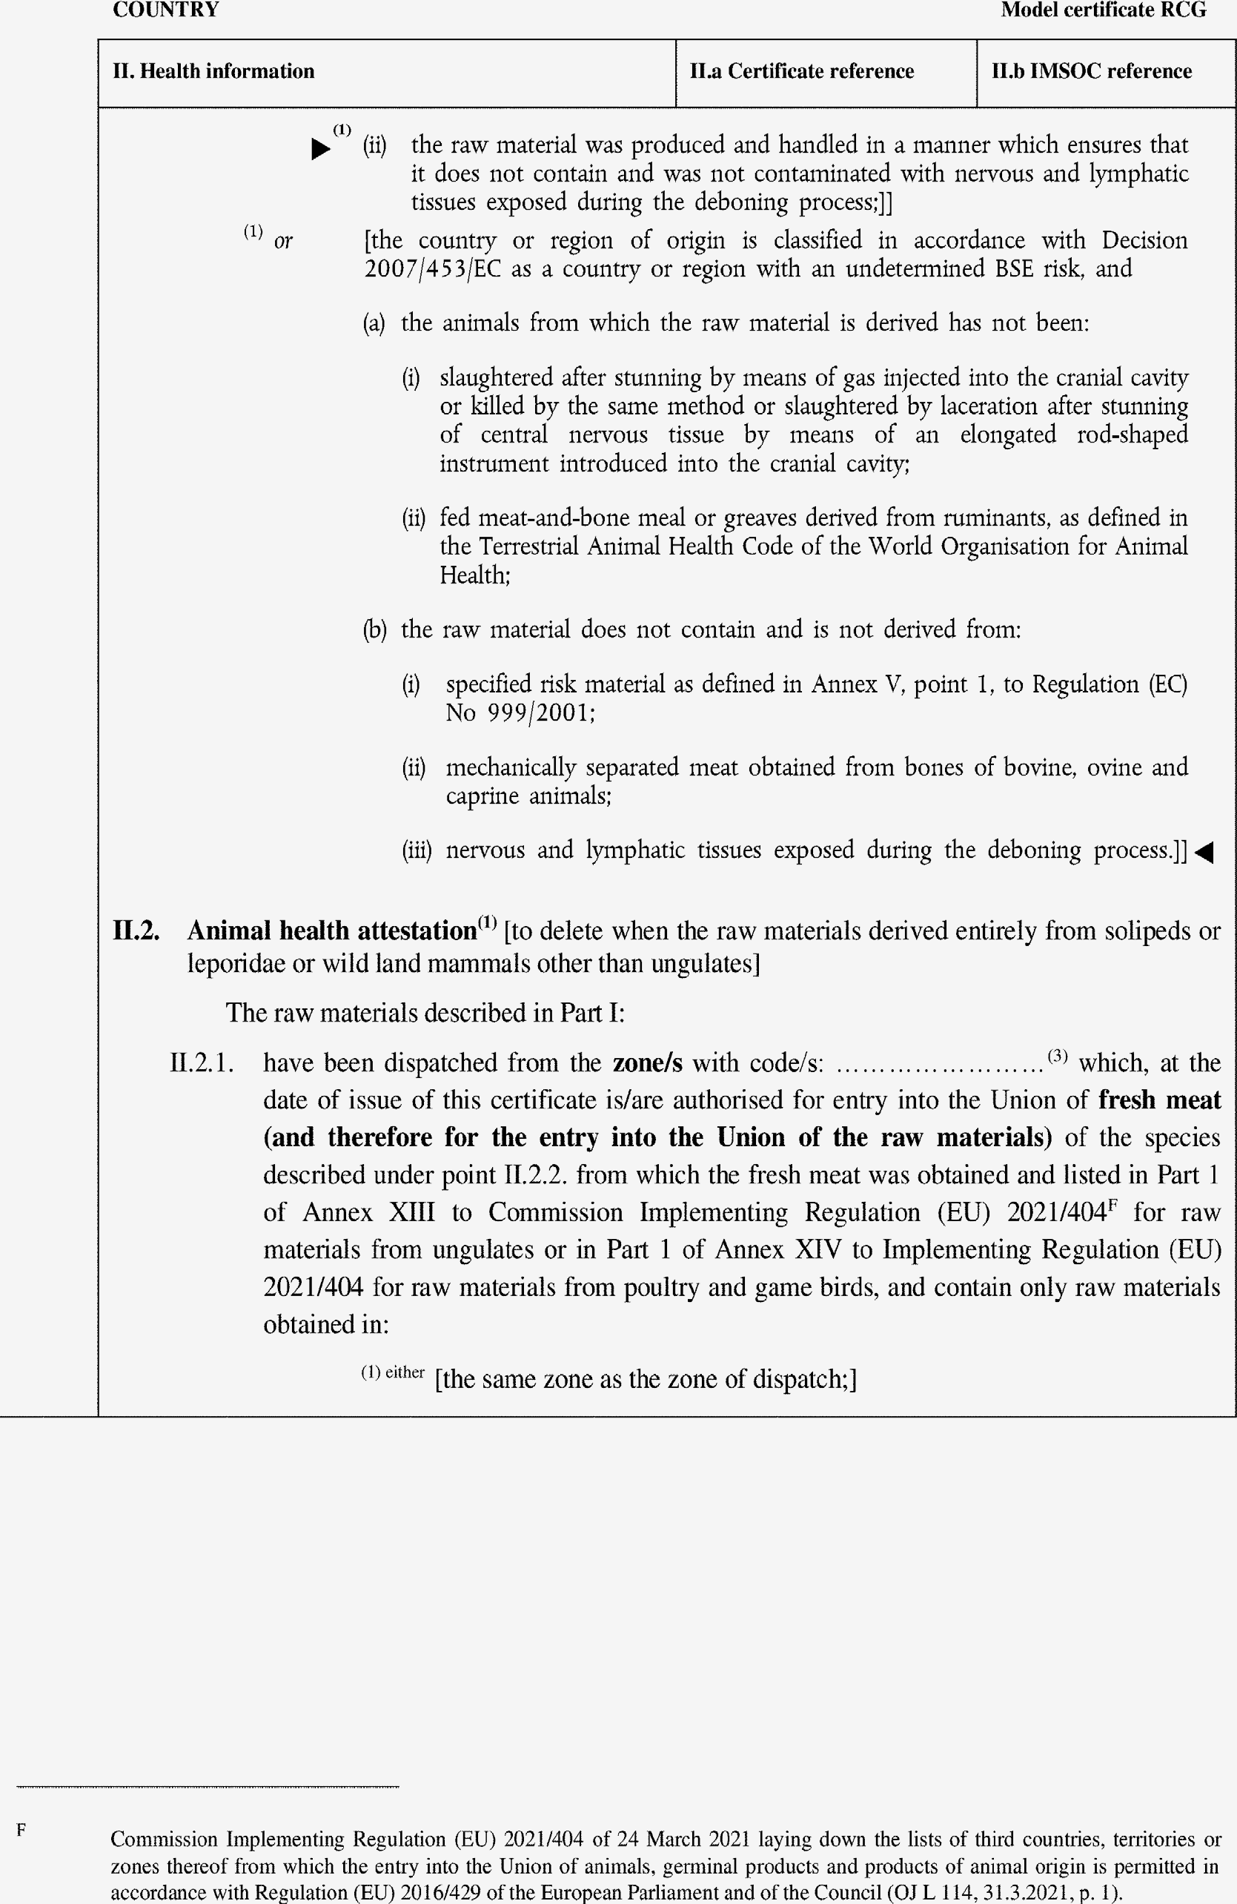

►(1) (2) M7

