CHAPTER 42

MODEL OFFICIAL CERTIFICATE FOR THE ENTRY INTO THE UNION OF COLLAGEN INTENDED FOR HUMAN CONSUMPTION (MODEL COL)

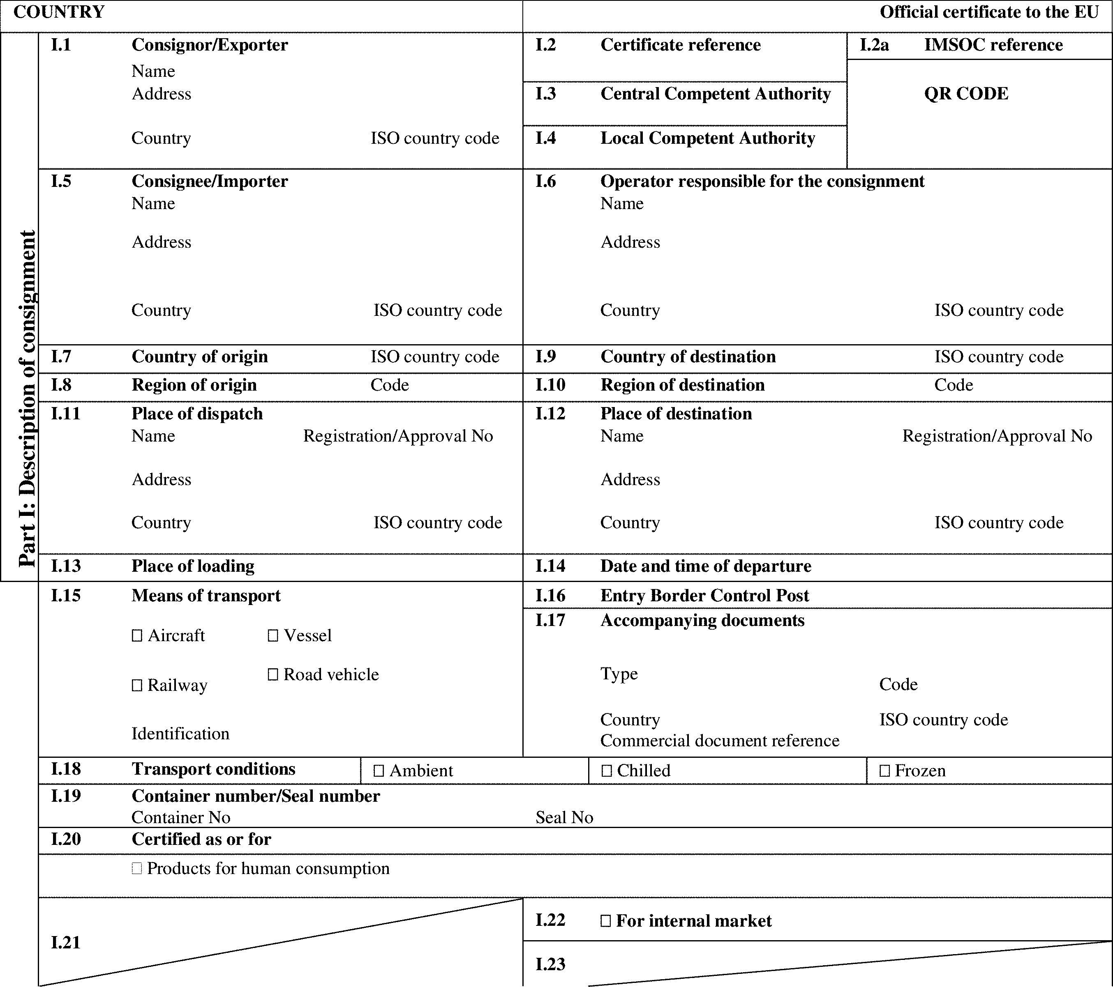

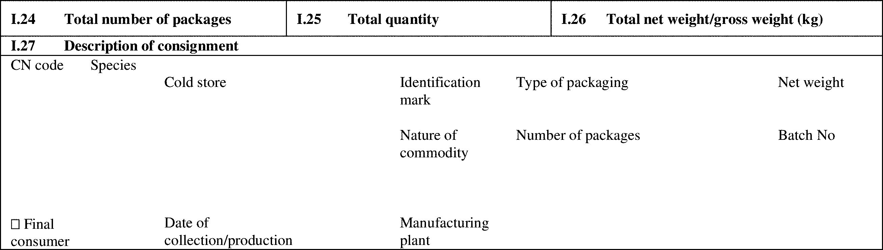

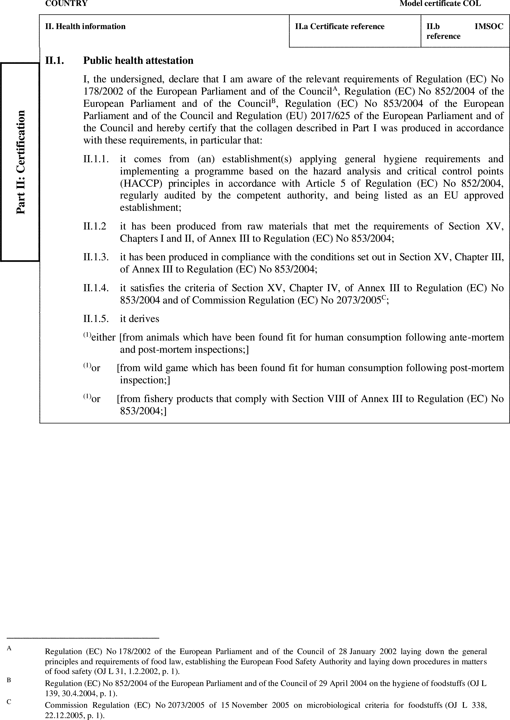

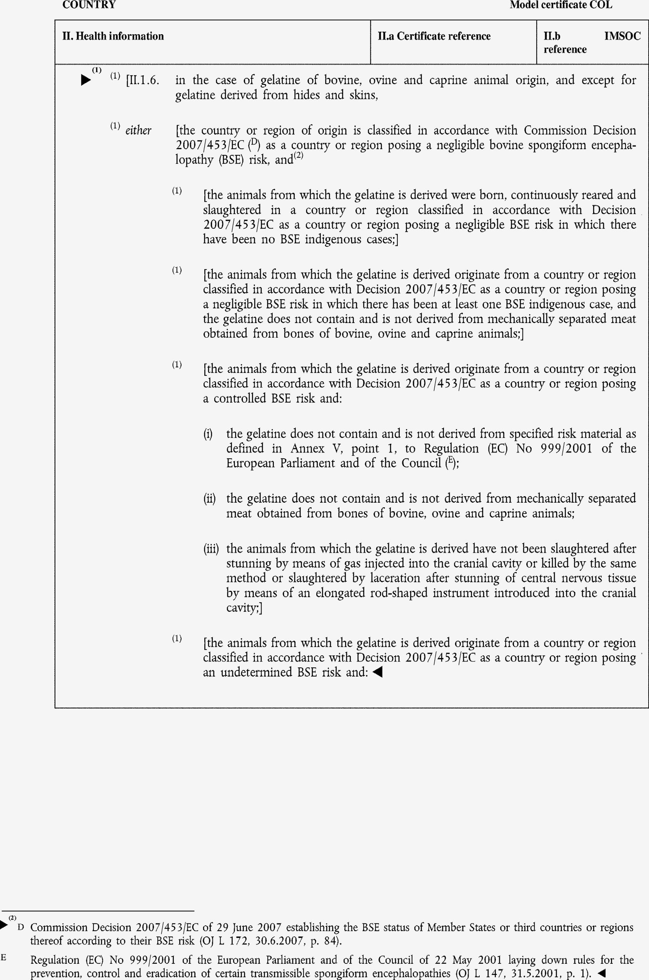

►(1) (2) M7

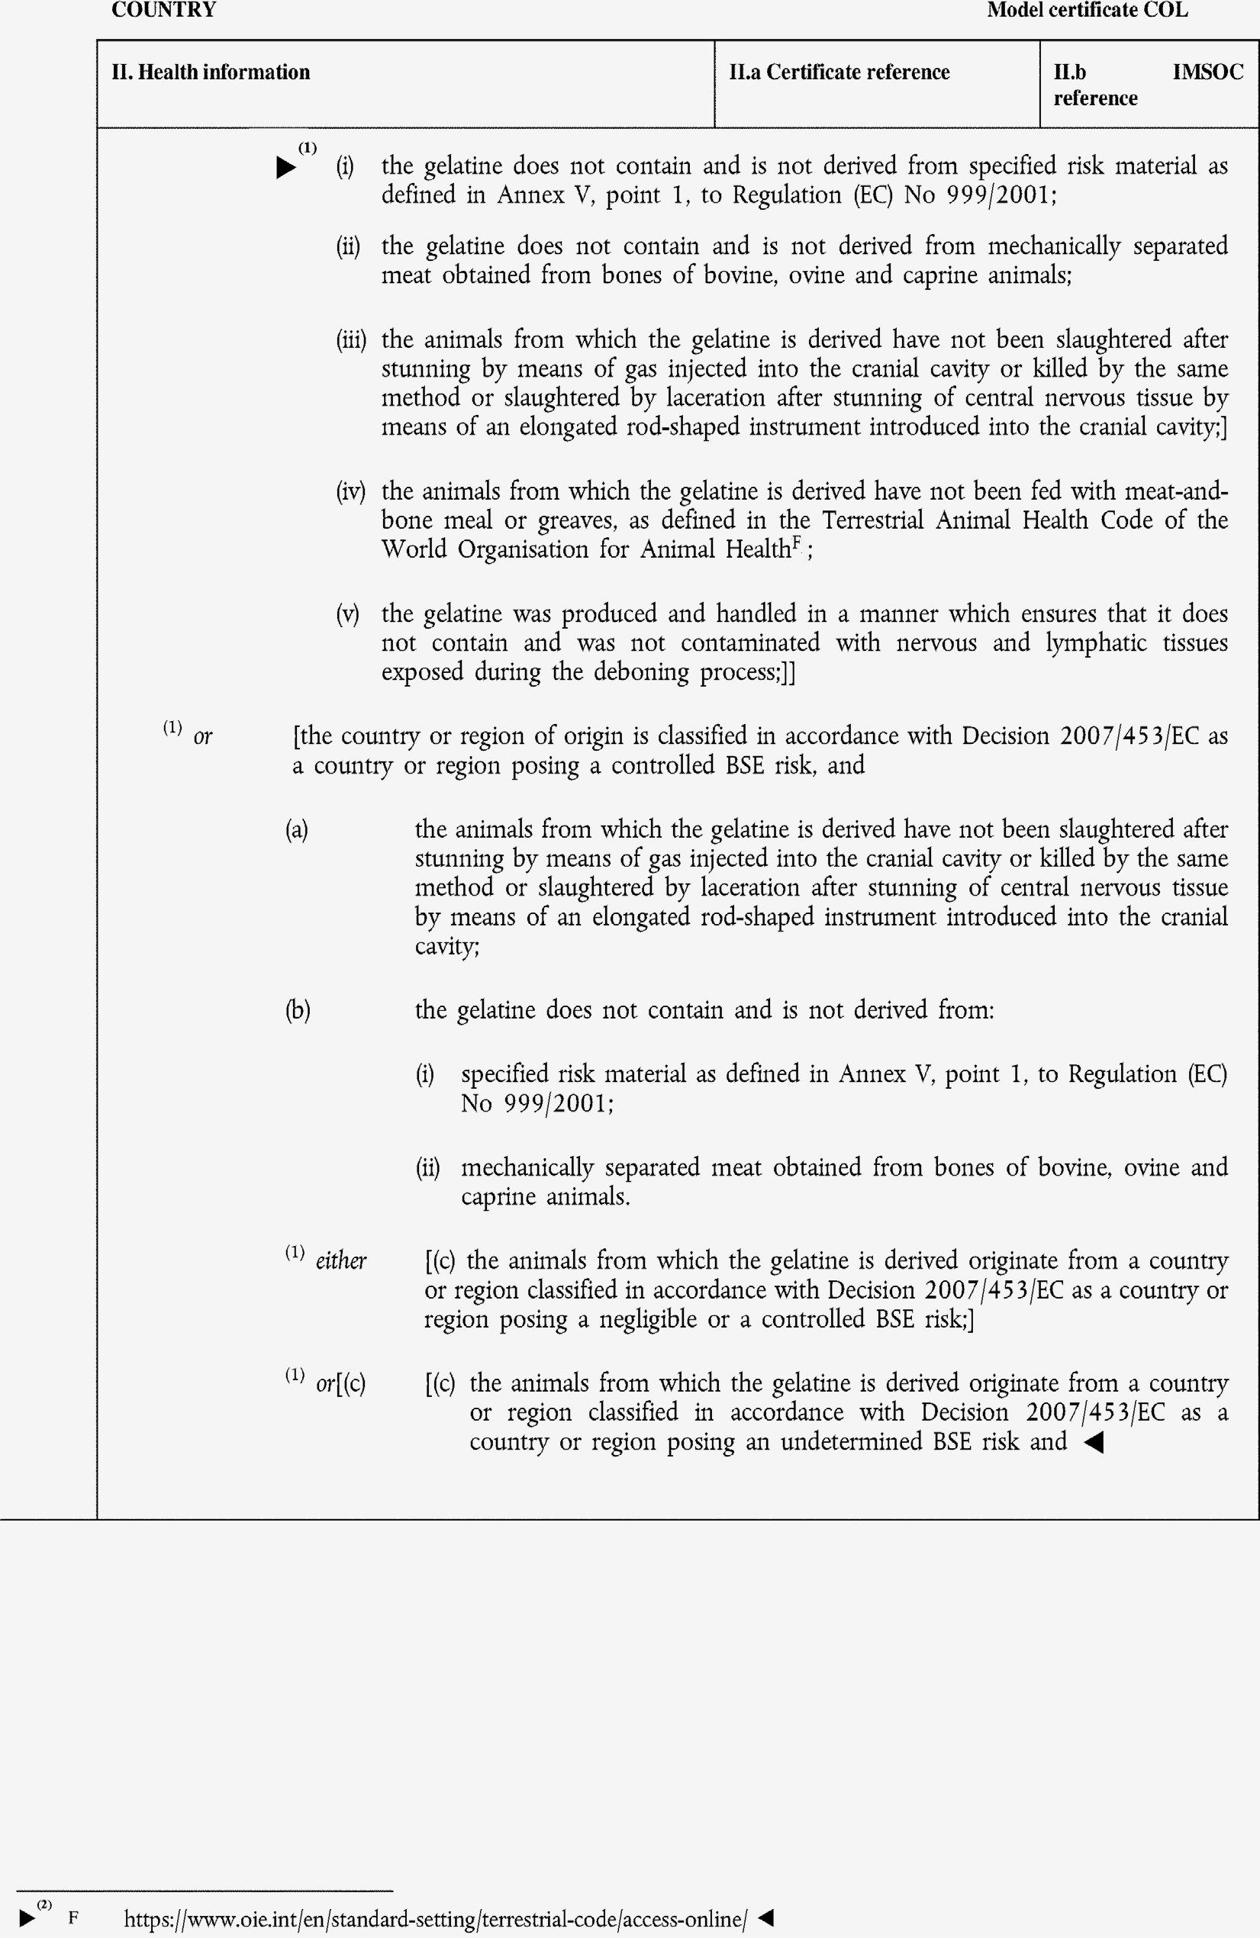

►(1) (2) M7

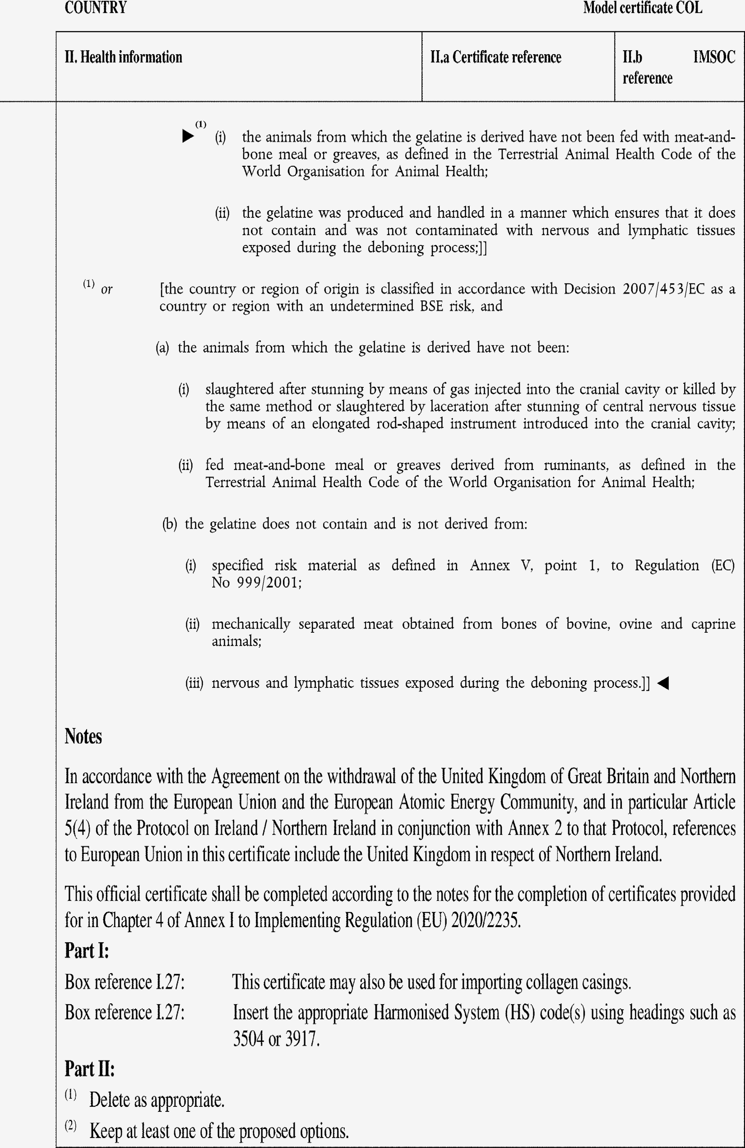

►(1) M7

