CHAPTER 41

MODEL OFFICIAL CERTIFICATE FOR THE ENTRY INTO THE UNION OF GELATINE INTENDED FOR HUMAN CONSUMPTION (MODEL GEL)

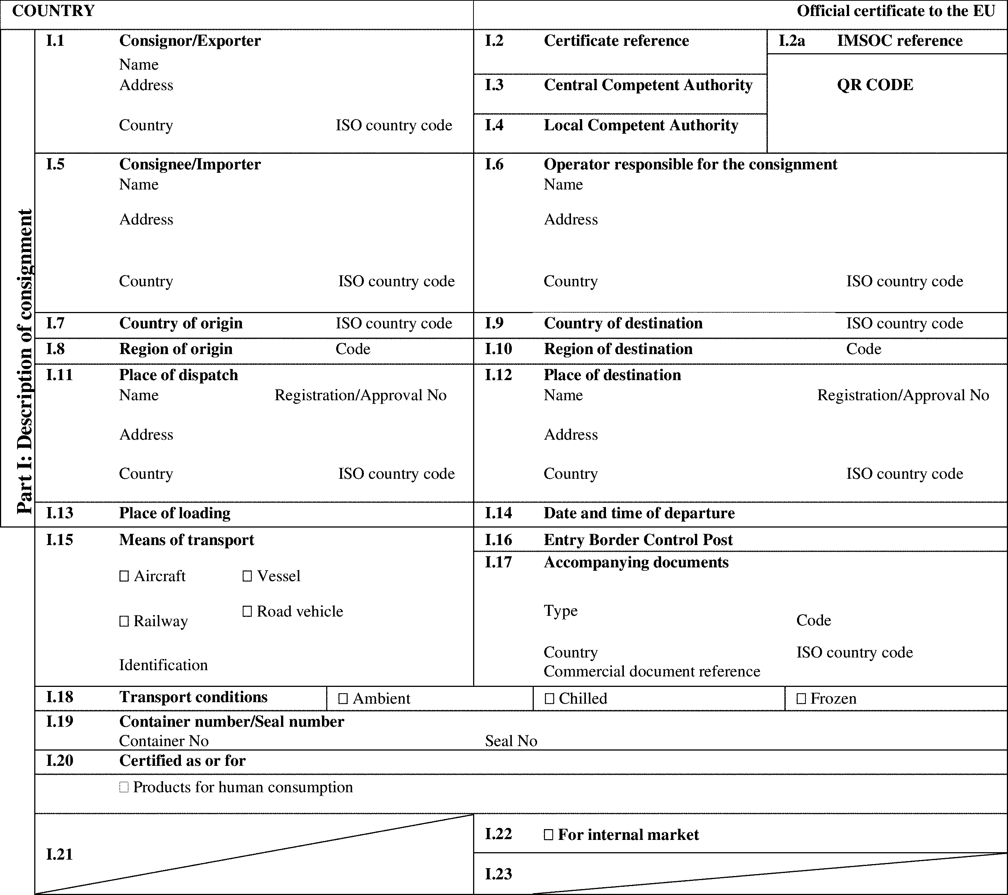

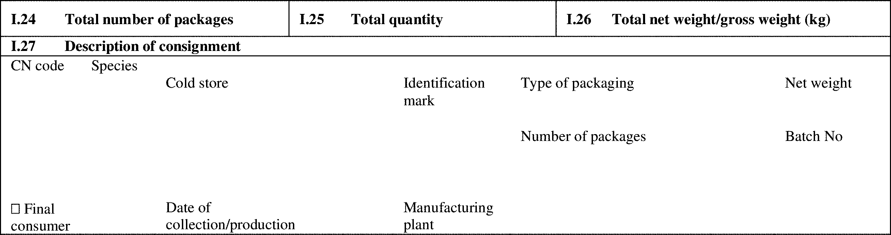

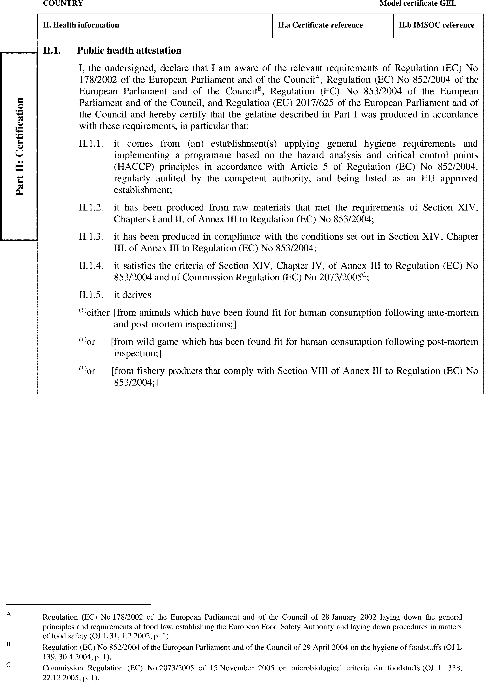

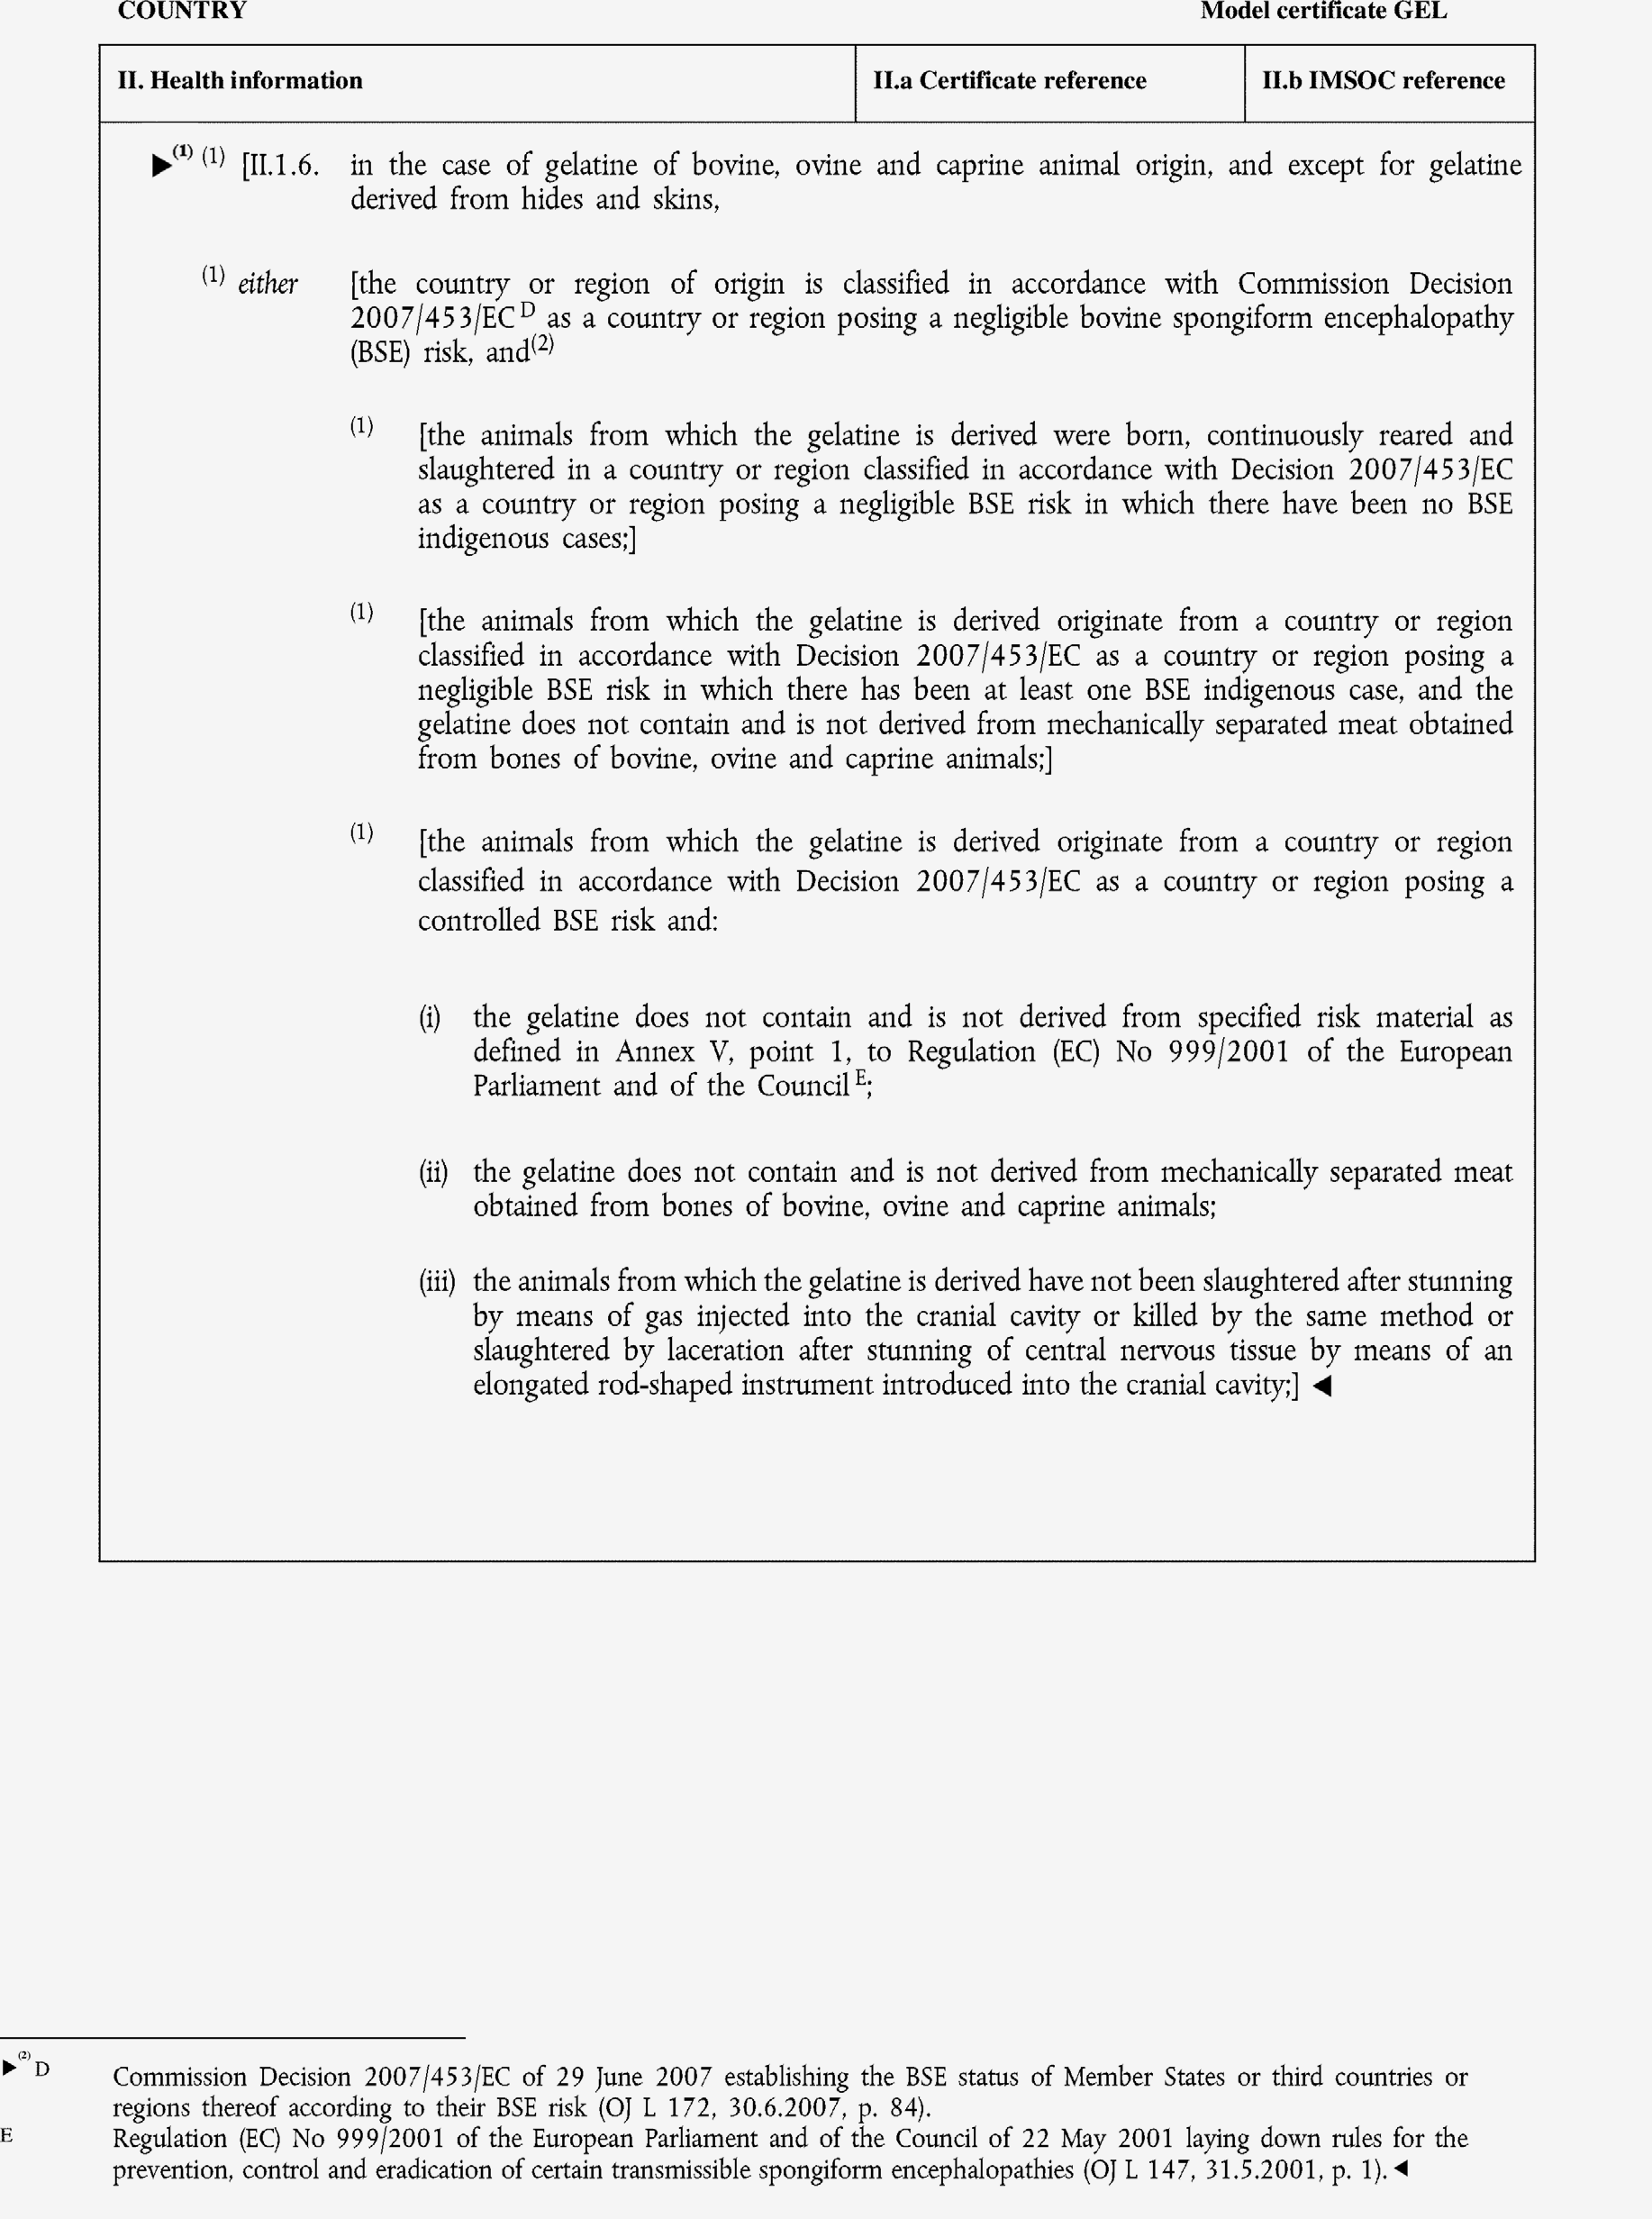

►(1) (2) M7

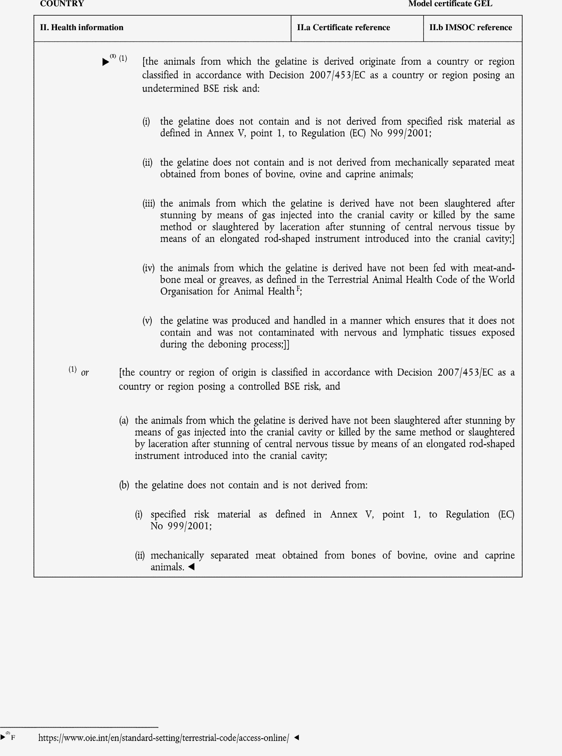

►(1) (2) M7

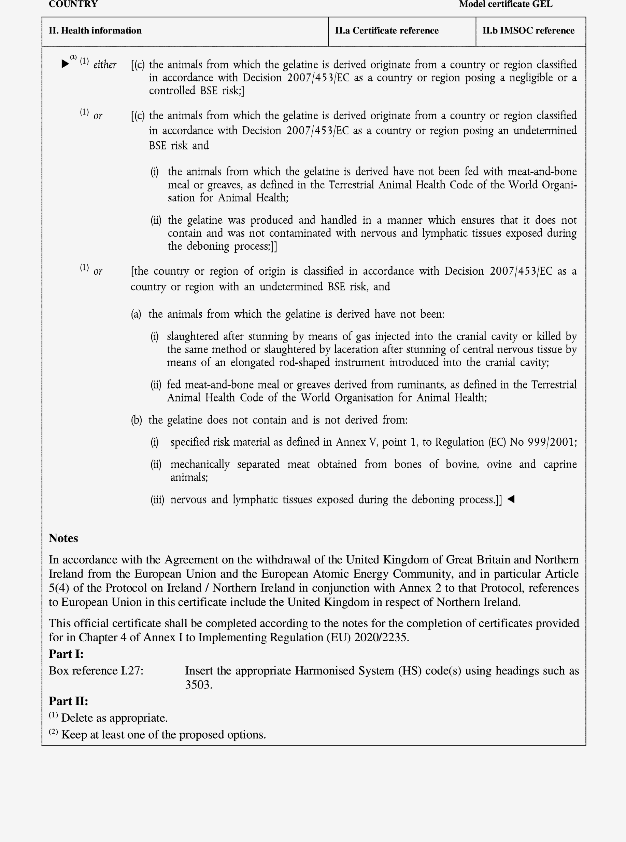

►(1) M7

