CHAPTER 39

MODEL OFFICIAL CERTIFICATE FOR THE ENTRY INTO THE UNION OF CHILLED, FROZEN OR PREPARED FROGS’ LEGS INTENDED FOR HUMAN CONSUMPTION (MODEL FRG)
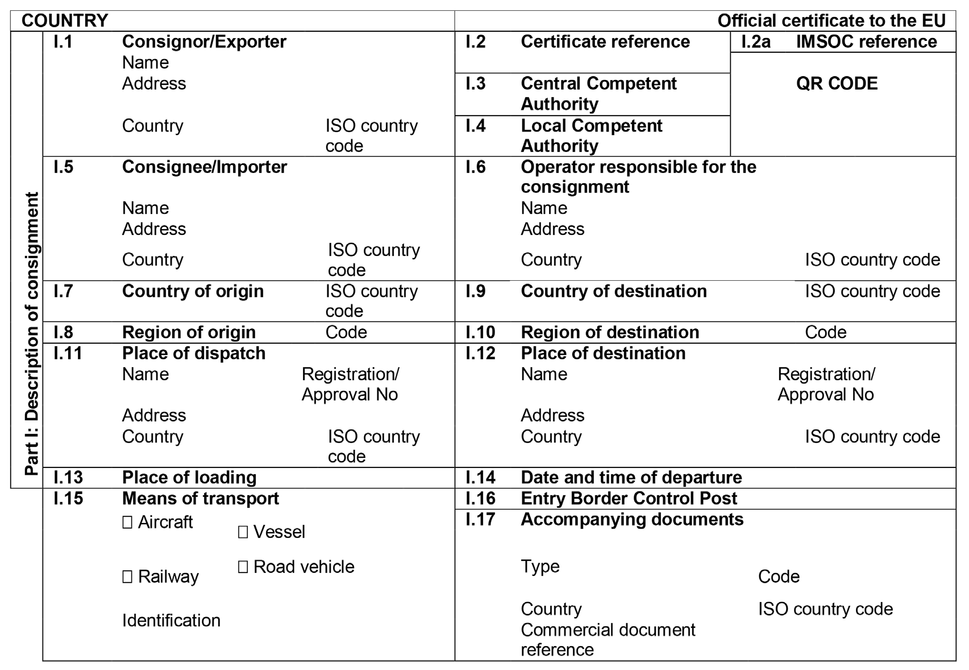

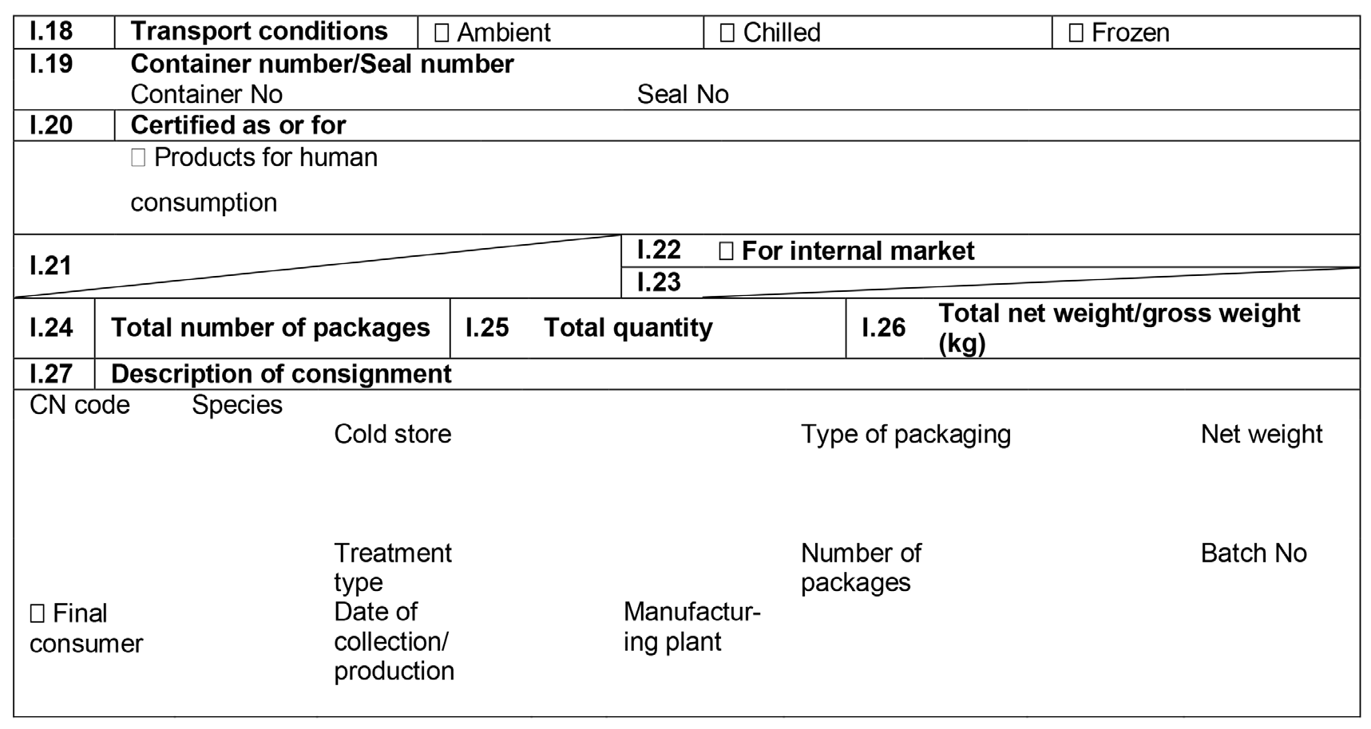

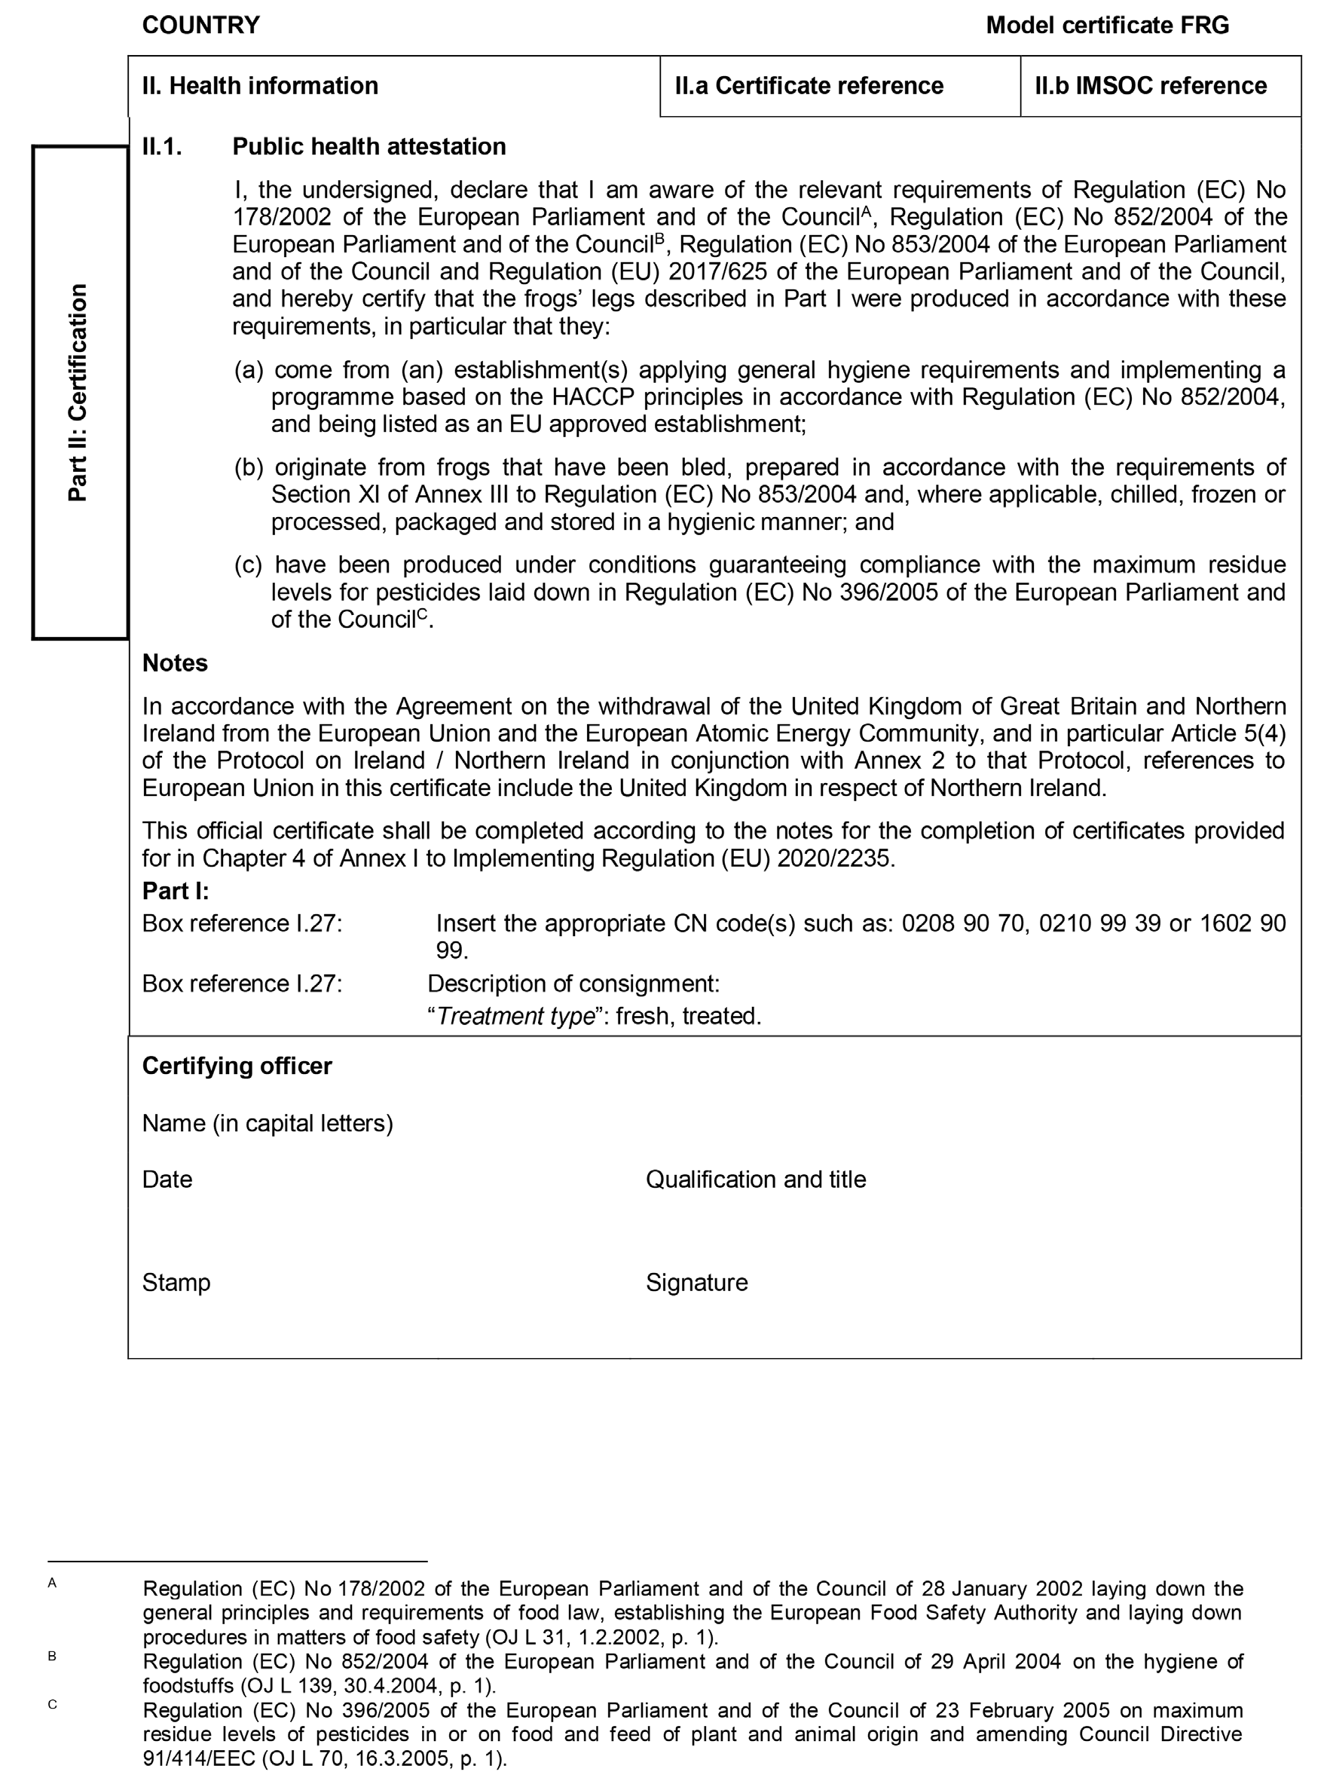
CHAPTER 40

MODEL OFFICIAL CERTIFICATE FOR THE ENTRY INTO THE UNION OF SNAILS INTENDED FOR HUMAN CONSUMPTION (MODEL SNS)
