CHAPTER 35

MODEL ANIMAL HEALTH/OFFICIAL CERTIFICATE FOR THE ENTRY INTO THE UNION OF DAIRY PRODUCTS INTENDED FOR HUMAN CONSUMPTION THAT ARE REQUIRED TO UNDERGO A PASTEURIZATION TREATMENT (MODEL DAIRY-PRODUCTS-PT)

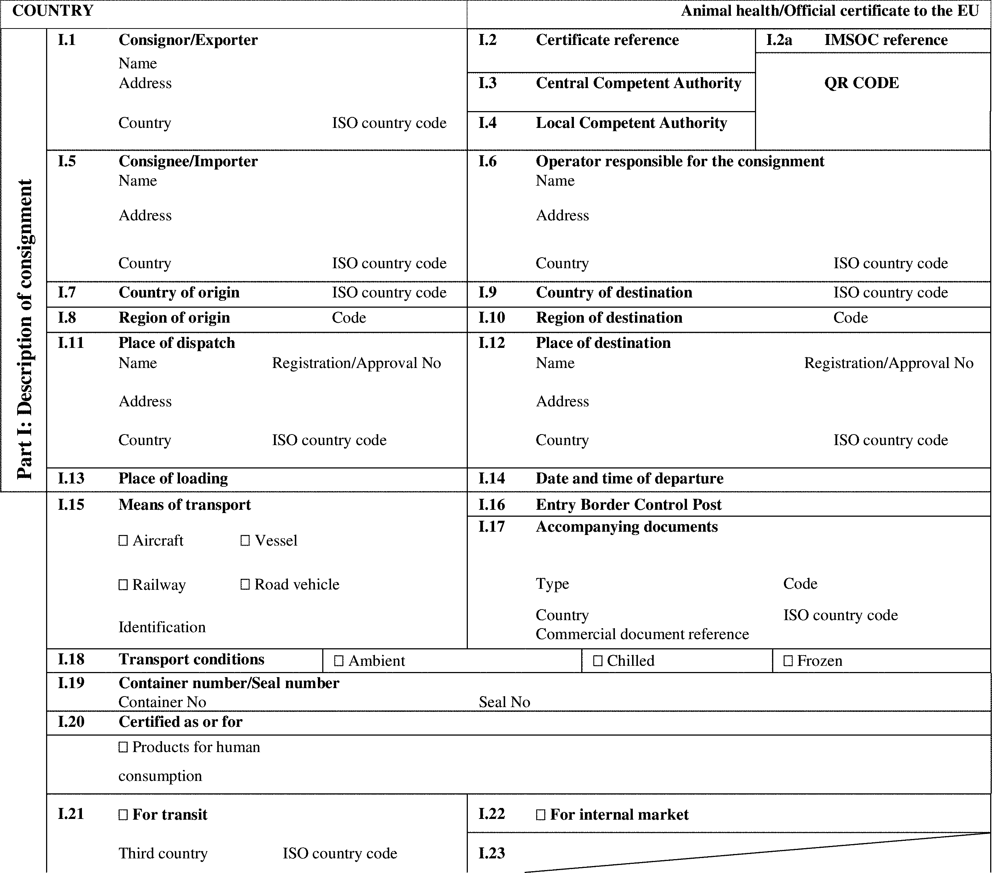

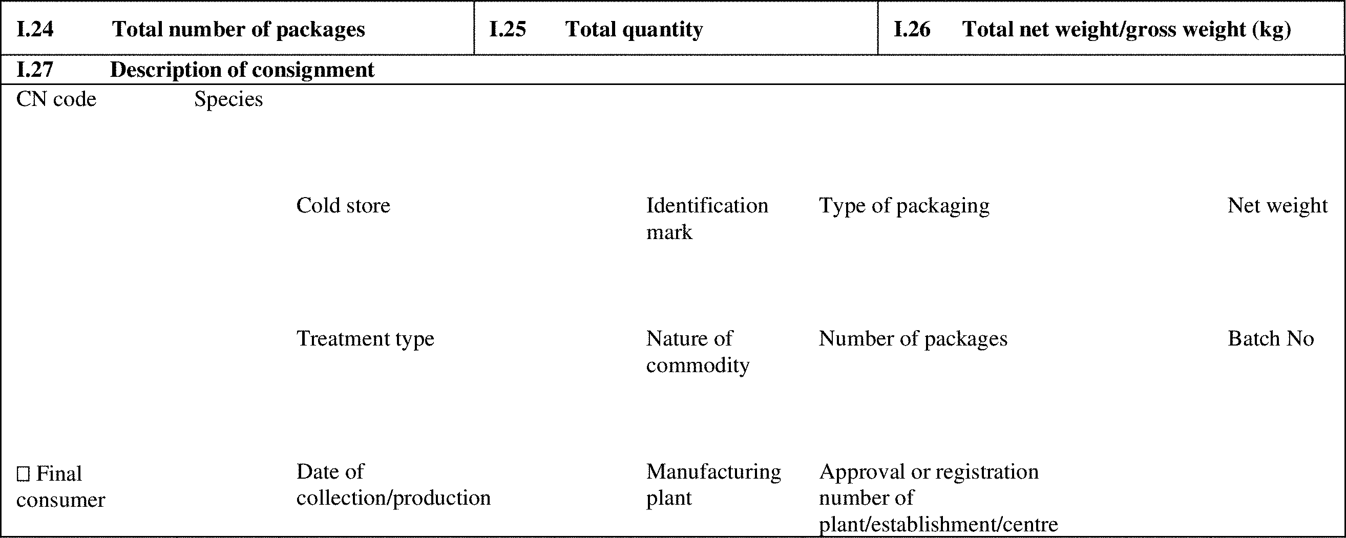

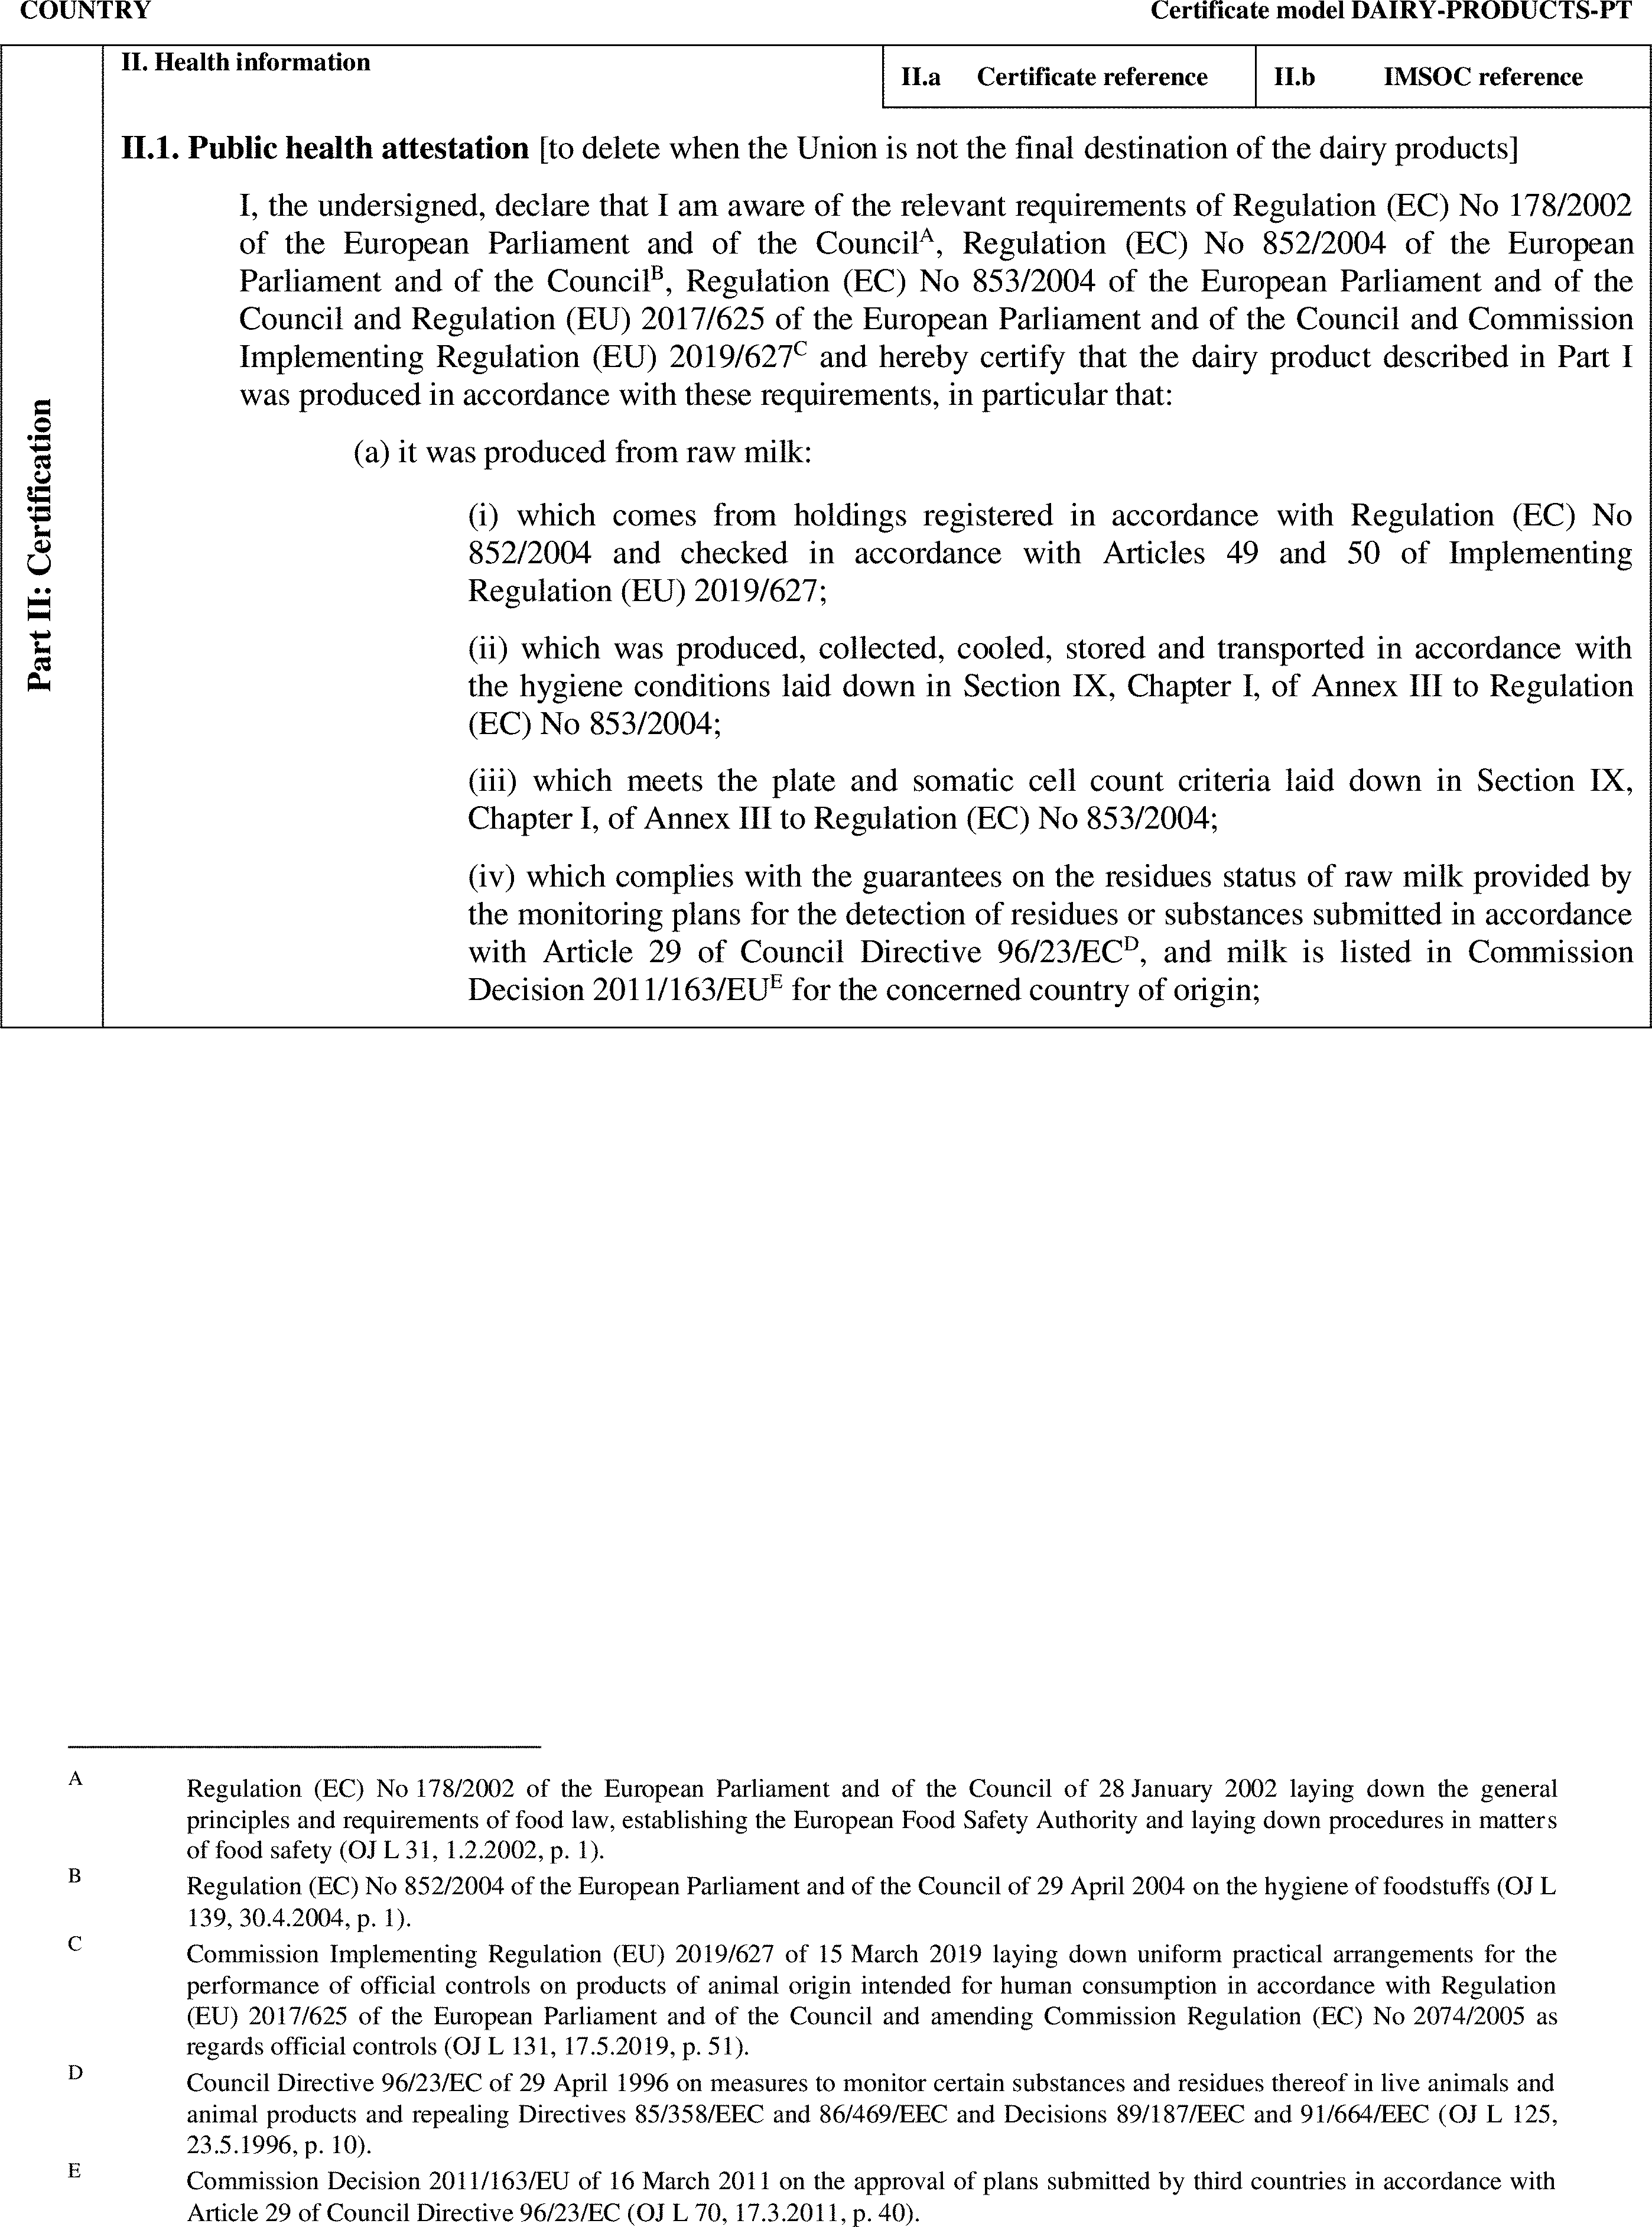

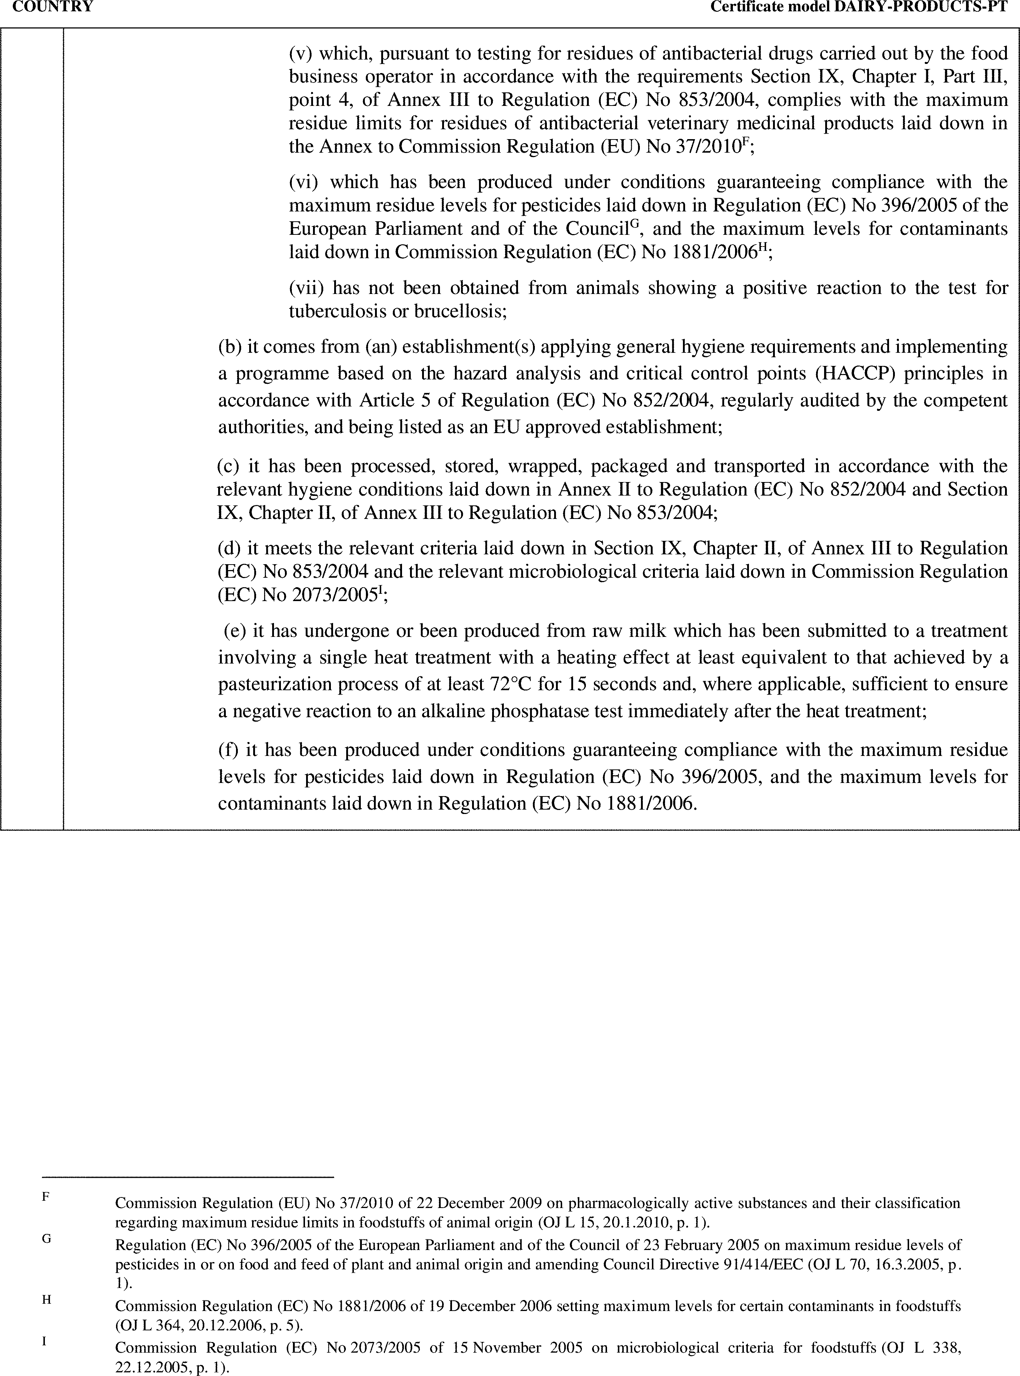

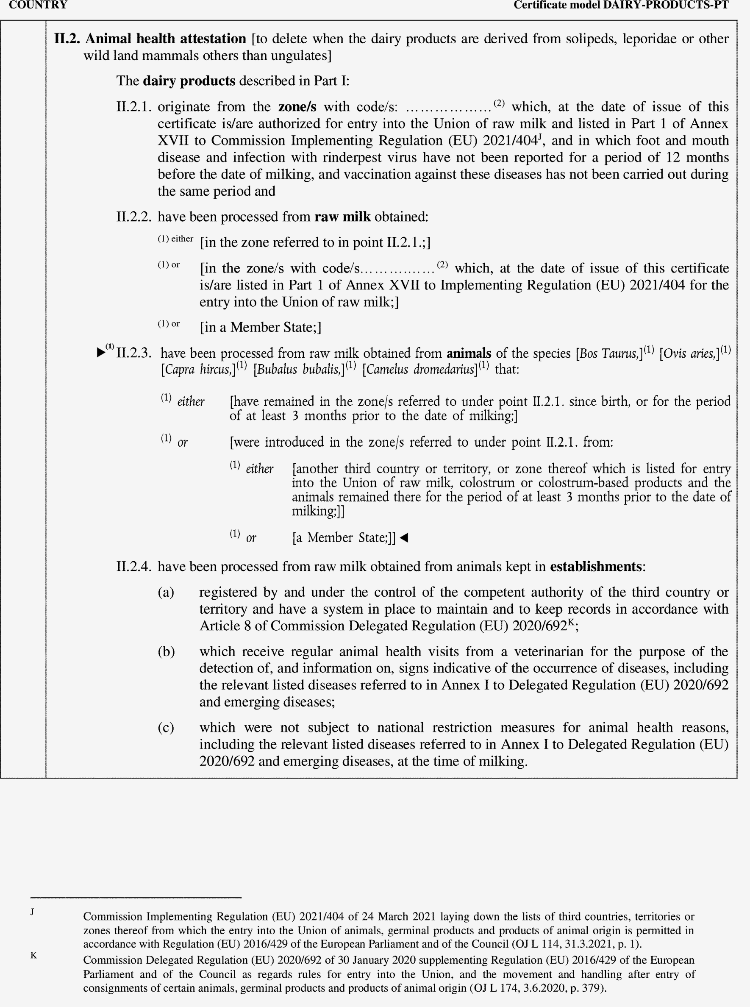

►(1) M7

