CHAPTER 33

MODEL ANIMAL HEALTH/OFFICIAL CERTIFICATE FOR THE ENTRY INTO THE UNION OF RAW MILK INTENDED FOR HUMAN CONSUMPTION (MODEL MILK-RM)

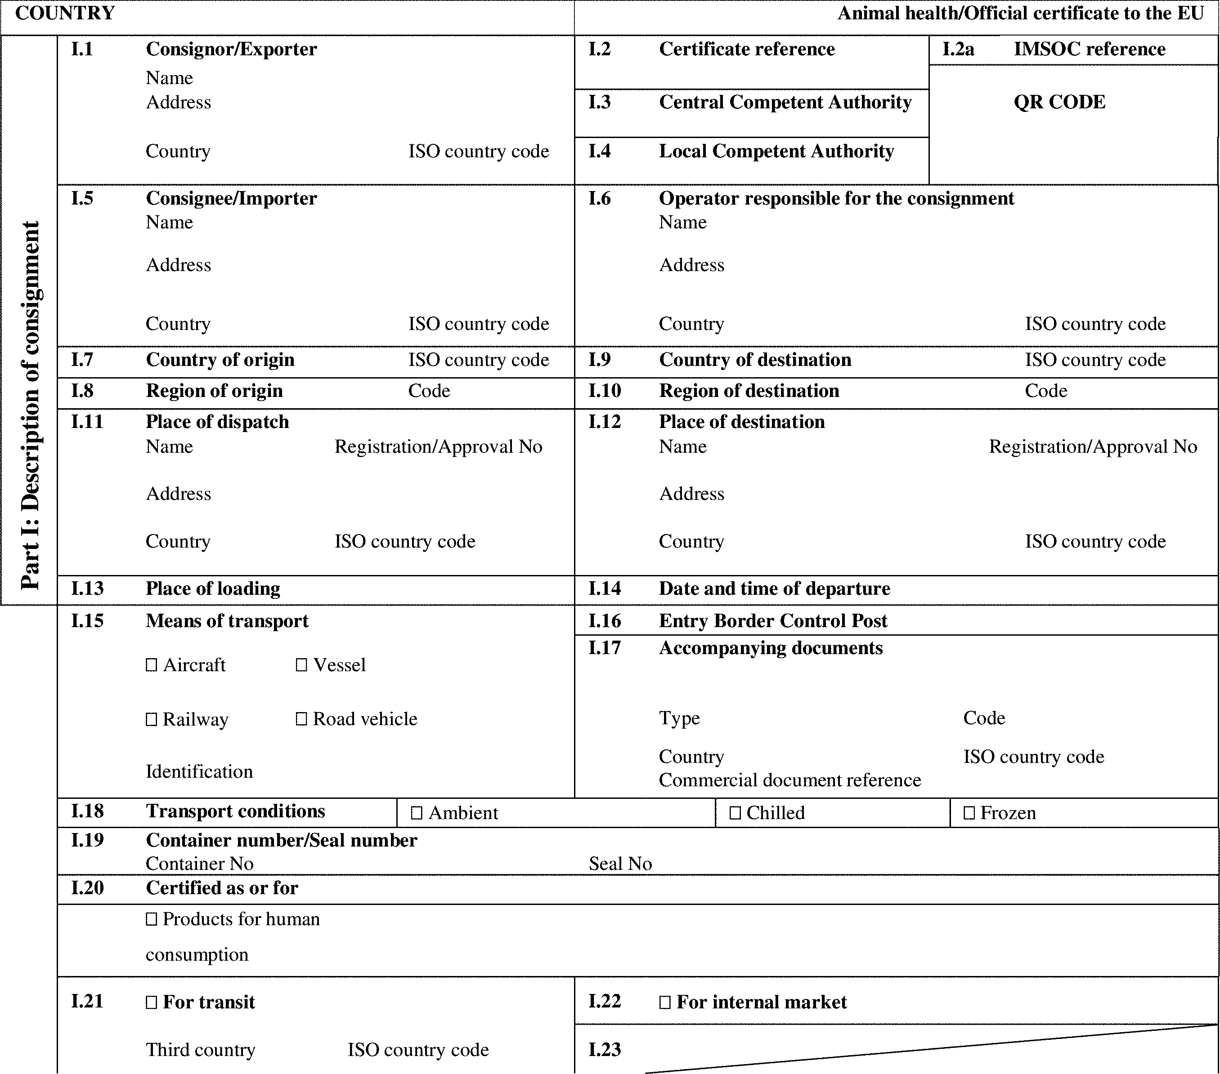

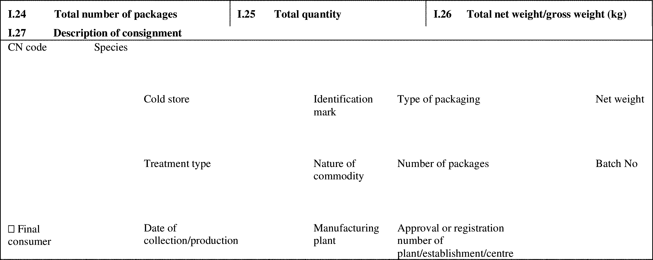

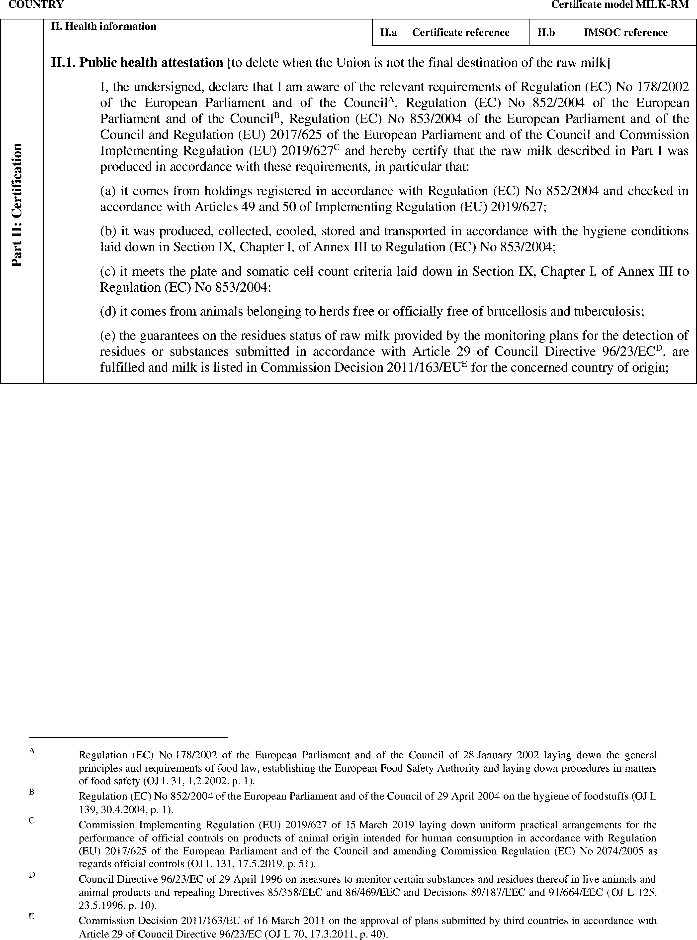

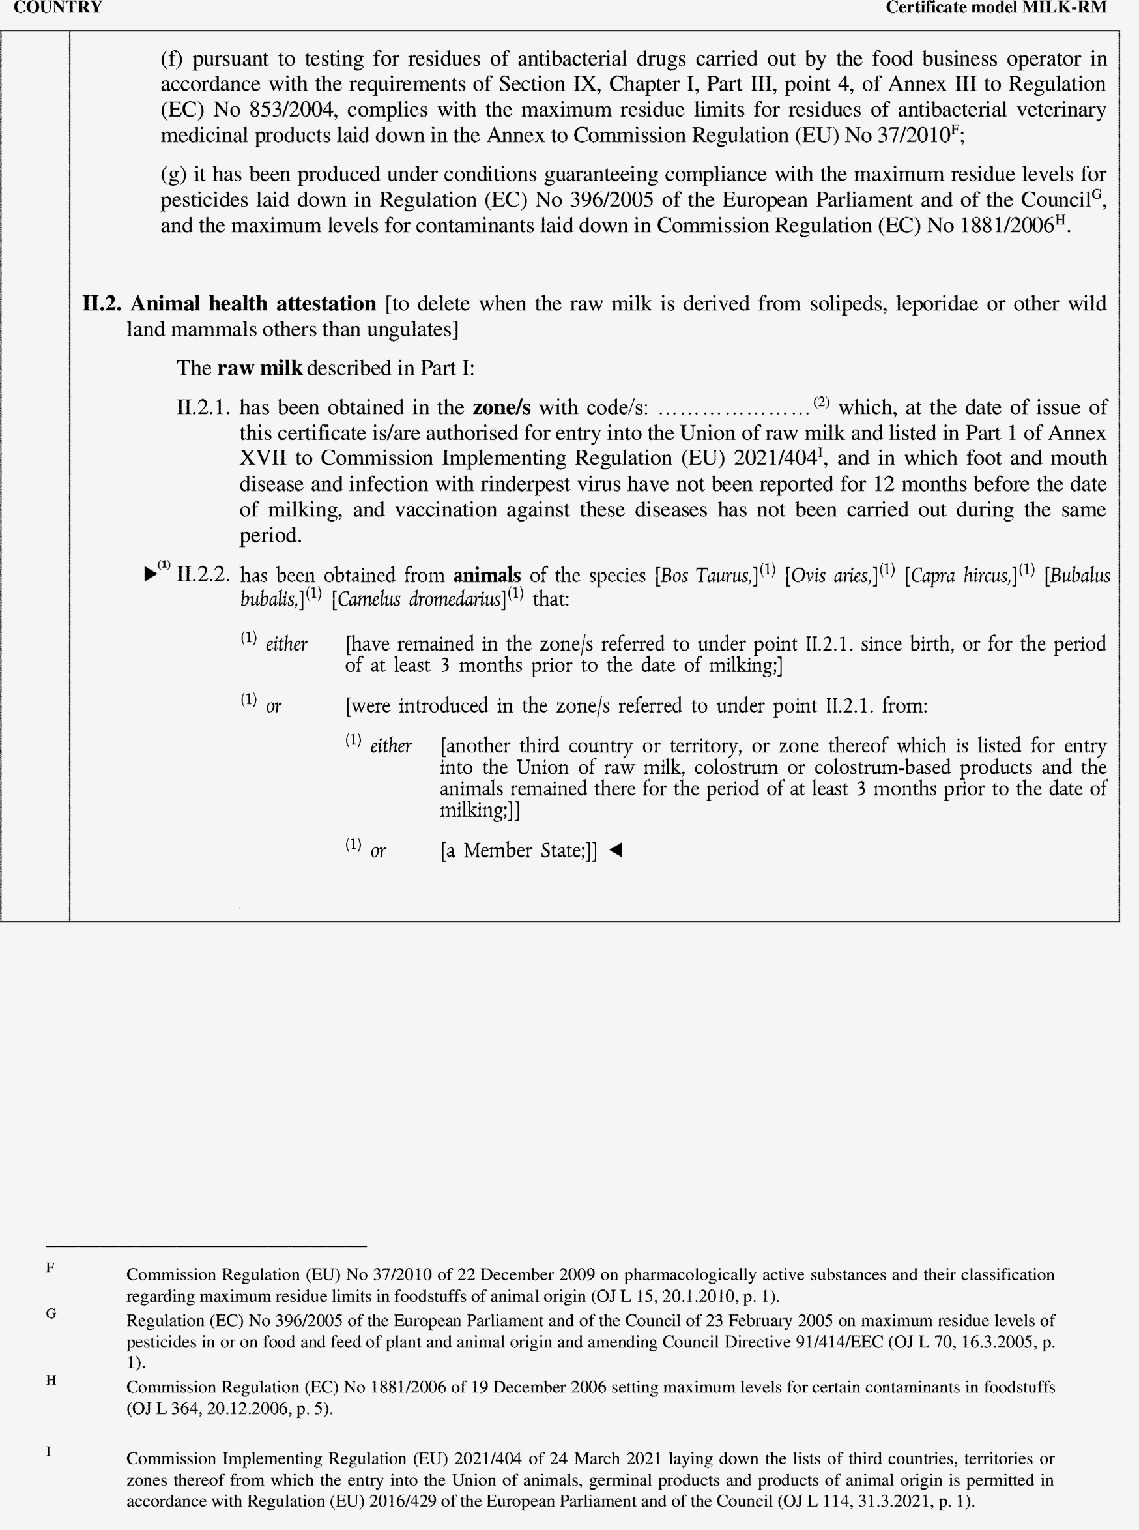

►(1) M7

