CHAPTER 31

MODEL ANIMAL HEALTH/OFFICIAL CERTIFICATE FOR THE ENTRY IN THE UNION OF LIVE BIVALVE MOLLUSCS, ECHINODERMS, TUNICATES, MARINE GASTROPODS AND PRODUCTS OF ANIMAL ORIGIN FROM THESE ANIMALS INTENDED FOR HUMAN CONSUMPTION (MODEL MOL-HC)

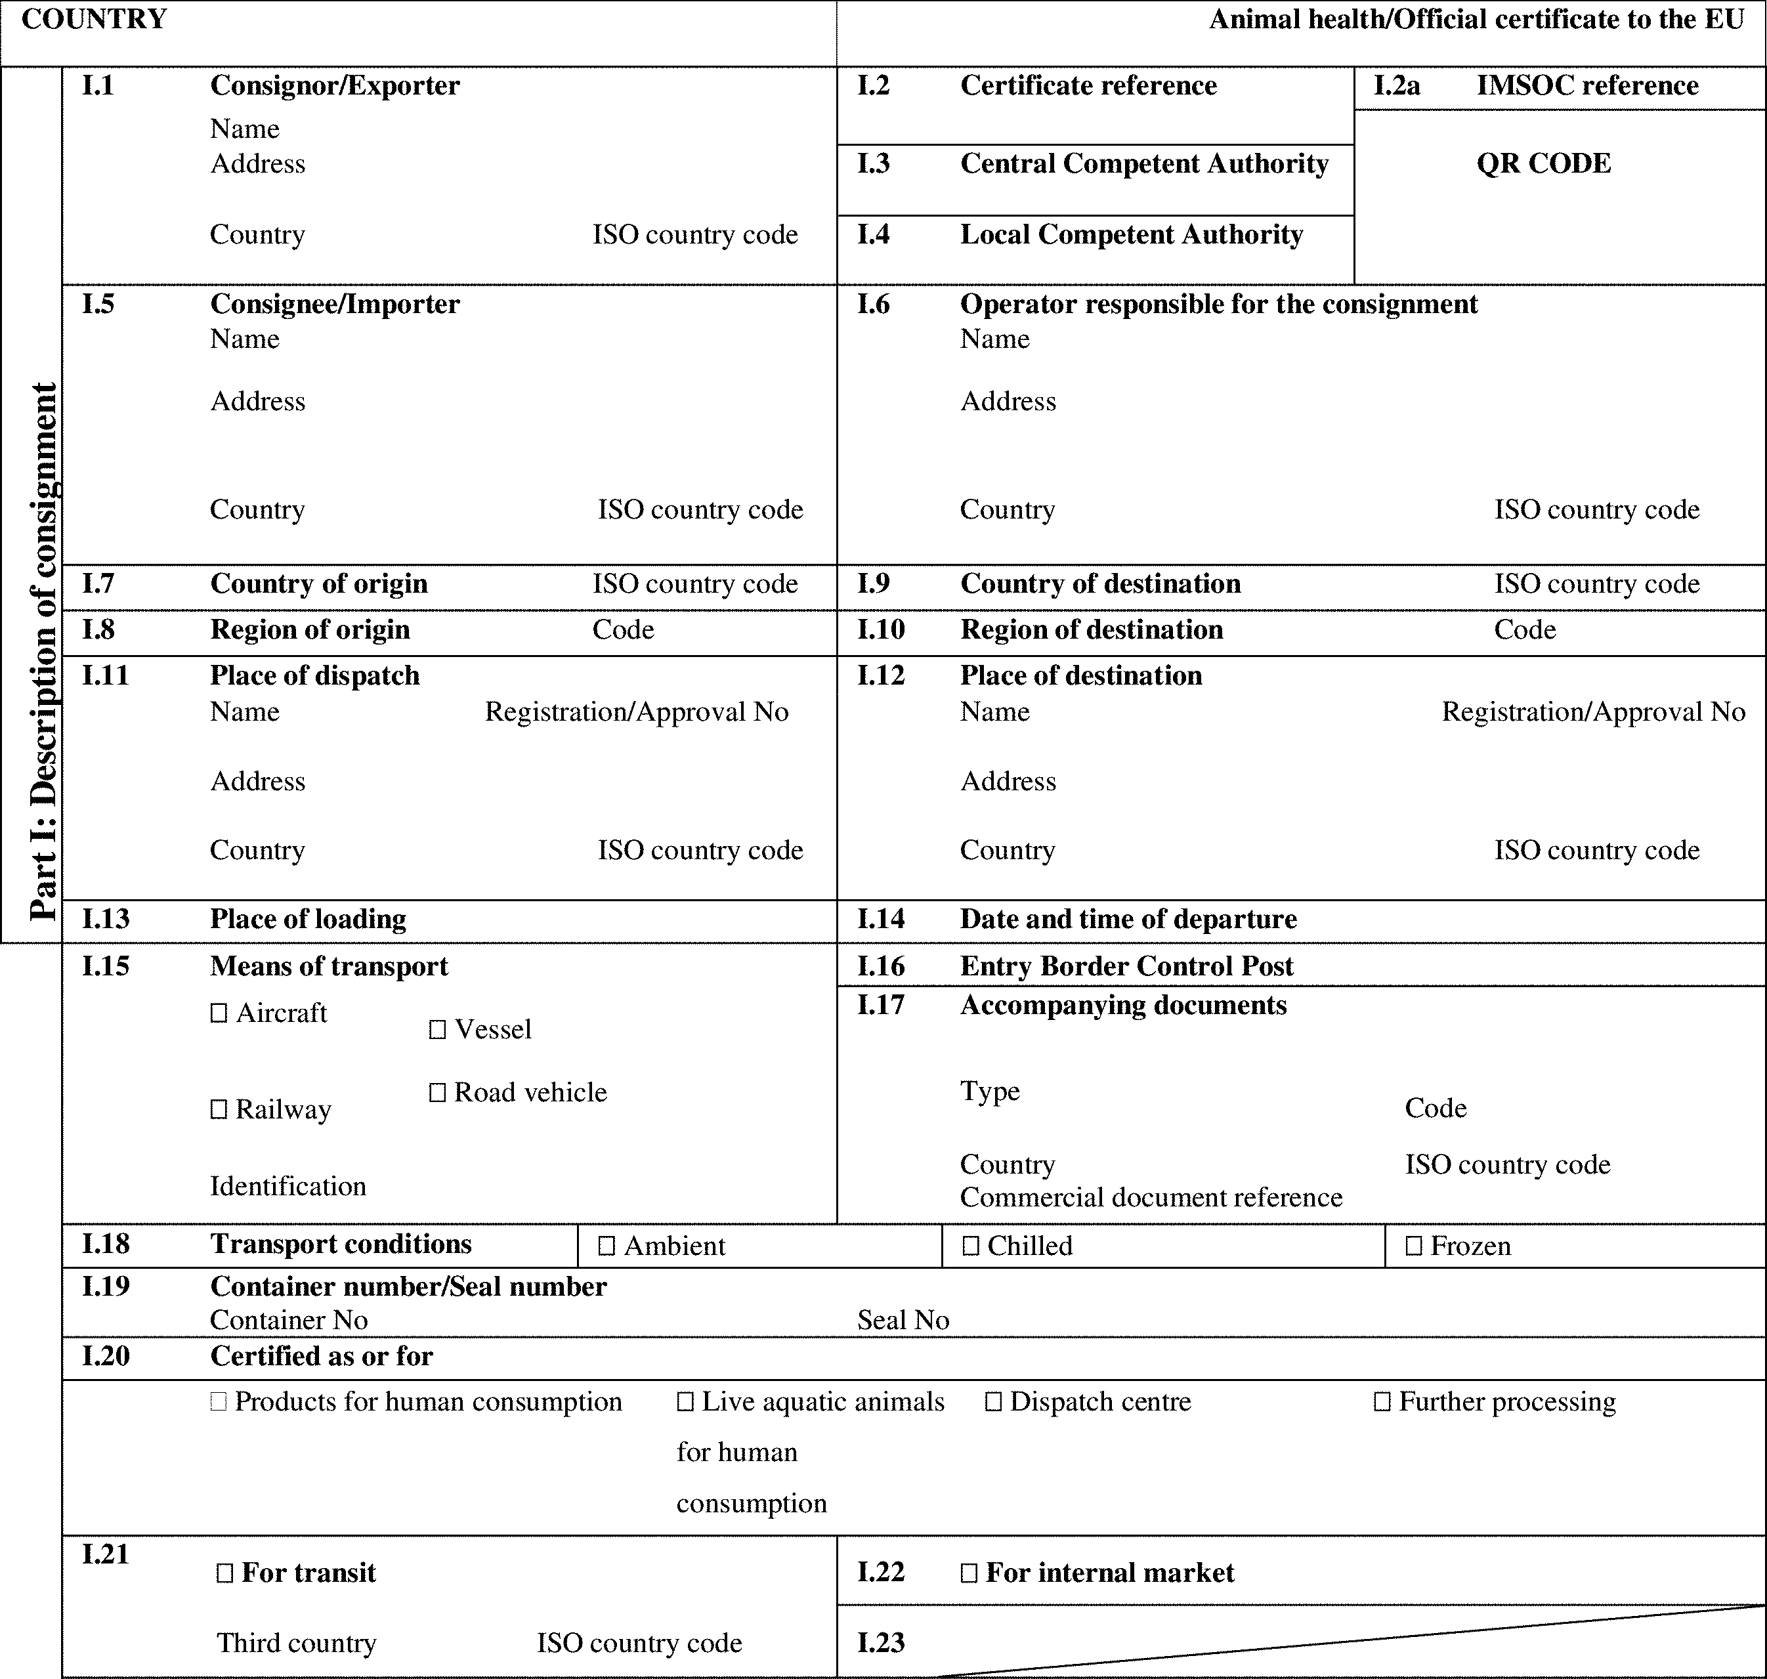

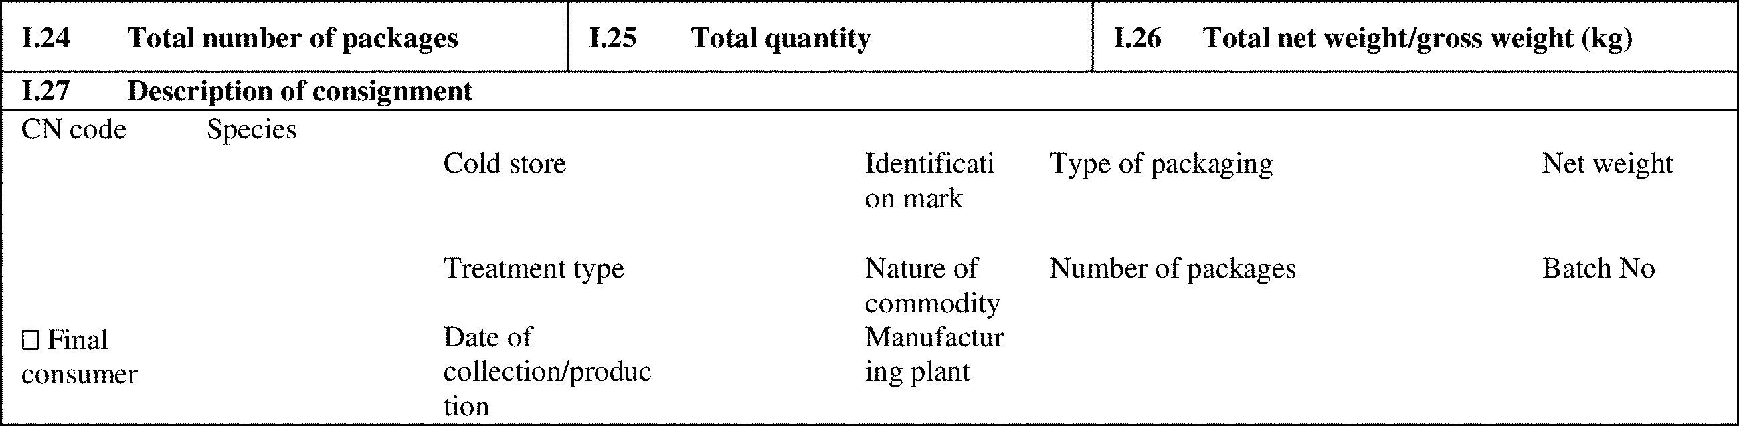

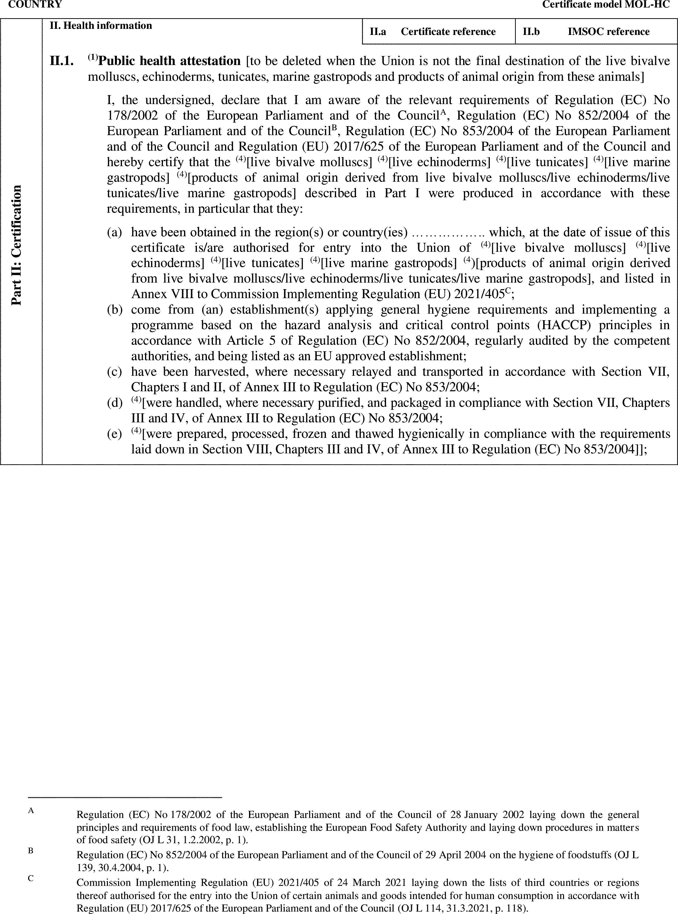

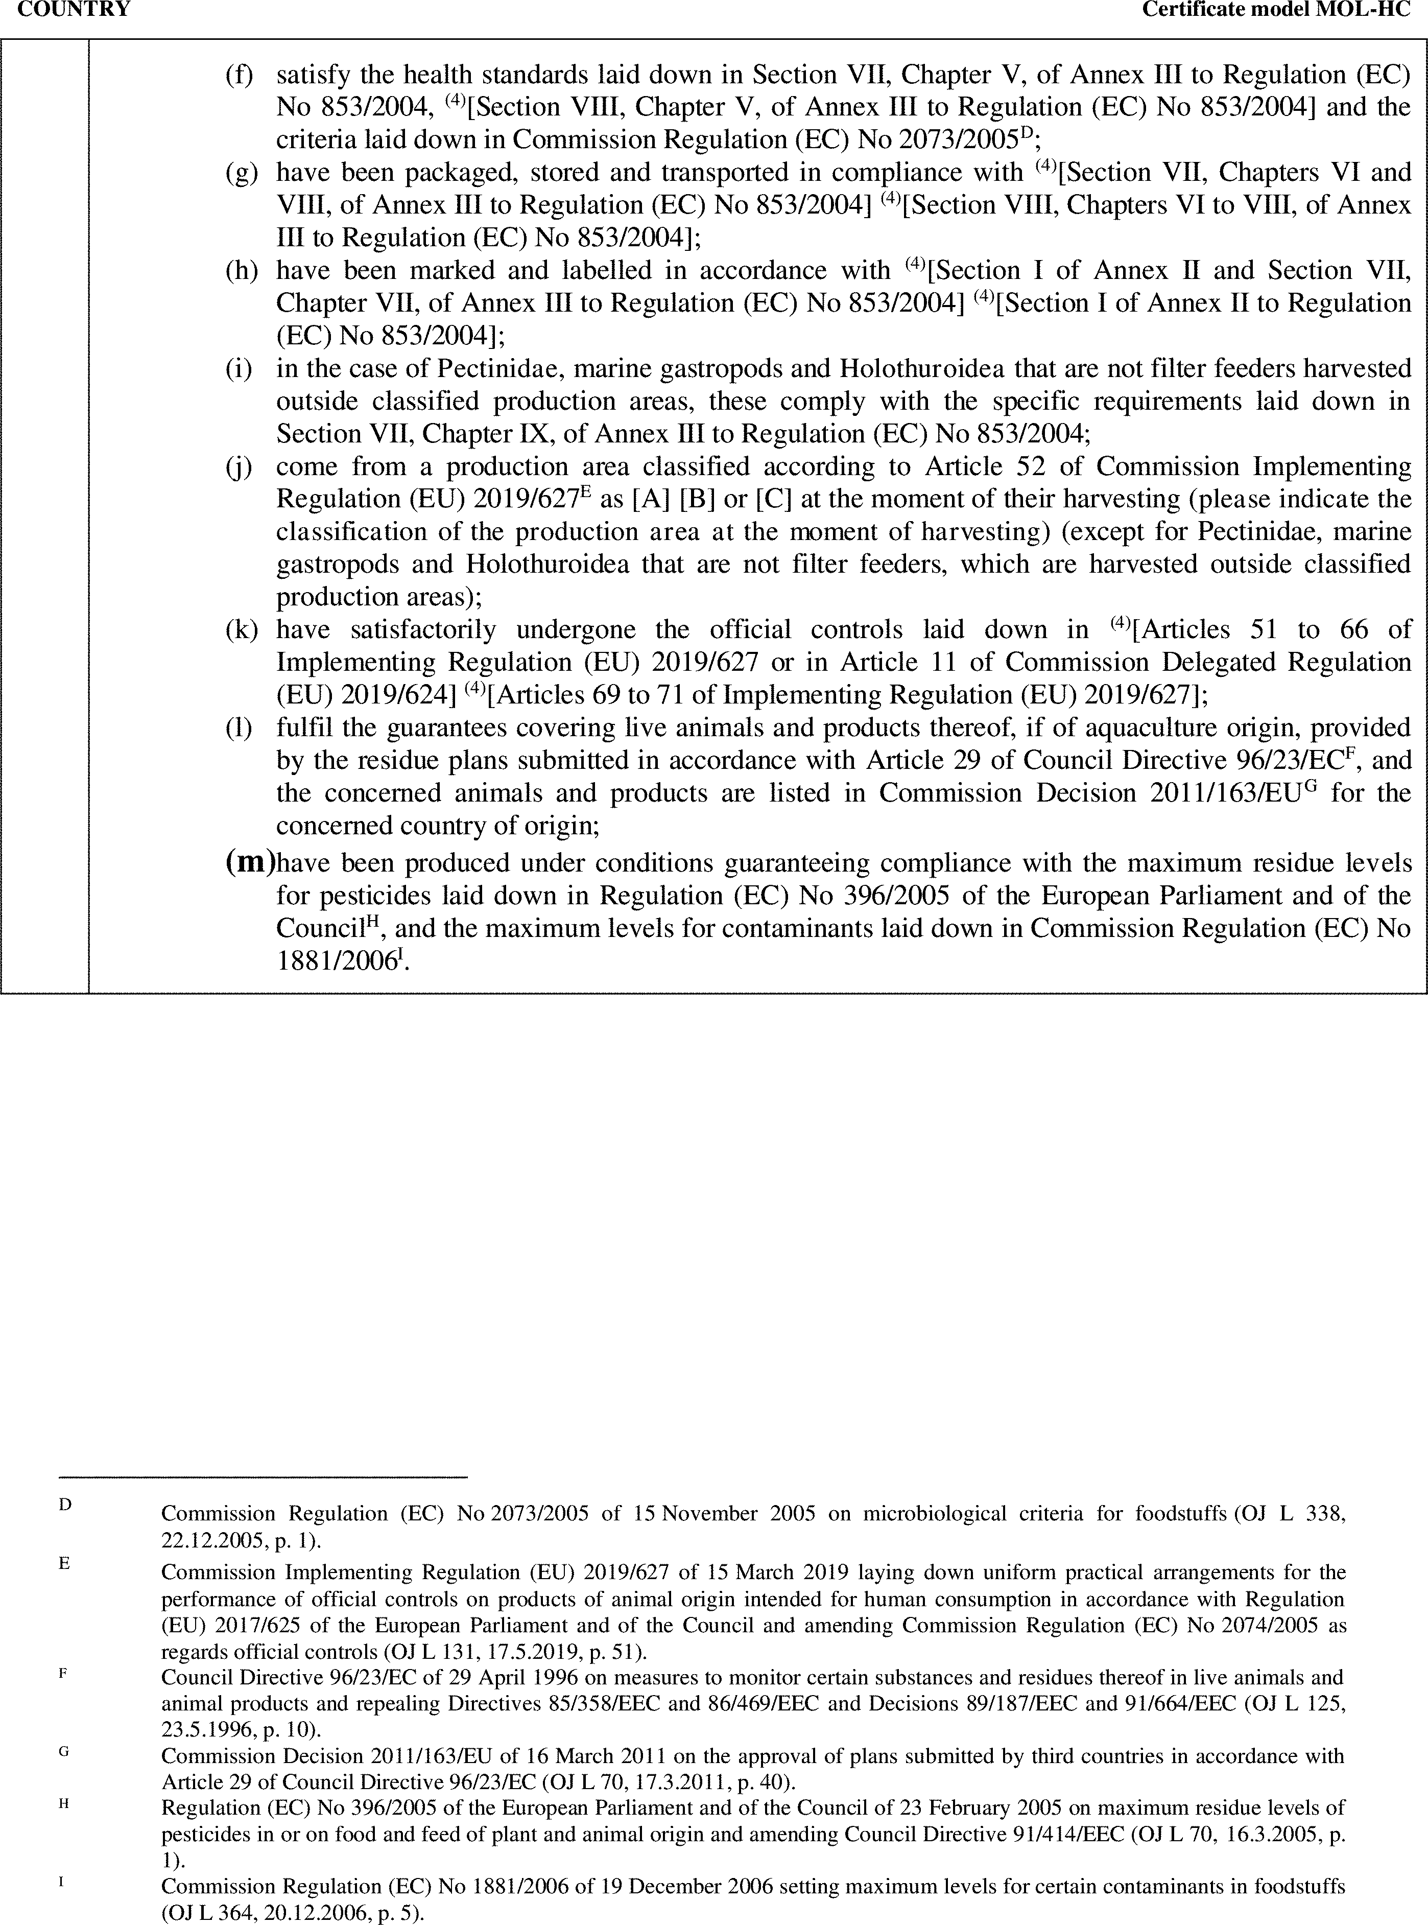

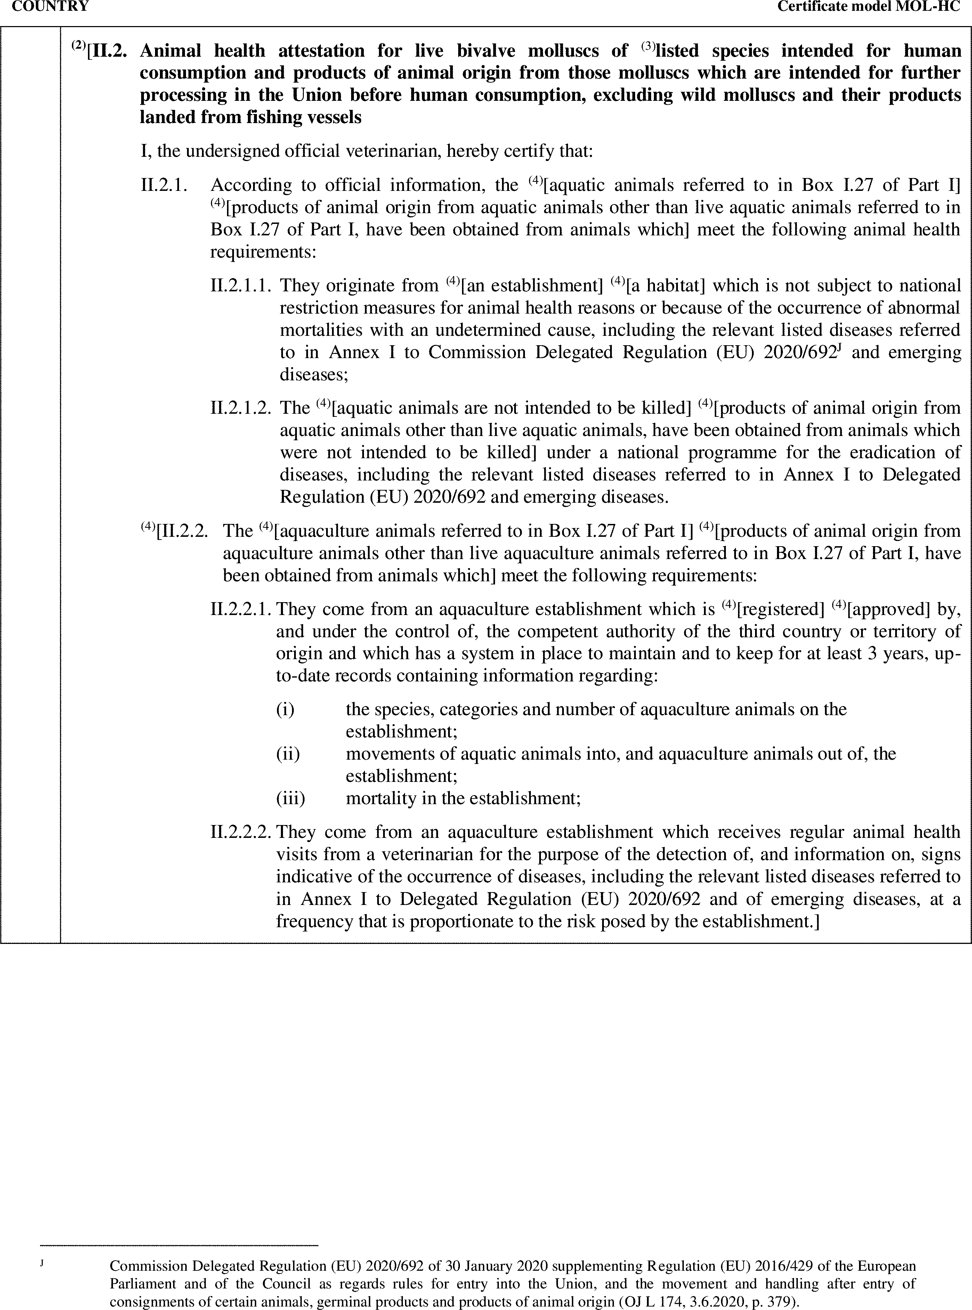

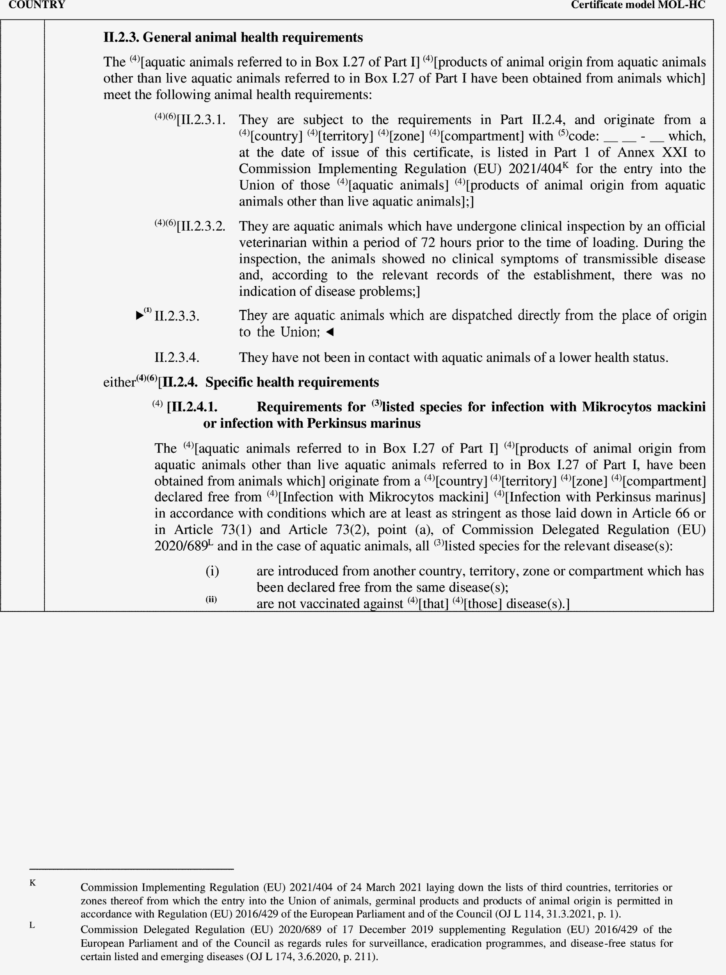

►(1) M7

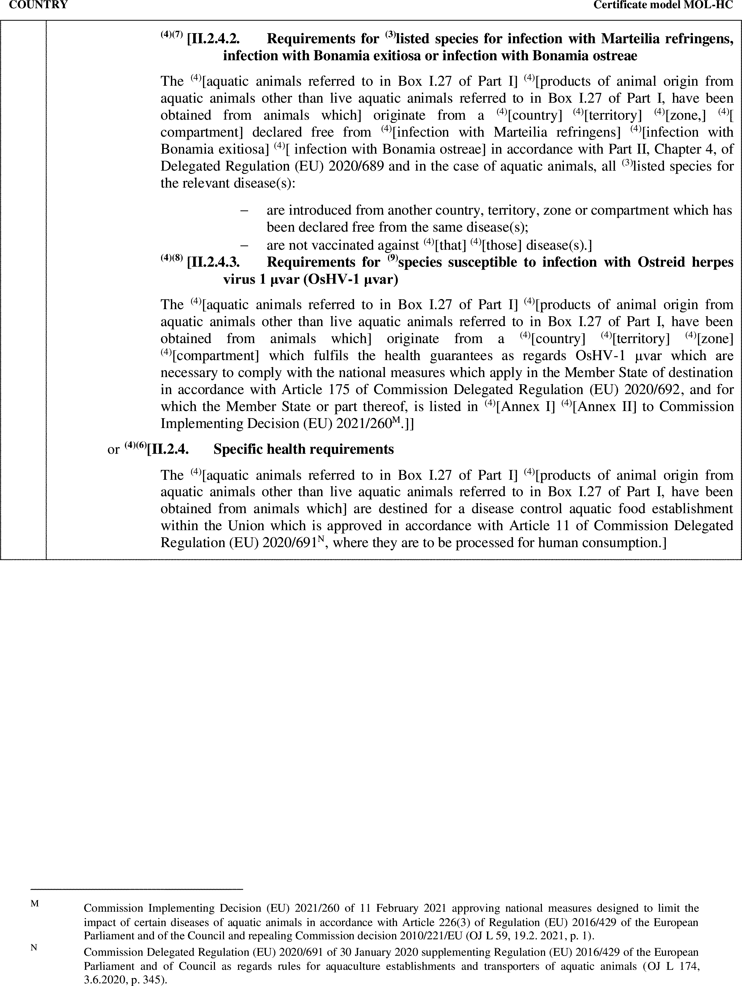

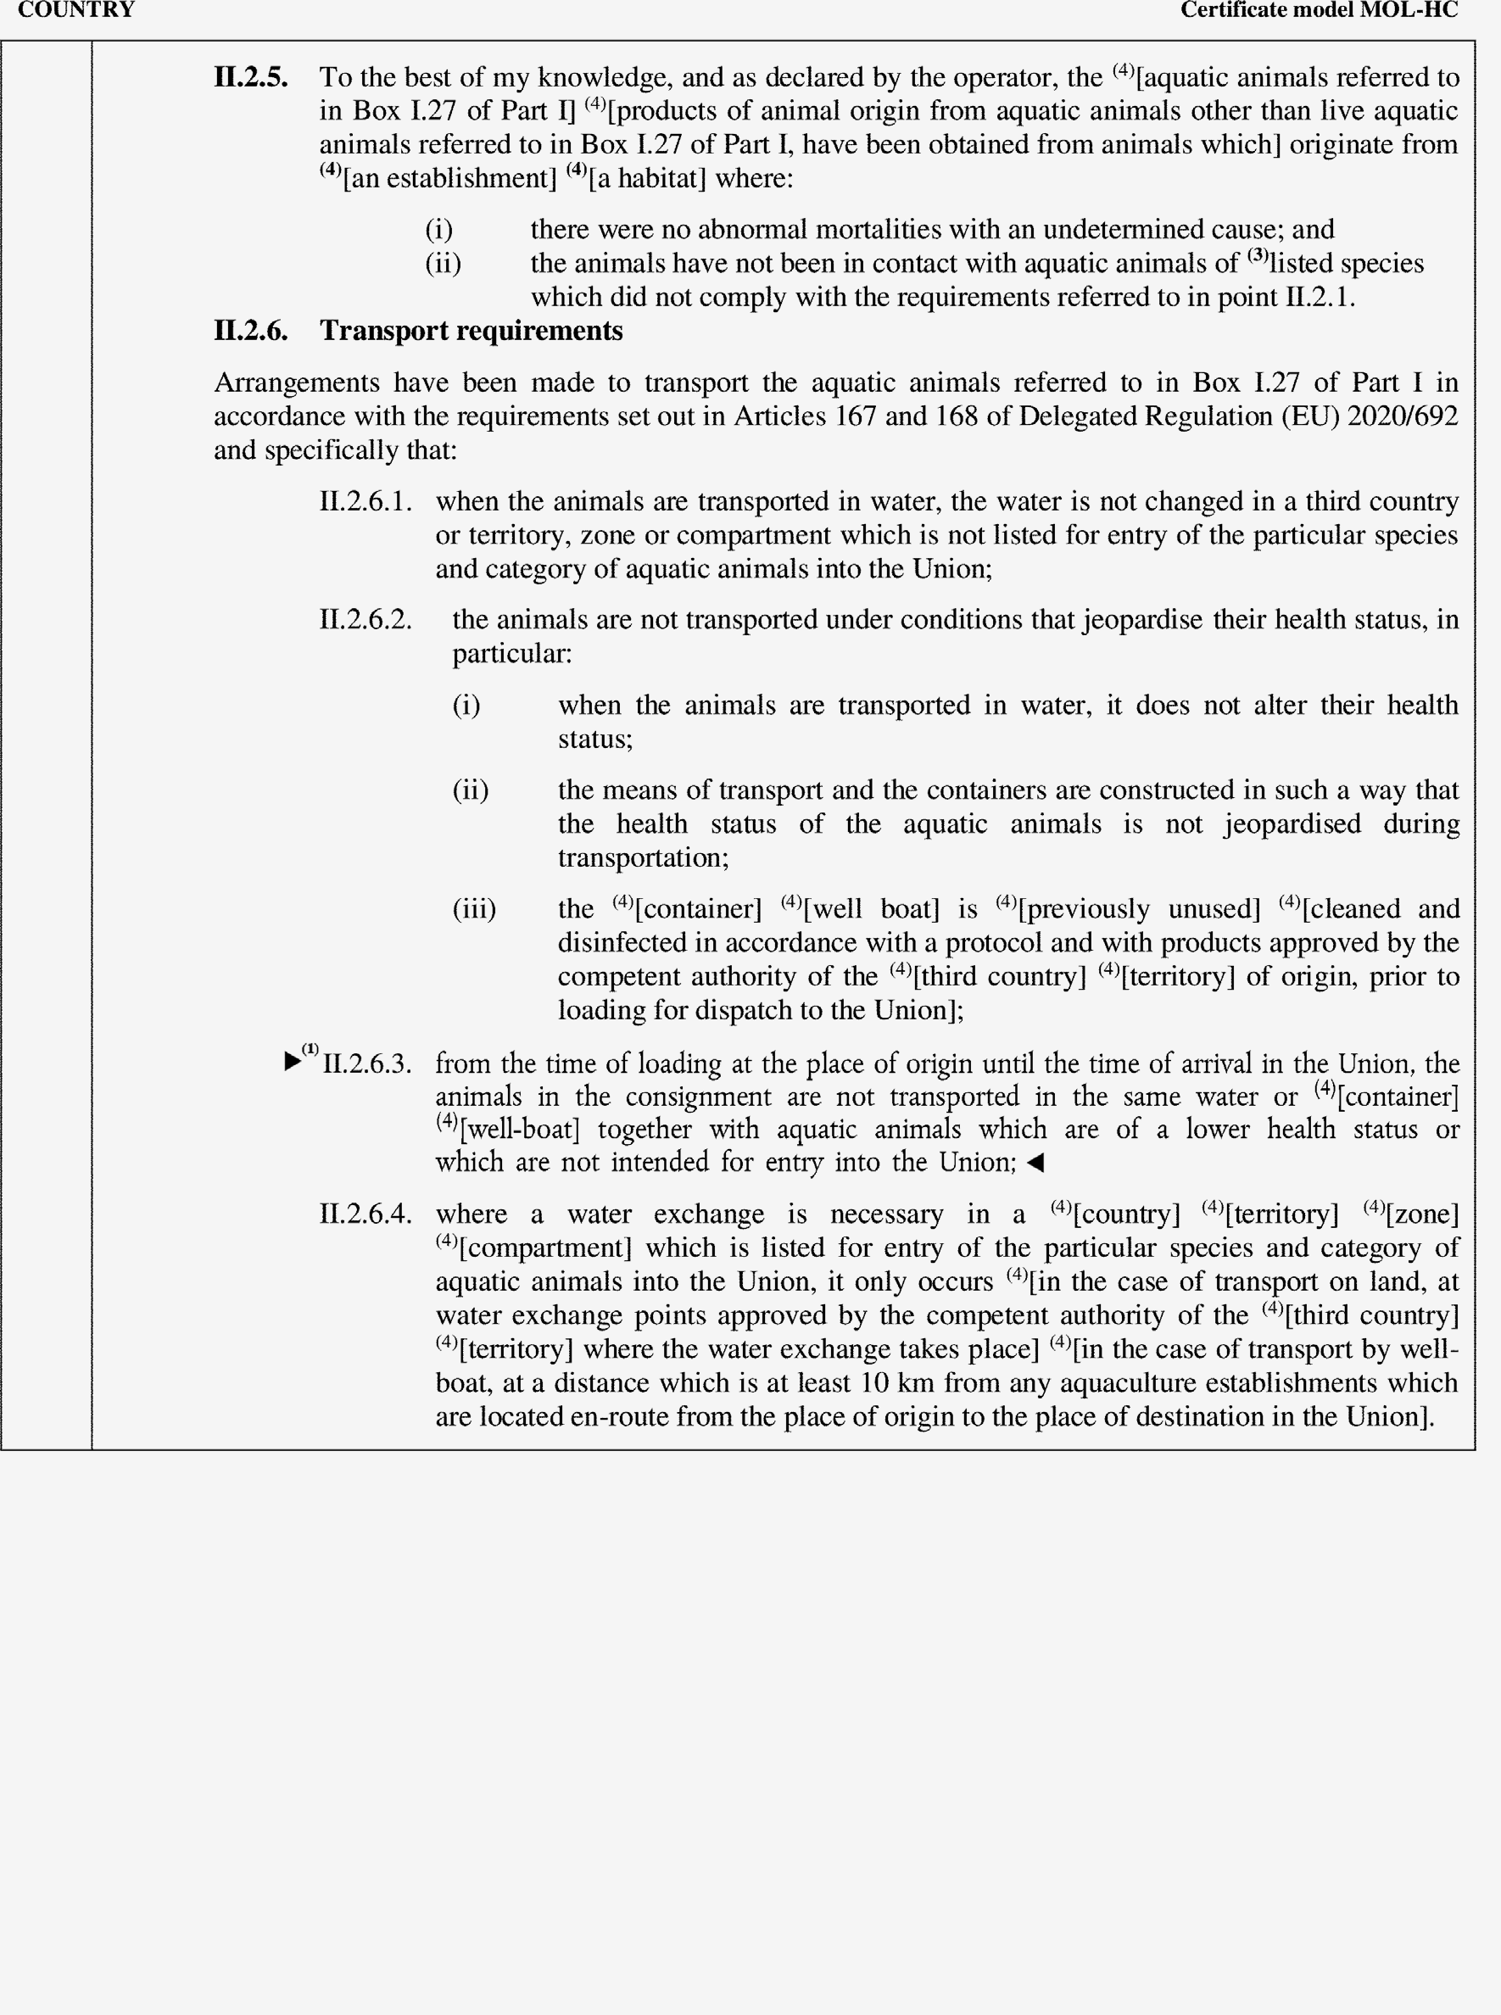

►(1) M7

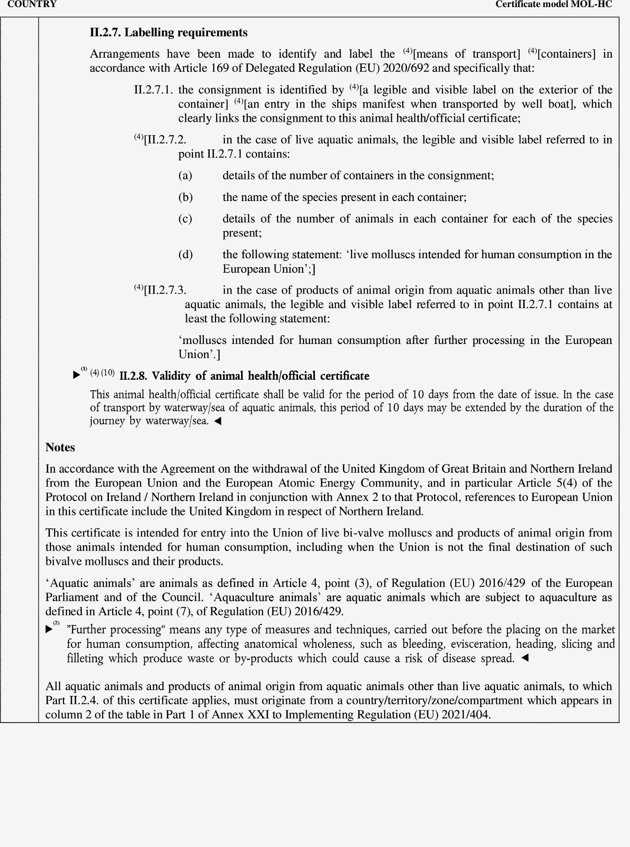

►(1) (2) M7

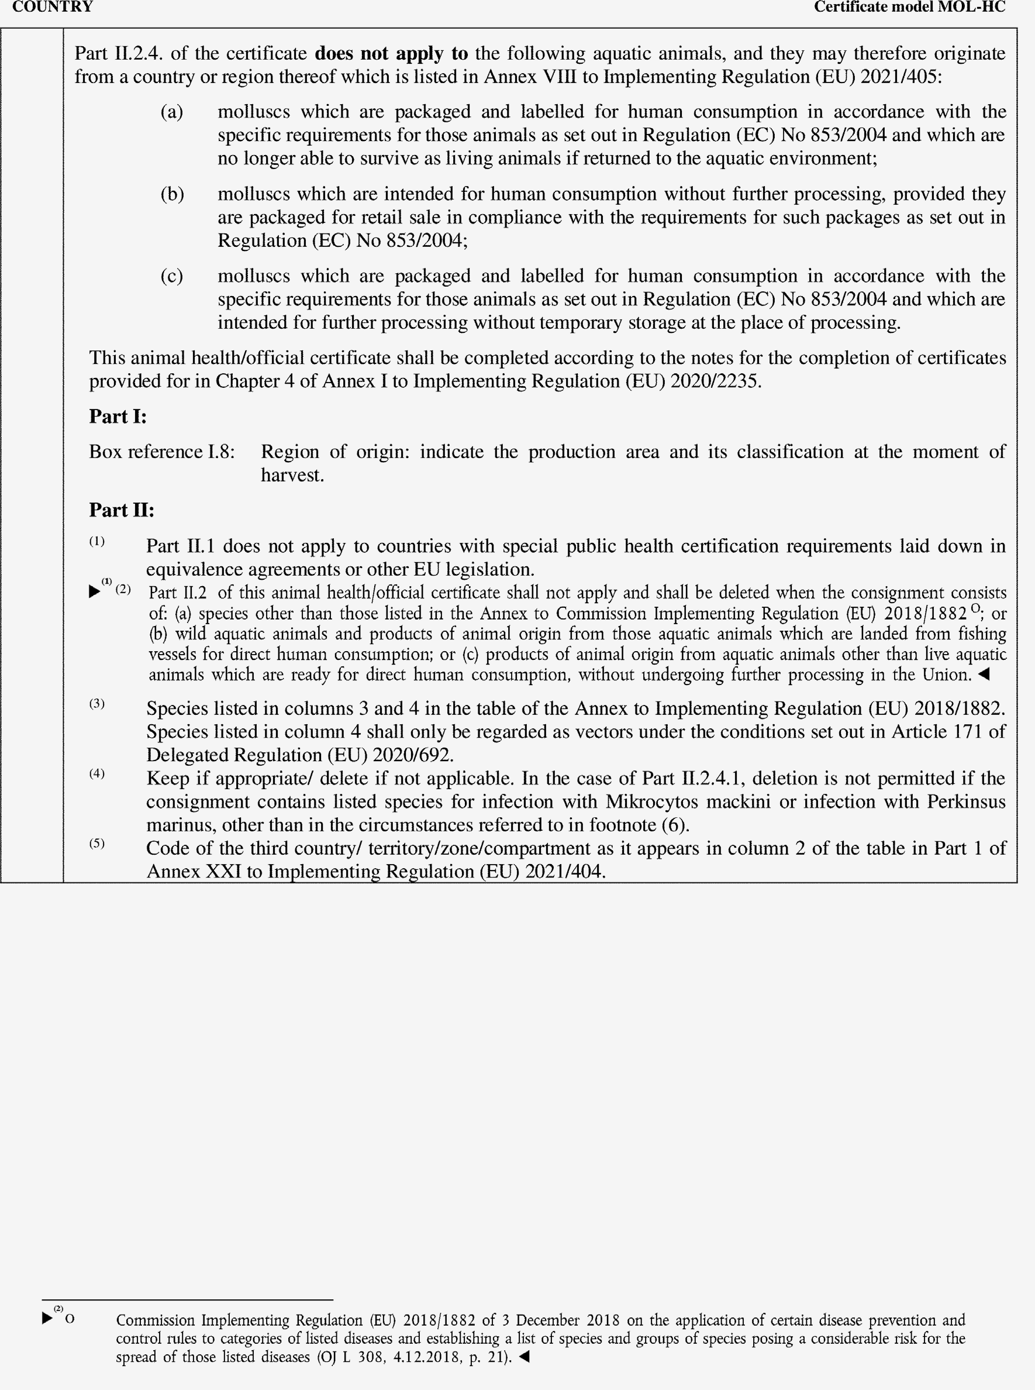

►(1) (2) M7

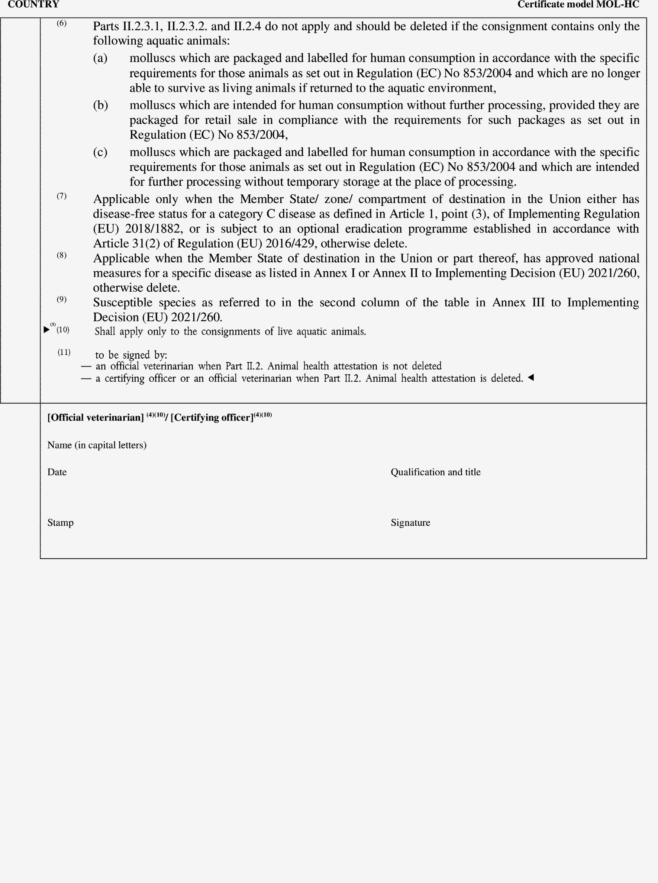

►(1) M7

