CHAPTER 26

MODEL ANIMAL HEALTH/OFFICIAL CERTIFICATE FOR THE ENTRY INTO THE UNION OF MEAT PRODUCTS INTENDED FOR HUMAN CONSUMPTION, INCLUDING RENDERED ANIMAL FATS AND GREAVES, MEAT EXTRACTS AND TREATED STOMACHS, BLADDERS AND INTESTINES, OTHERS THAN CASINGS, THAT ARE REQUIRED TO UNDERGO A SPECIFIC RISK-MITIGATING TREATMENT (MODEL MPST)

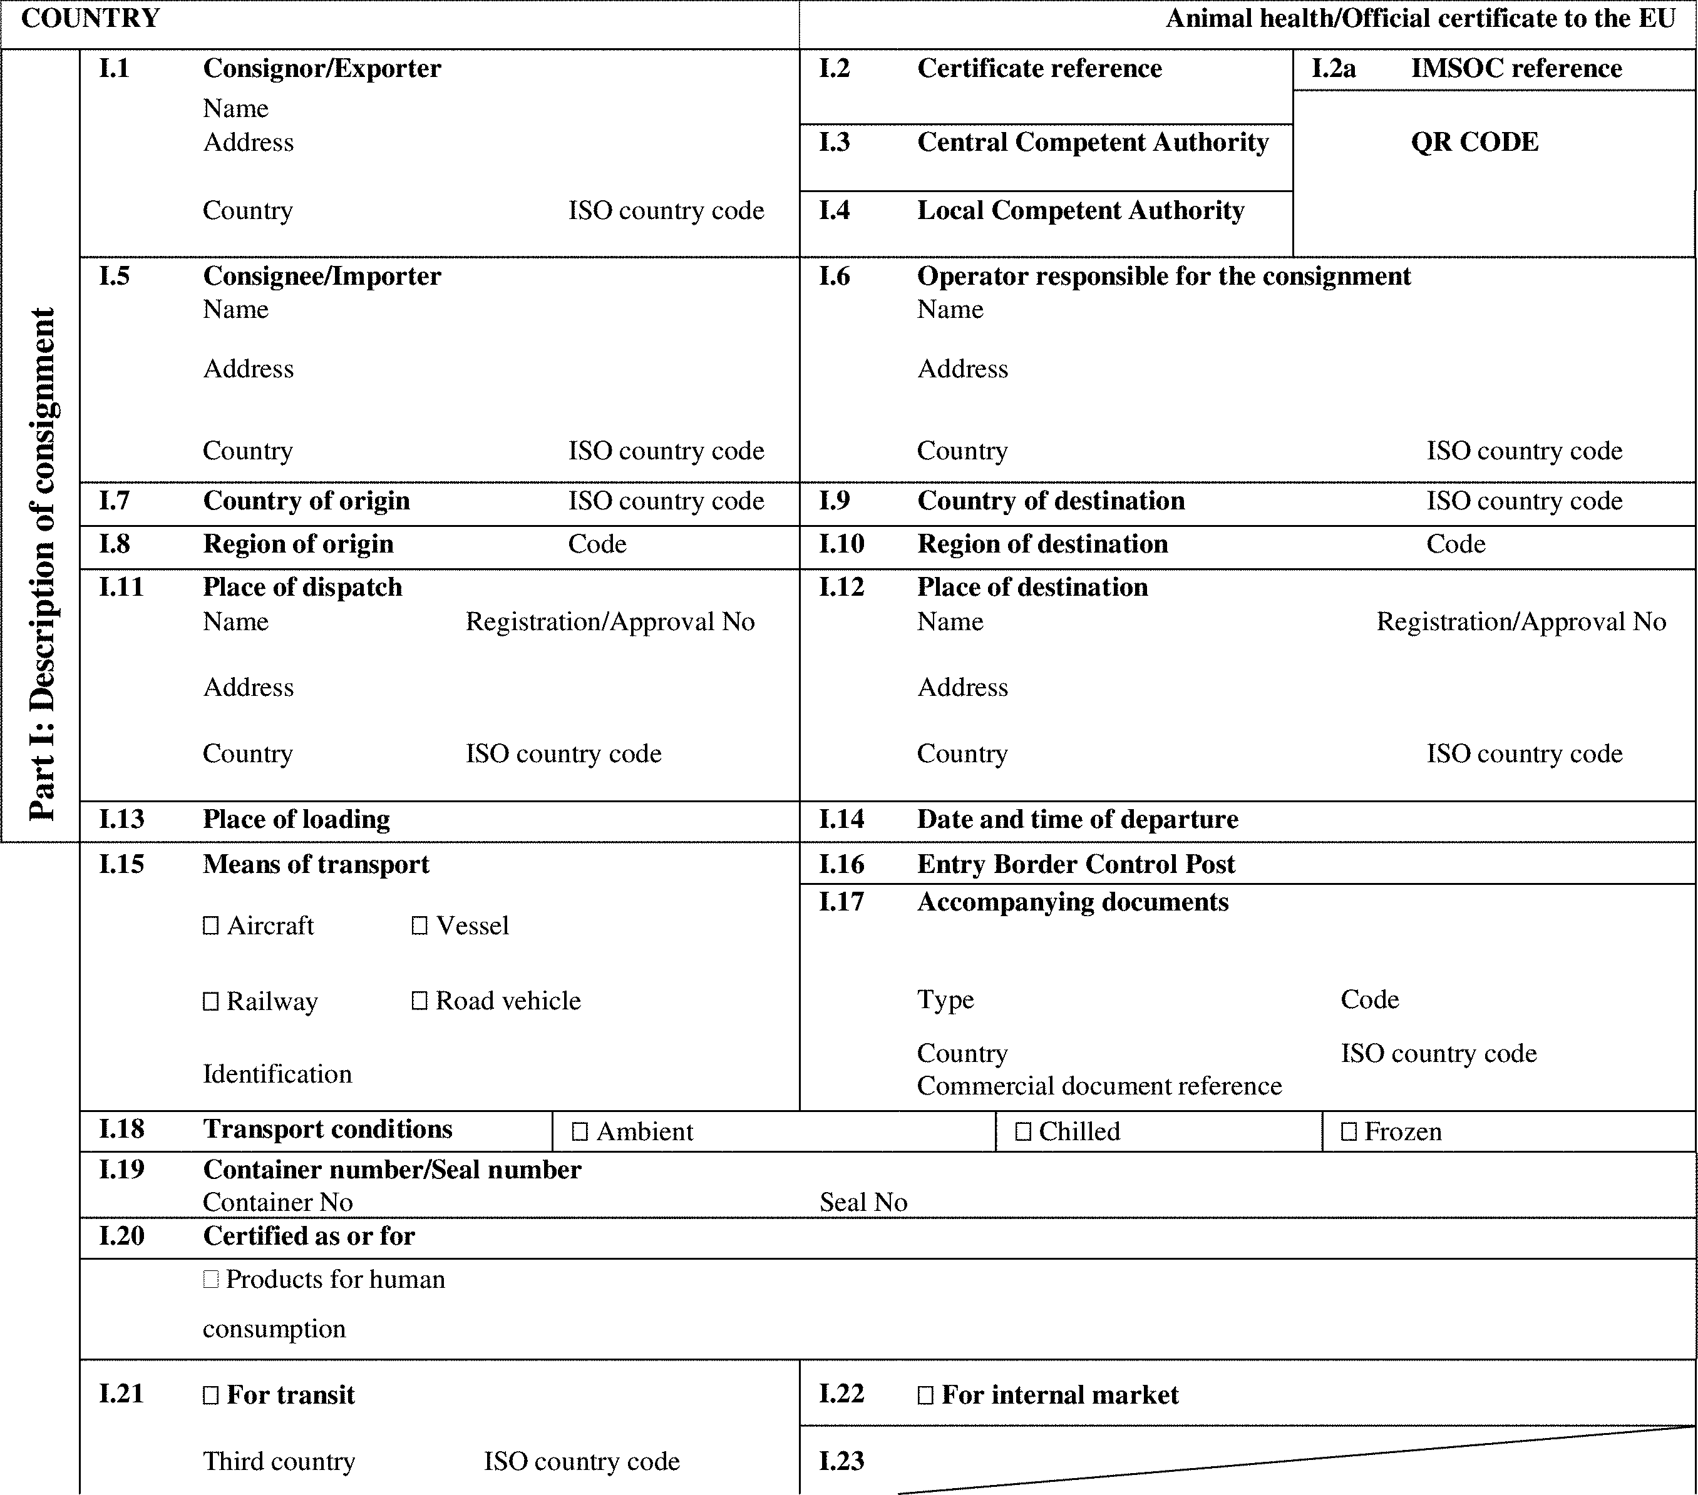

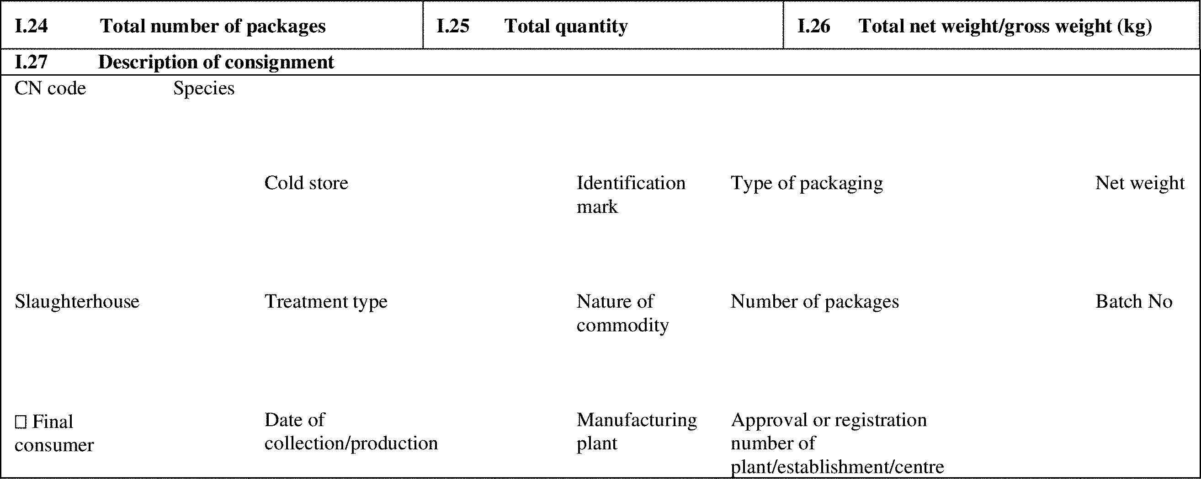

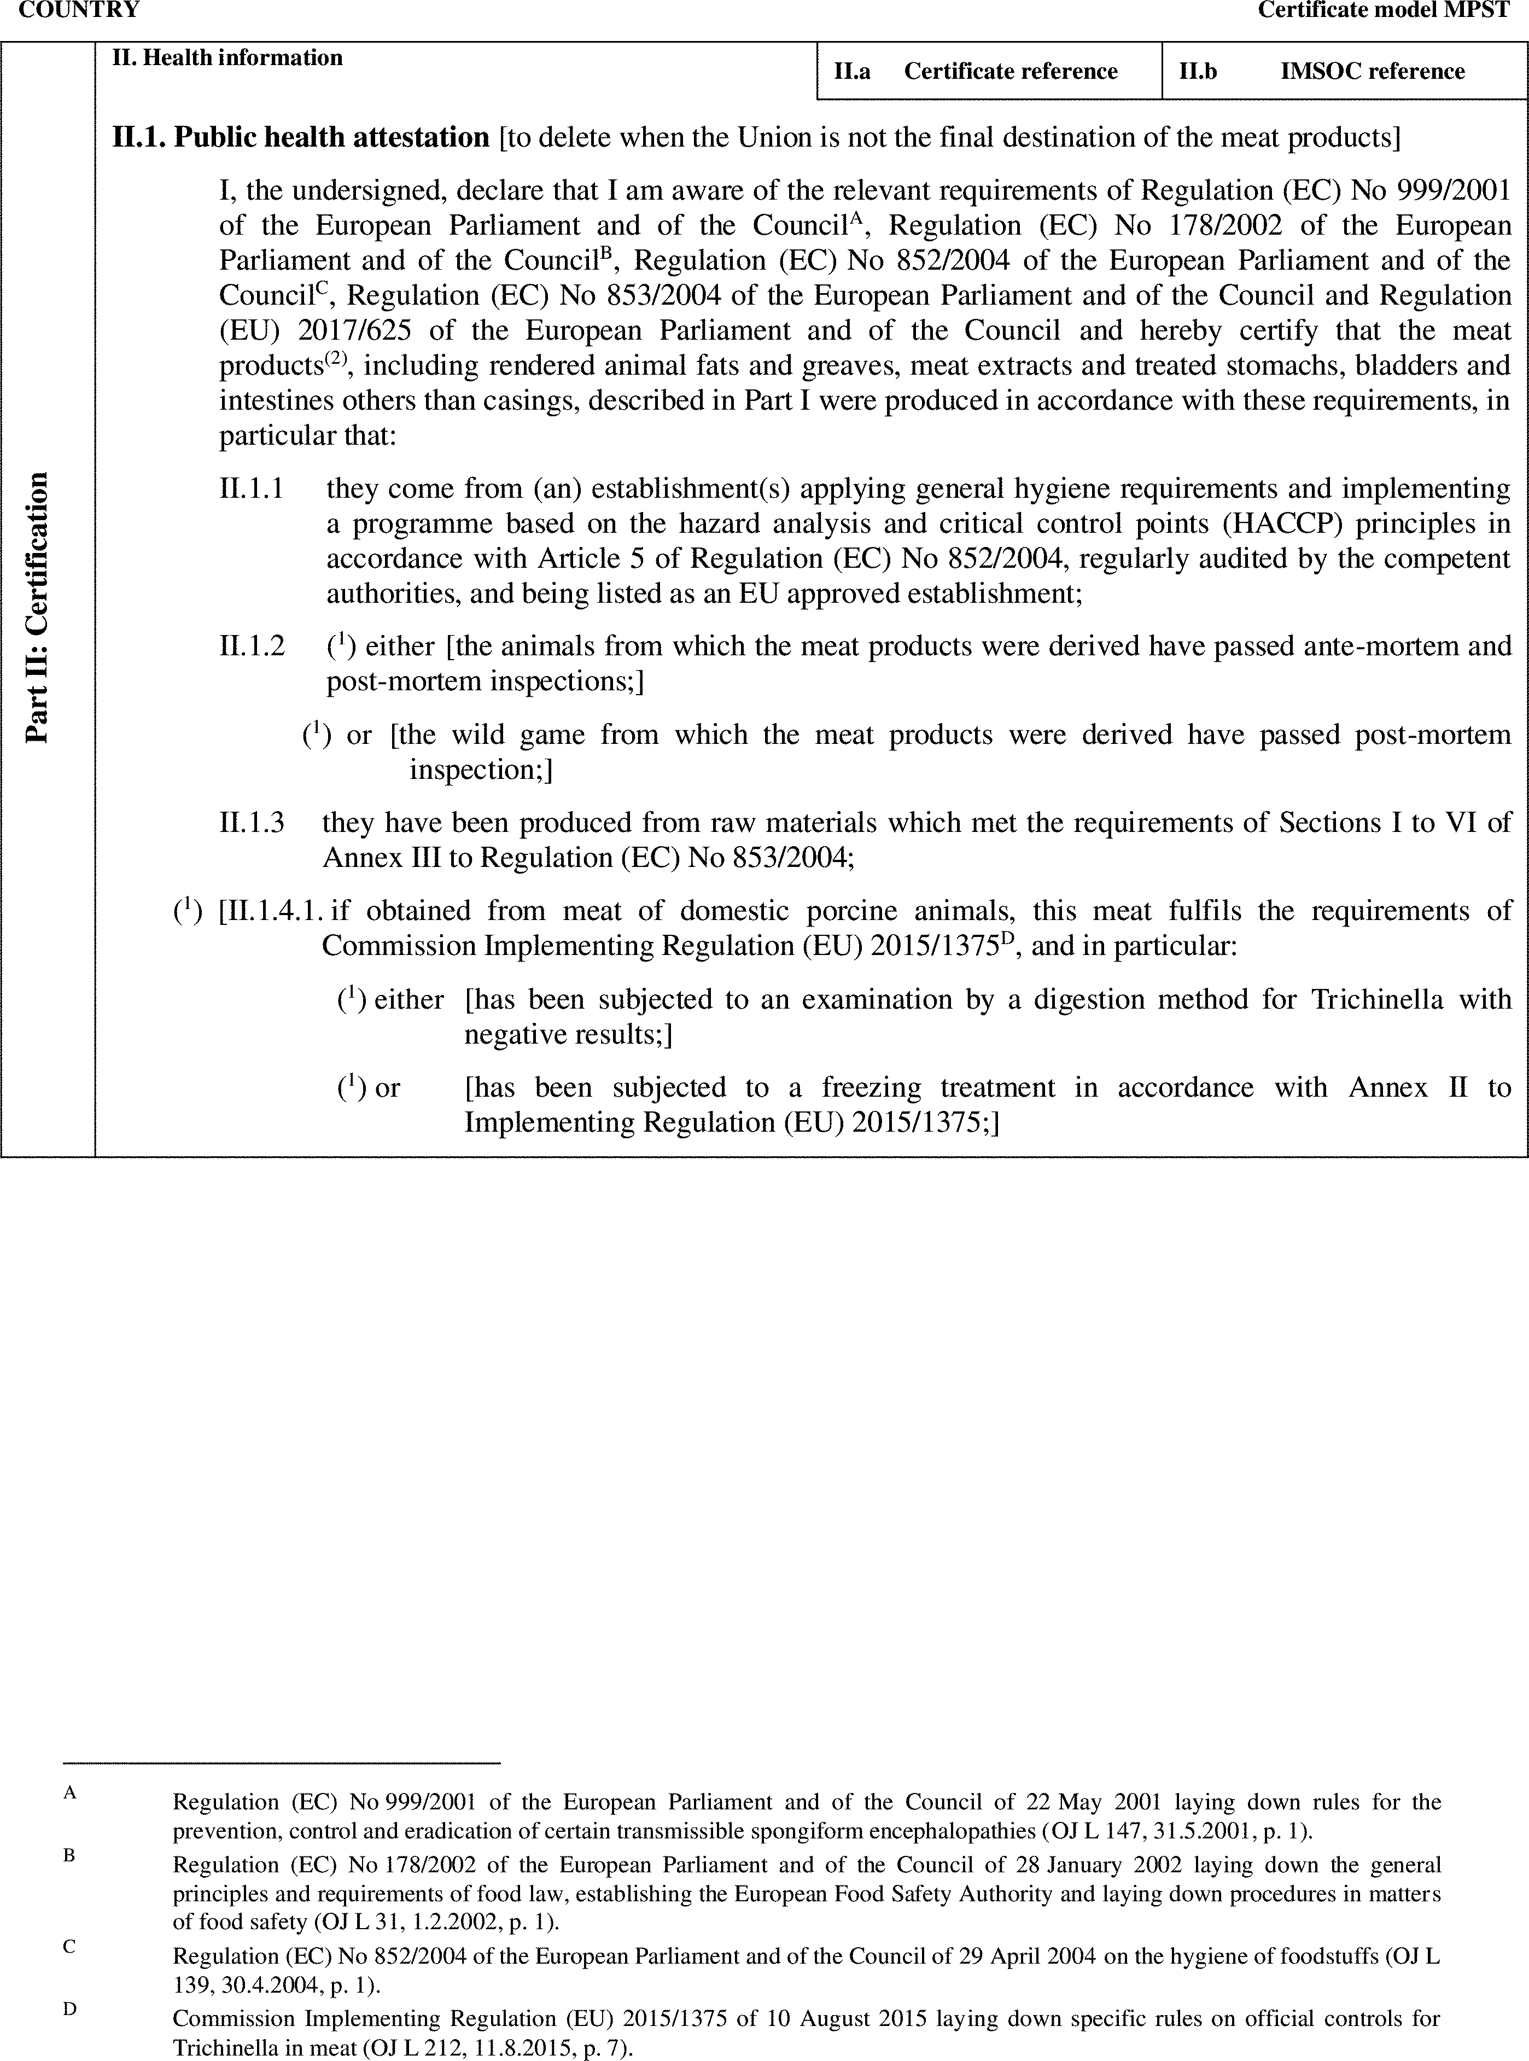

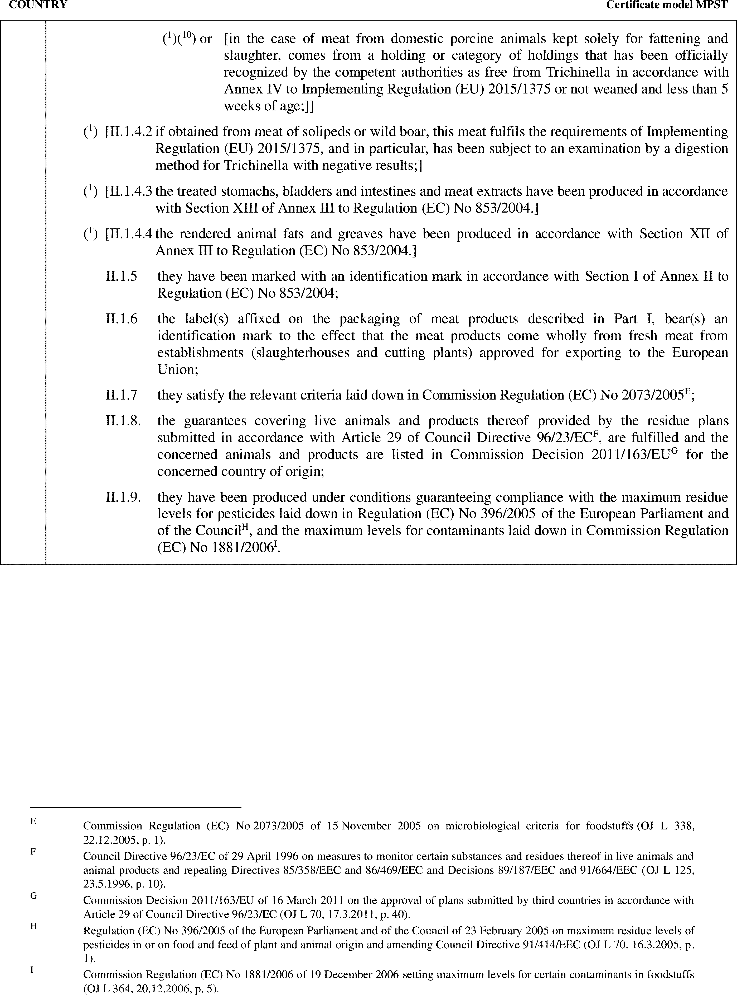

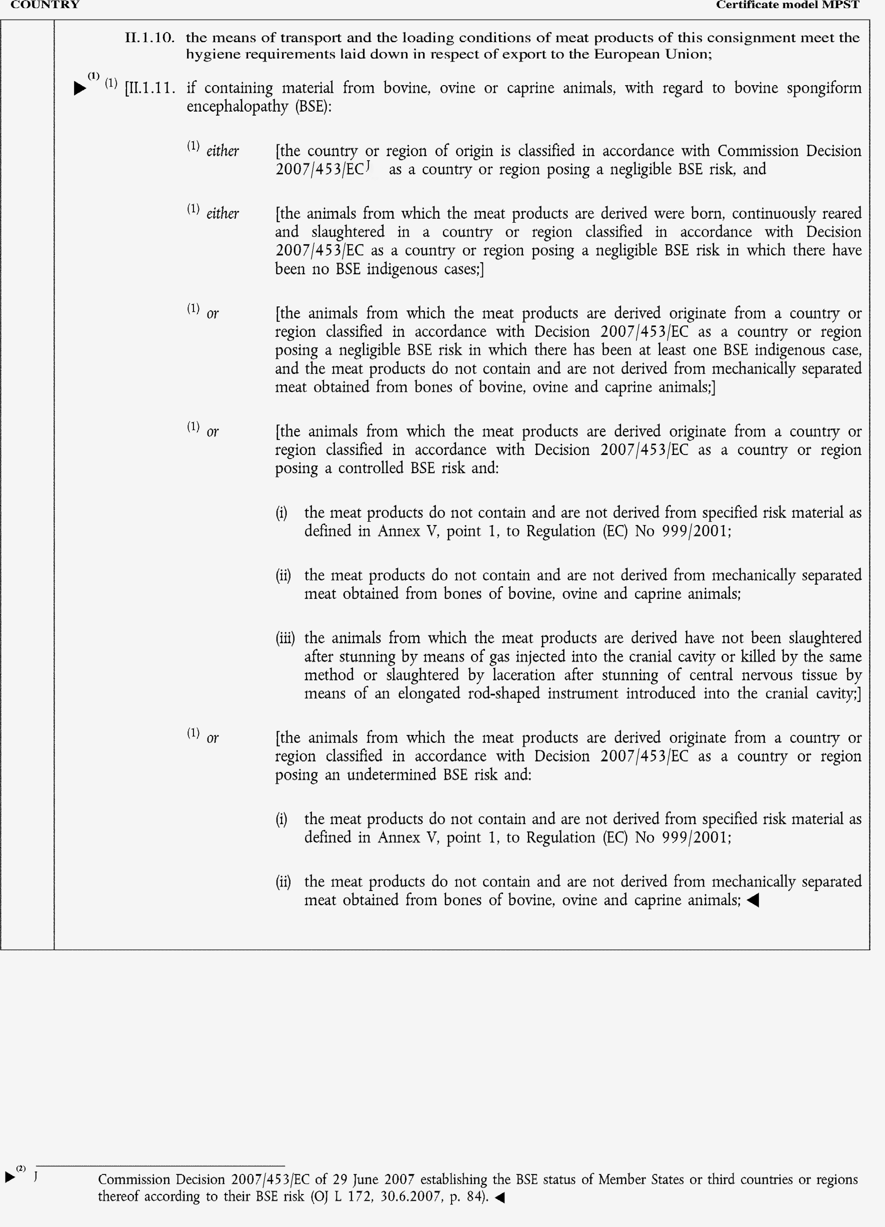

►(1) (2) M7

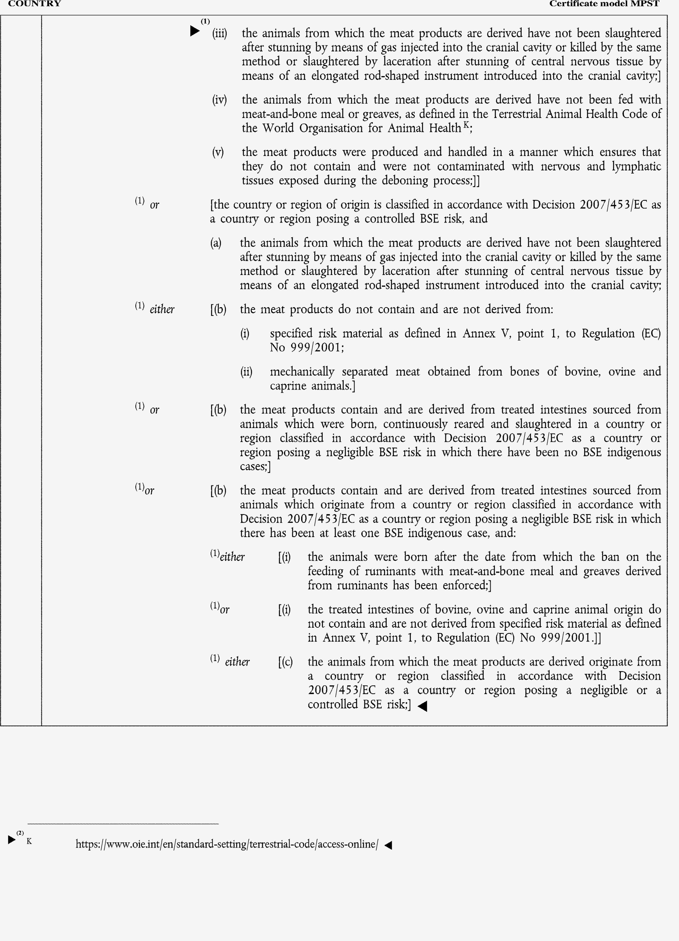

►(1) (2) M7

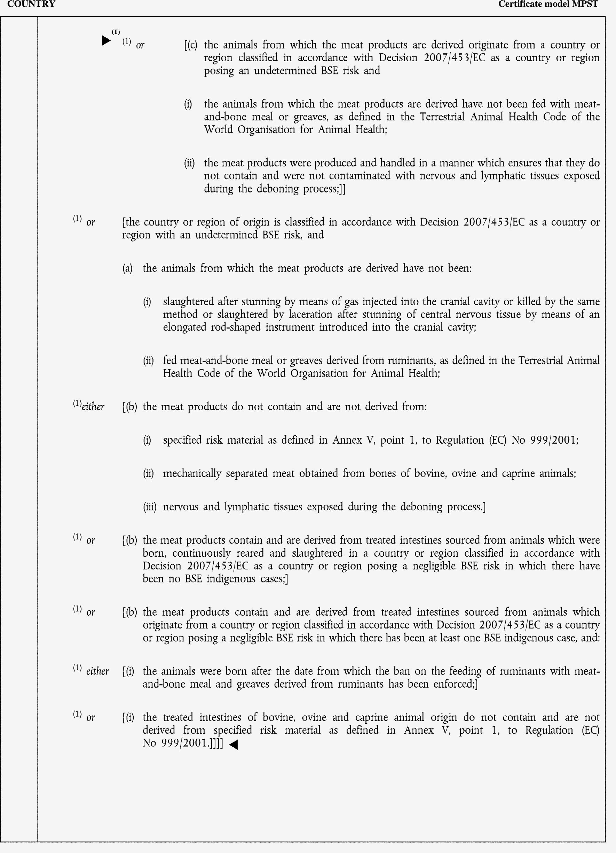

►(1) M7

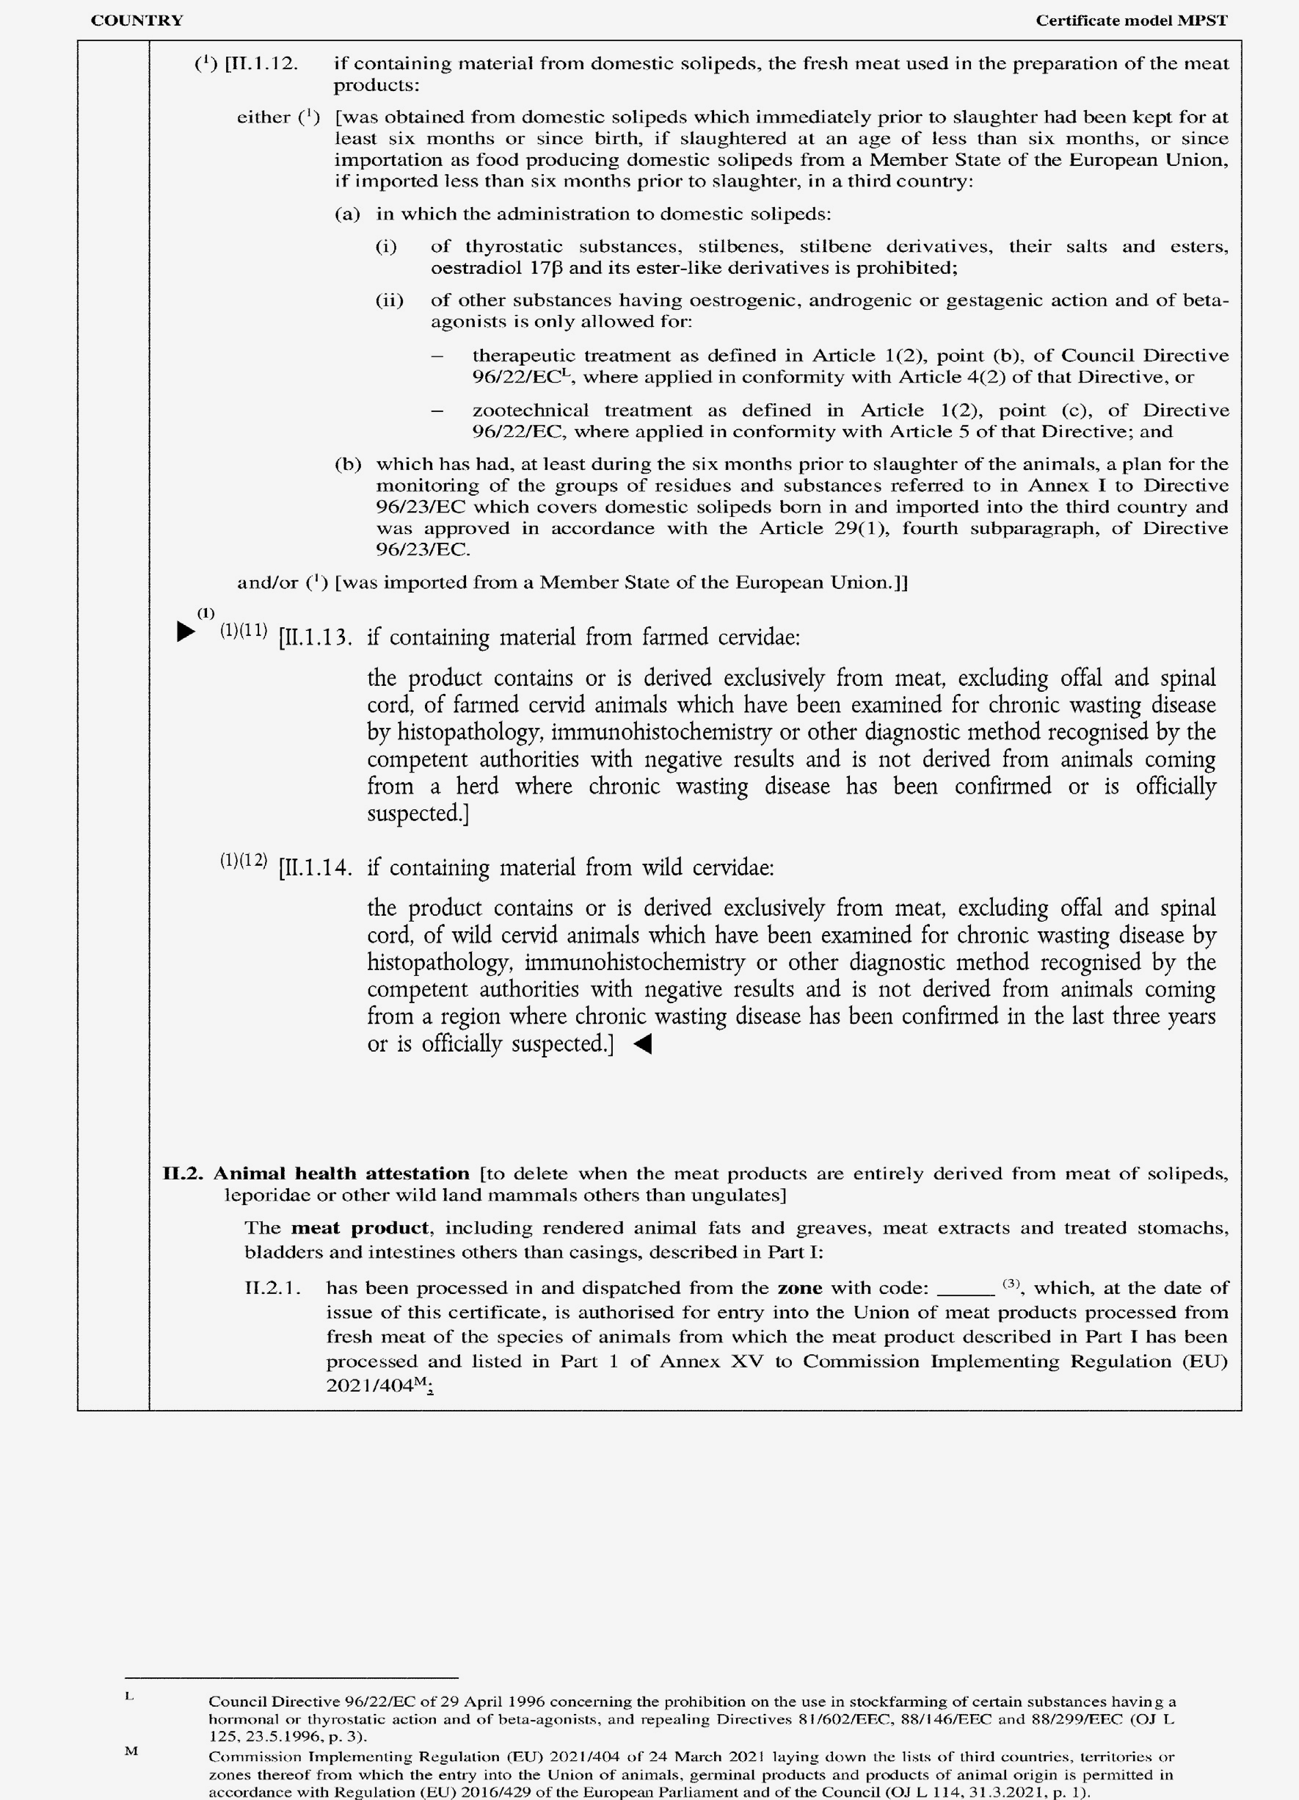

►(1) M7

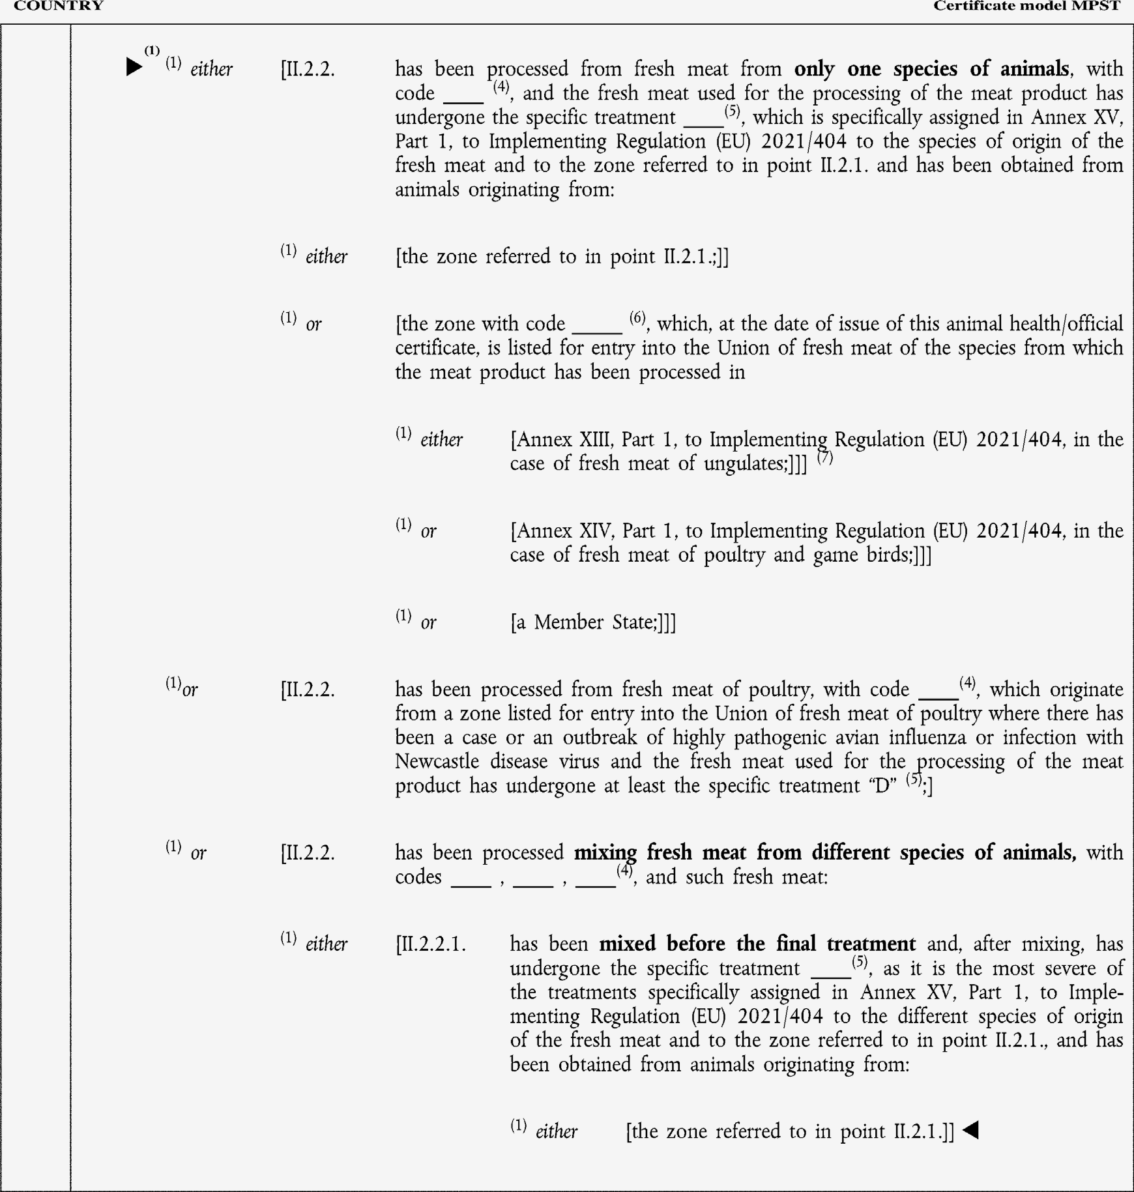

►(1) M7

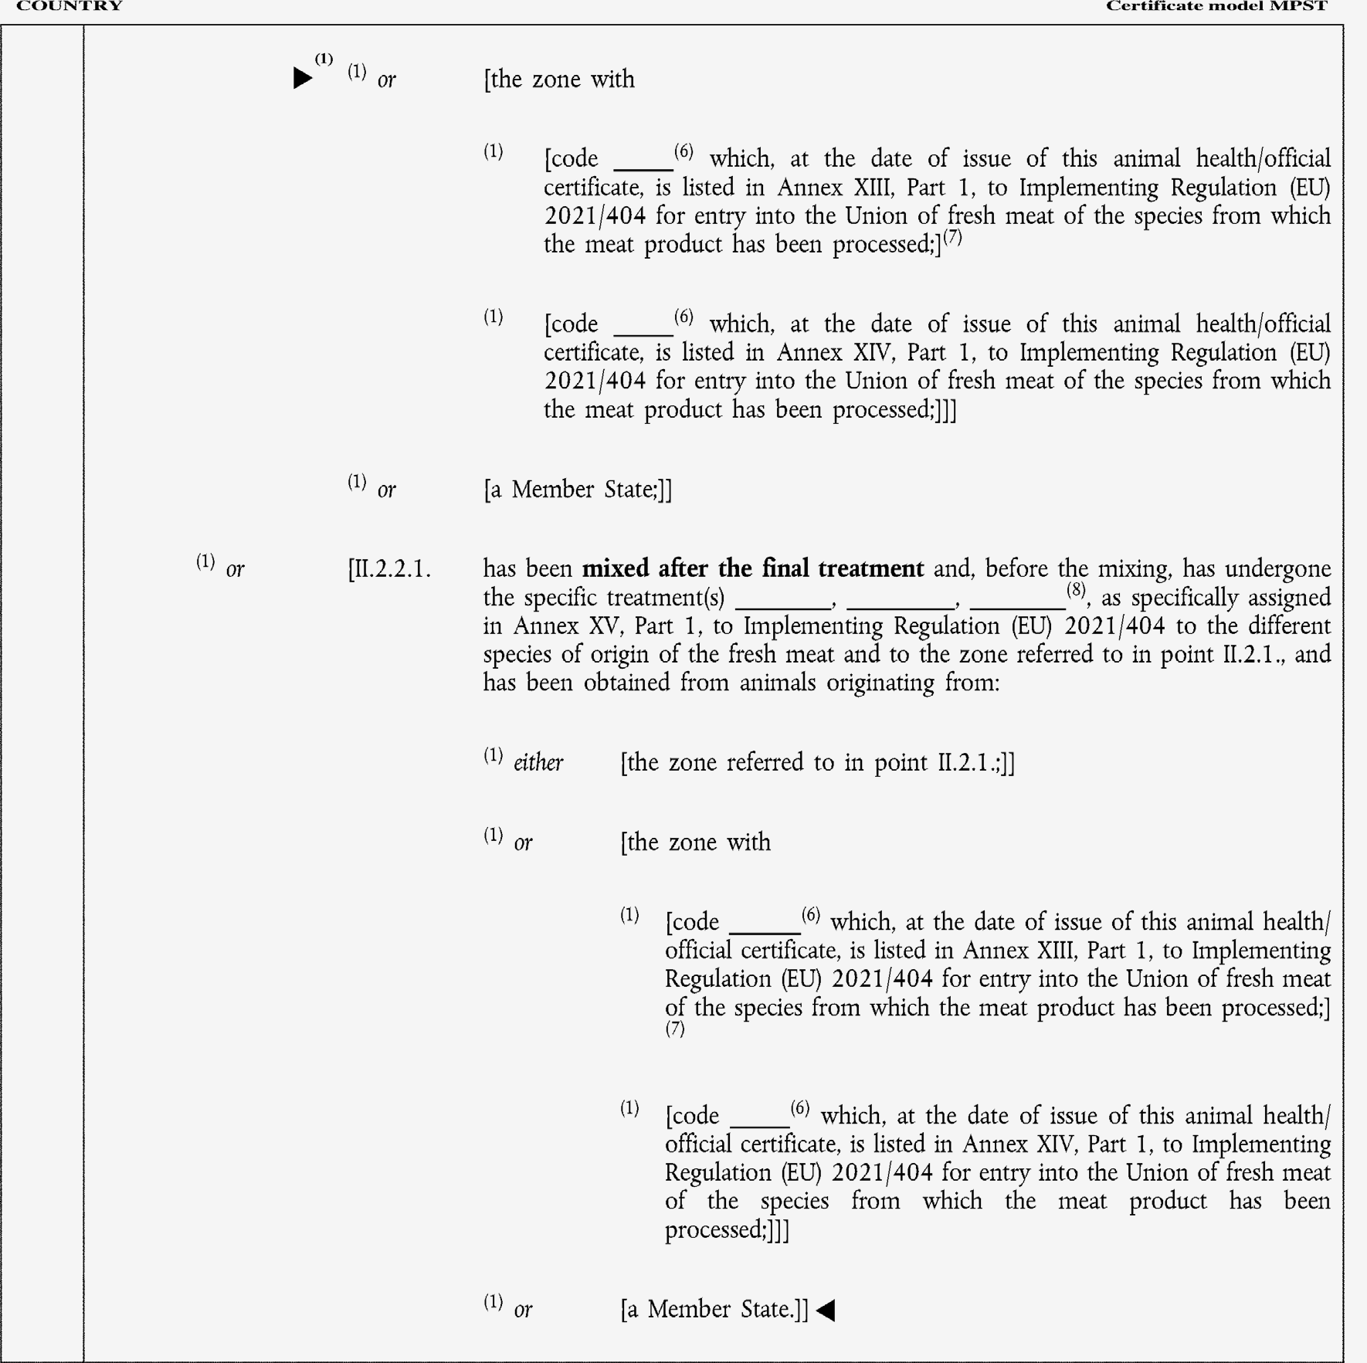

►(1) M7

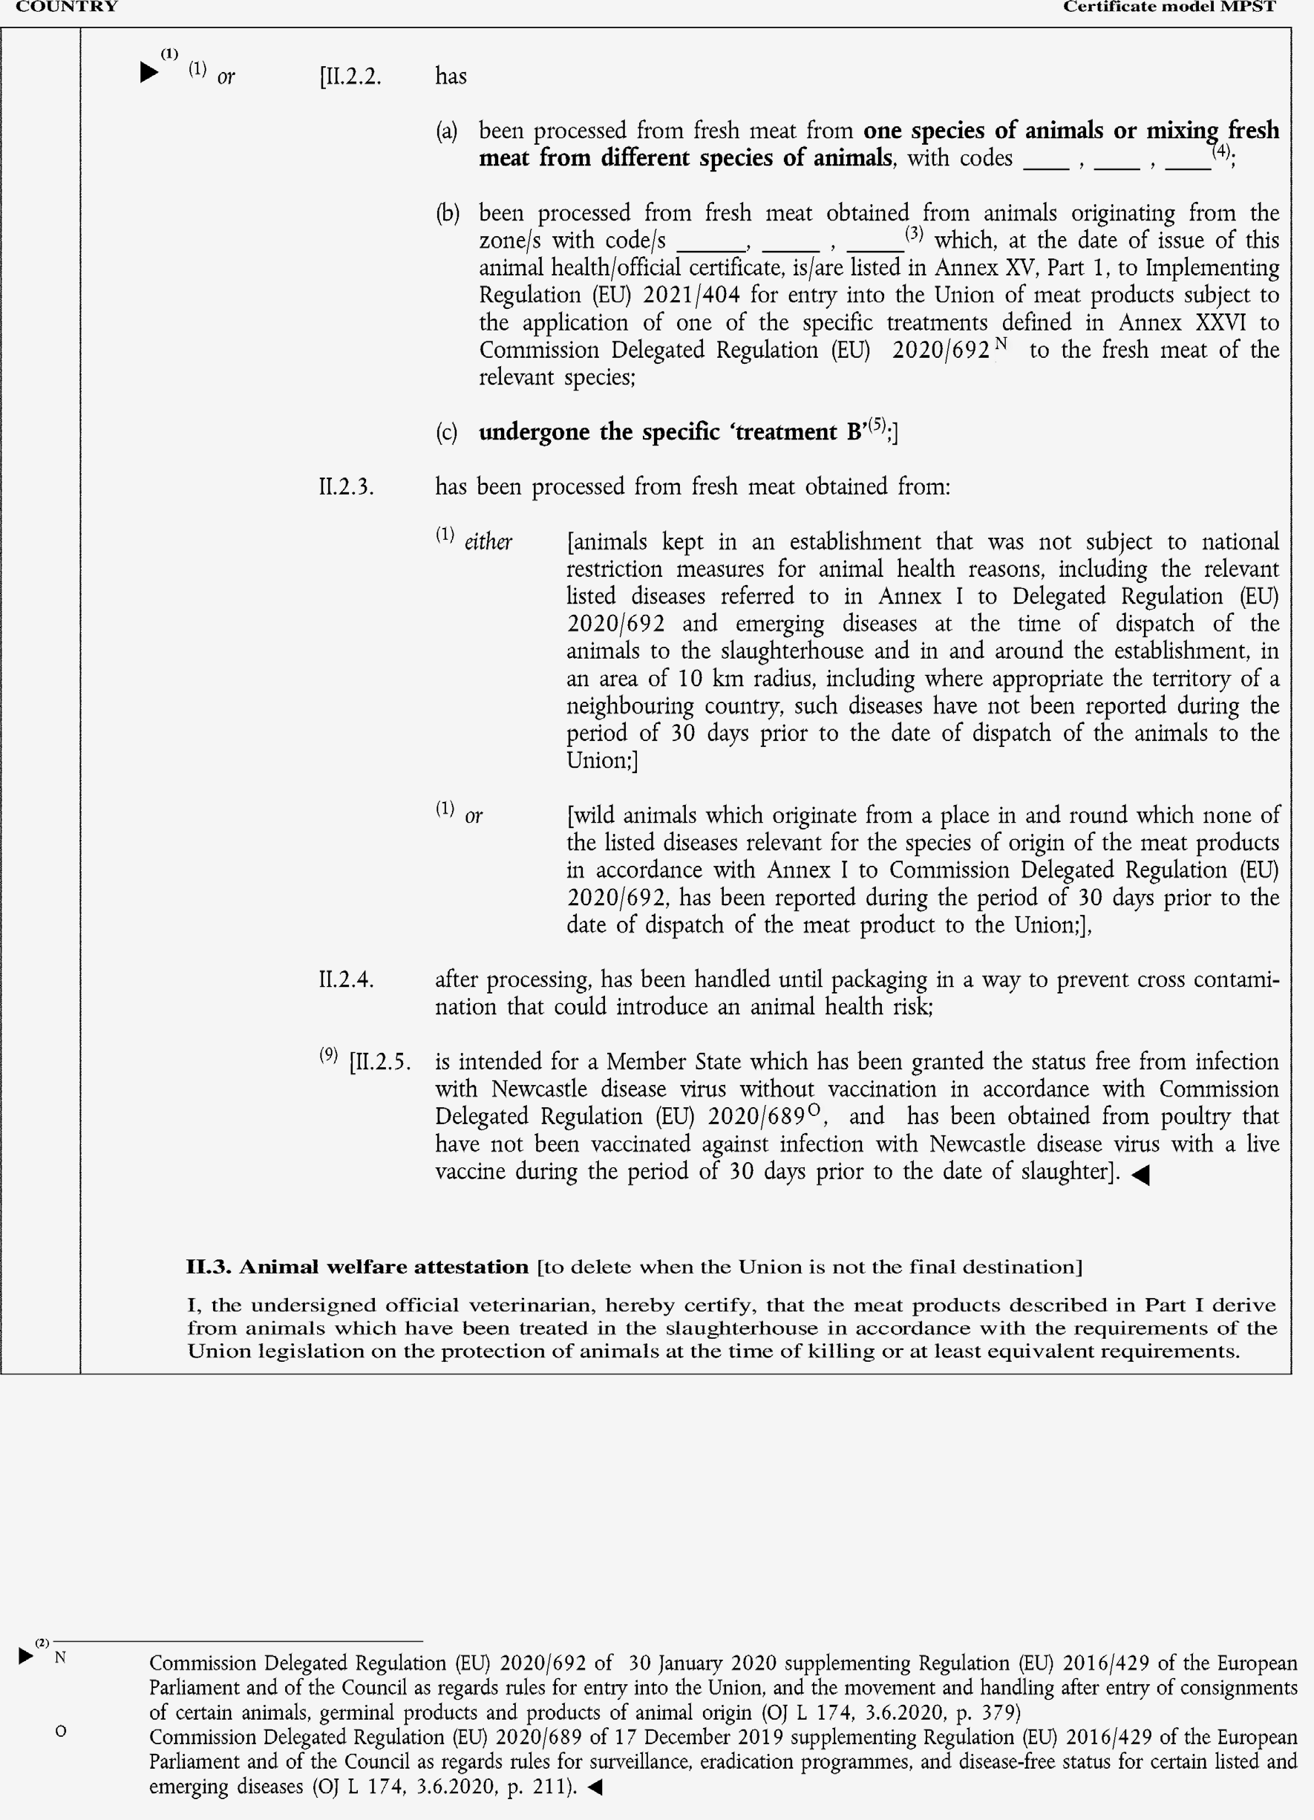

►(1) (2) M7

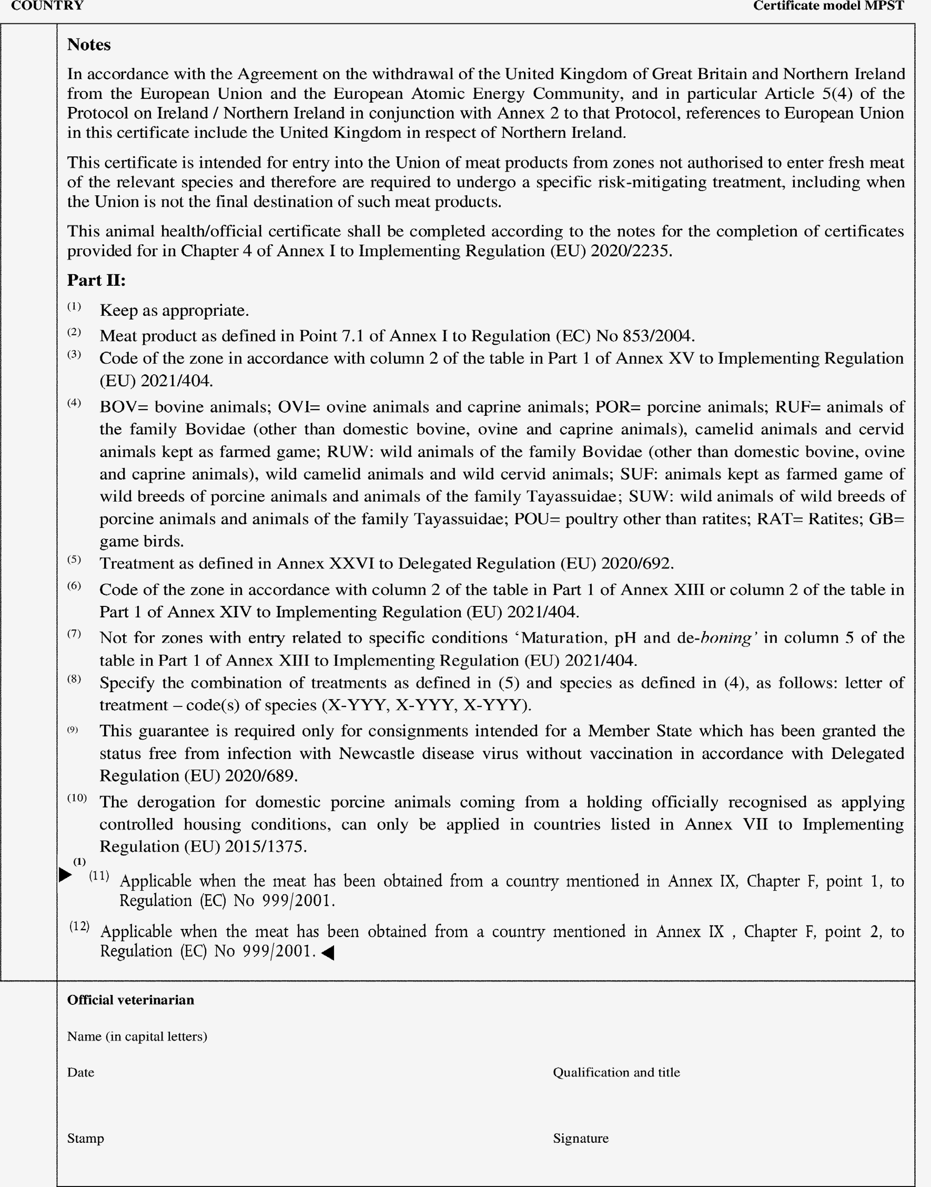

►(1) M7

